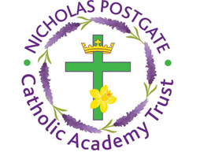

St. Edward’s Catholic Primary School,
a Catholic Voluntary Academy,
Eastbourne Road,
Middlesbrough,
Cleveland.
TS5 6QS

Tel: 01642 819507
Fax: 01642 811902

Email: enquiries@stedwards.npcat.org.uk
Website: www.stedwards.npcat.org.uk
Twitter: @SaintEdwardsRC

Headteacher: Mrs MD Brown B.Ed (Hons) NPQH

Prayer for Today

Our prayer today is a blessing for summer

May you walk with God this summer in whatever you do and wherever you go.

May you talk to God this summer and every day and in every situation.

May you talk with God every day.








Nicholas Postgate Catholic Academy Trust, Company No. 09203984
Registered Address: Trinity Catholic College, Saltersgill Avenue, Middlesbrough. TS4 3JW

