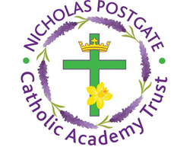

St. Edward’s Catholic Primary School,
a Catholic Voluntary Academy,
Eastbourne Road,
Middlesbrough,
Cleveland.
TS5 6QS

Tel: 01642 819507
Fax: 01642 811902

Email: enquiries@stedwards.npcat.org.uk
Website: www.stedwards.npcat.org.uk
Twitter: @SaintEdwardsRC

Headteacher: Mrs MD Brown B.Ed (Hons) NPQH

Prayer for Today

Our prayer today is:

Look to this day, for it is life, the very life of life. In its brief course lie all the realities and truths of existence. The joys of growth, the splendour of action, the glory of power.
For yesterday is but a memory and tomorrow is only a vision. But today well lived makes every yesterday a memory of happiness and every tomorrow a vision of hope.
Look well therefore, to this day! “








Nicholas Postgate Catholic Academy Trust, Company No. 09203984
Registered Address: Trinity Catholic College, Saltersgill Avenue, Middlesbrough. TS4 3JW

