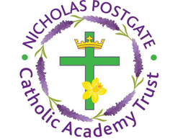

St. Edward’s Catholic Primary School,
a Catholic Voluntary Academy,
Eastbourne Road,
Middlesbrough,
Cleveland.
TS5 6QS

Tel: 01642 819507
Fax: 01642 811902

Email: enquiries@stedwards.npcat.org.uk
Website: www.stedwards.npcat.org.uk
Twitter: @SaintEdwardsRC

Headteacher: Mrs MD Brown B.Ed (Hons) NPQH

Prayer for Today

Our prayer today is:

Gracious God, thank you for the gift of today. Refresh me. Invite me to discover your presence in each person that I meet and every event that I encounter. Teach me when to speak and when to listen. When to ponder and when to share. In moments of challenge and decision attune my heart to the whisperings of your Wisdom. As I undertake ordinary and unnoticed tasks, gift me with simple joy. When my day goes well, may I rejoice. When it grows difficult, surprise me with new possibilities. When life is overwhelming, call me to Sabbath moments to restore your Peace and Harmony. May my living today reveal your Goodness.








Nicholas Postgate Catholic Academy Trust, Company No. 09203984
Registered Address: Trinity Catholic College, Saltersgill Avenue, Middlesbrough. TS4 3JW

