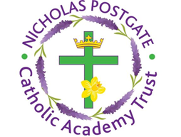

**St. Edward’s Catholic Primary School,**

a Catholic Voluntary Academy,

Eastbourne Road,

Middlesbrough,

Cleveland.

TS5 6QS

Tel: 01642 819507

Fax: 01642 811902

Email: enquiries@stedwards.npcat.org.uk

Website: [www.stedwards.npcat.org.uk/](http://www.stedwards.npcat.org.uk/)

Twitter: @SaintEdwardsRC

Headteacher: Mrs MD Brown B.Ed (Hons) NPQH

Monday 13th July 2020

Dear Parents/Guardians,

Just to inform you that school will not be open during the six weeks holidays for all pupils.  As such, home learning resources will end wb 13.7.20.  Thank you for engaging in this learning during the period of enforced closure.

School will close on Friday July 17th at 3:15pm.  There will be a training day on Tuesday 1st September and pupils will return to school on Wednesday 2nd September.

More specific details will follow before the end of term.

Kind regards

Mrs M D Brown





**Nicholas Postgate Catholic Academy Trust**, Company No. 09203984

Registered Address: Trinity Catholic College, Saltersgill Avenue, Middlesbrough. TS4