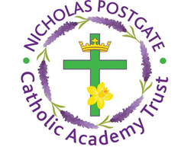

St. Edward’s Catholic Primary School,
a Catholic Voluntary Academy,
Eastbourne Road,
Middlesbrough,
Cleveland.
TS5 6QS

Tel: 01642 819507
Fax: 01642 811902

Email: enquiries@stedwards.npcat.org.uk
Website: www.stedwards.npcat.org.uk
Twitter: @SaintEdwardsRC

Headteacher: Mrs MD Brown B.Ed (Hons) NPQH

Prayer for Today

Our prayer today is:

Father, we thank you for the gift of your creation, for the creatures and plants on whom we depend for our existence. May we learn to respect the environment you have created so that future generations will see your glory.

Amen








Nicholas Postgate Catholic Academy Trust, Company No. 09203984
Registered Address: Trinity Catholic College, Saltersgill Avenue, Middlesbrough. TS4 3JW

