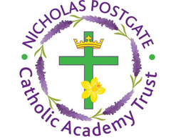
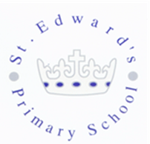
St. Edward’s Catholic Primary School,
a Catholic Voluntary Academy,
Eastbourne Road,
Middlesbrough,
Cleveland.
TS5 6QS

Tel: 01642 819507
Fax: 01642 811902

Email: enquiries@stedwards.npcat.org.uk
Website: www.stedwards.npcat.org.uk
Twitter: @SaintEdwardsRC

Headteacher: Mrs MD Brown B.Ed (Hons) NPQH

Prayer for Today
Our prayer today is:

People are often unreasonable, irrational, and self-centred. Forgive them anyway. If you are kind, people may accuse you of selfish, ulterior motives. Be kind anyway. If you are successful, you will win some unfaithful friends and some genuine enemies. Succeed anyway. If you are honest and sincere people may deceive you. Be honest and sincere anyway. What you spend years creating, others could destroy overnight. Create anyway. The good you do today, will often be forgotten. Do good anyway. Give the best you have, and it will never be enough. Give your best anyway. In the final analysis, it is between you and God. It was never between you and them anyway.




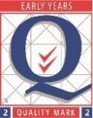
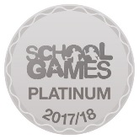
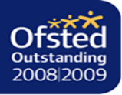

Nicholas Postgate Catholic Academy Trust, Company No. 09203984
Registered Address: Trinity Catholic College, Saltersgill Avenue, Middlesbrough. TS4 3JW

