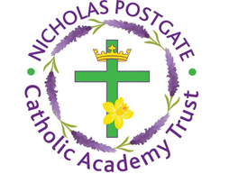

St. Edward’s Catholic Primary School,
a Catholic Voluntary Academy,
Eastbourne Road,
Middlesbrough,
Cleveland.
TS5 6QS

Tel: 01642 819507
Fax: 01642 811902

Email: enquiries@stedwards.npcat.org.uk
Website: www.stedwards.npcat.org.uk
Twitter: @SaintEdwardsRC

Headteacher: Mrs MD Brown B.Ed (Hons) NPQH

Prayer for Today

Our prayer today on this, the feast of the birthday of John the Baptist is:

O God, who hast made this day to be honourable in our eyes by the commemoration of blessed John, grant unto Thy people the grace of spiritual joy, and direct the minds of all Thy faithful into the way of everlasting salvation.
Through Christ our Lord.
Amen








Nicholas Postgate Catholic Academy Trust, Company No. 09203984
Registered Address: Trinity Catholic College, Saltersgill Avenue, Middlesbrough. TS4 3JW

