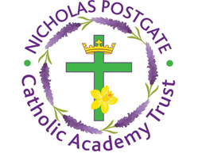
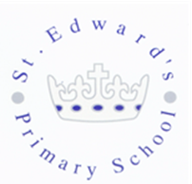
St. Edward’s Catholic Primary School,
a Catholic Voluntary Academy,
Eastbourne Road,
Middlesbrough,
Cleveland.
TS5 6QS

Tel: 01642 819507
Fax: 01642 811902

Email: enquiries@stedwards.npcat.org.uk
Website: www.stedwards.npcat.org.uk
Twitter: @SaintEdwardsRC

Headteacher: Mrs MD Brown B.Ed (Hons) NPQH

Prayer for Today

Dear all,

Today, as well as keeping refugees in our prayers, we also pray for
Sacred Heart Catholic Primary and Sacred Heart Catholic Secondary who are celebrating their feast day today. We keep these communities from our NPCAT family in our prayers and ask God to bless the students, staff and families.

Lord, you deserve all honour and praise,
because your love is perfect and your heart sublime.
My heart is filled to overflowing with gratitude
for the many blessings and graces you have bestowed upon me and those
whom I love.
Forever undeserving, may I always be attentive
and never take for granted the gifts of mercy and love
that flow so freely and generously from your Sacred Heart.
Heart of Jesus, I adore you.
Heart of Jesus, I praise you.
Heart of Jesus, I thank you.
Heart of Jesus, I love you forever and always.
Amen.








Nicholas Postgate Catholic Academy Trust, Company No. 09203984
Registered Address: Trinity Catholic College, Saltersgill Avenue, Middlesbrough. TS4 3JW

