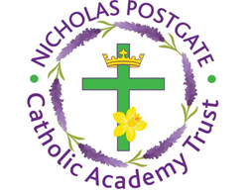

St. Edward’s Catholic Primary School,
a Catholic Voluntary Academy,
Eastbourne Road,
Middlesbrough,
Cleveland.
TS5 6QS

Tel: 01642 819507
Fax: 01642 811902

Email: enquiries@stedwards.npcat.org.uk
Website: www.stedwards.npcat.org.uk
Twitter: @SaintEdwardsRC

Headteacher: Mrs MD Brown B.Ed (Hons) NPQH

Prayer for Today

Dear all,

Today let us pray again for equality in our society. As we rebuild it after the pandemic, let us rebuild a fairer and more justice society.

Lord Jesus, we pray a blessing for all those actively engaged in the struggle for racial justice. Grant that they may:
Hear the voices crying for justice;
Engage in developing a better understanding;
Act to bring about change;
Lead and inspire others by their good example.
Amen.








Nicholas Postgate Catholic Academy Trust, Company No. 09203984
Registered Address: Trinity Catholic College, Saltersgill Avenue, Middlesbrough. TS4 3JW

