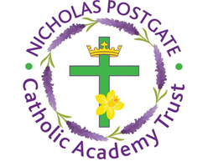
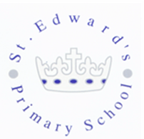
St. Edward’s Catholic Primary School,
a Catholic Voluntary Academy,
Eastbourne Road,
Middlesbrough,
Cleveland.
TS5 6QS

Tel: 01642 819507
Fax: 01642 811902

Email: enquiries@stedwards.npcat.org.uk
Website: www.stedwards.npcat.org.uk
Twitter: @SaintEdwardsRC

Headteacher: Mrs MD Brown B.Ed (Hons) NPQH

Prayer for Today

Dear all,

Loving God,
Loving God,
Open our minds and touch our hearts, so that we can be part of Creation, your gift.
Be present to those in need in these difficult times.
Help us to show creative solidarity as we confront the consequences of the pandemic.
Make us courageous in embracing the changes required to seek the common good.
Now more than ever, may we all feel interconnected and interdependent.
Enable us to succeed in listening and responding to the cry of the Earth and the cry of the poor.
May their current sufferings become the birth pangs
of a more fraternal and sustainable world.
We pray through Christ our Lord. Amen.








Nicholas Postgate Catholic Academy Trust, Company No. 09203984
Registered Address: Trinity Catholic College, Saltersgill Avenue, Middlesbrough. TS4 3JW

