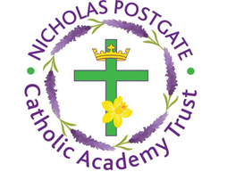
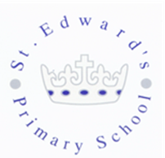
St. Edward’s Catholic Primary School,
a Catholic Voluntary Academy,
Eastbourne Road,
Middlesbrough,
Cleveland.
TS5 6QS

Tel: 01642 819507
Fax: 01642 811902

Email: enquiries@stedwards.npcat.org.uk
Website: www.stedwards.npcat.org.uk
Twitter: @SaintEdwardsRC

Headteacher: Mrs MD Brown B.Ed (Hons) NPQH

Prayer for Today

Dear all,

Today our reflection is a poem I found on the Alone together website. It is written by Fr Luke Bell OSB

Get out of your head.
Your head doesn't have all the answers.
There are worries in your head. There are anxieties in your head.
Get into your hands.
You have two hands. You have one hand for loving. You have one hand for doing.
Work with your hands.
Your hands will work together. They will not complain. They will not expect to be paid.
Live in your hands. Watch what they do. Love what they do. Treasure what they make.
Be in your heart. Let your hands take you out of your head. Let them take you nearer to themselves. Let them take you to your heart.

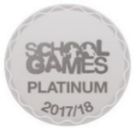
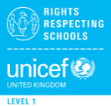

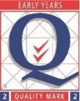
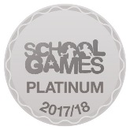
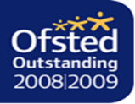

Nicholas Postgate Catholic Academy Trust, Company No. 09203984
Registered Address: Trinity Catholic College, Saltersgill Avenue, Middlesbrough. TS4 3JW

