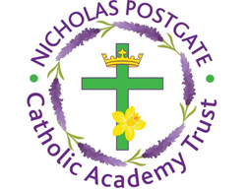

St. Edward’s Catholic Primary School,
a Catholic Voluntary Academy,
Eastbourne Road,
Middlesbrough,
Cleveland.
TS5 6QS

Tel: 01642 819507
Fax: 01642 811902

Email: enquiries@stedwards.npcat.org.uk
Website: www.stedwards.npcat.org.uk
Twitter: @SaintEdwardsRC

Headteacher: Mrs MD Brown B.Ed (Hons) NPQH

Prayer for Today

Dear all,

our prayer today is called "Deep Peace"
Deep peace of the running wave to you.
Deep peace of the flowing air to you.
Deep peace of the quiet earth to you.
Deep peace of the shining stars to you.
Deep peace of the Son of peace to you.
Amen








Nicholas Postgate Catholic Academy Trust, Company No. 09203984
Registered Address: Trinity Catholic College, Saltersgill Avenue, Middlesbrough. TS4 3JW

