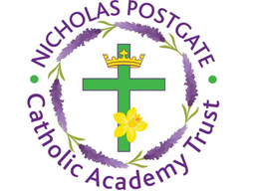

St. Edward’s Catholic Primary School,
a Catholic Voluntary Academy,
Eastbourne Road,
Middlesbrough,
Cleveland.
TS5 6QS

Tel: 01642 819507
Fax: 01642 811902

Email: enquiries@stedwards.npcat.org.uk
Website: www.stedwards.npcat.org.uk
Twitter: @SaintEdwardsRC

Headteacher: Mrs MD Brown B.Ed (Hons) NPQH

Prayer for Today

At this time Pope Francis has asked us to pray for children and families. This is our intention today. Let us pause for a moment to pray for our families and those we know.

O God, who by the grace of the Holy Spirit have filled the hearts of your faithful with gifts of charity, grant health of mind and body to our children and their families, for whom we beseech your mercy, that they may love you with all their strength and, with all their love, do what is pleasing to you. We ask this through Christ our Lord.

Amen.








Nicholas Postgate Catholic Academy Trust, Company No. 09203984
Registered Address: Trinity Catholic College, Saltersgill Avenue, Middlesbrough. TS4 3JW

