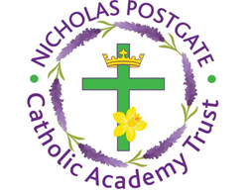

St. Edward’s Catholic Primary School,
a Catholic Voluntary Academy,
Eastbourne Road,
Middlesbrough,
Cleveland.
TS5 6QS

Tel: 01642 819507
Fax: 01642 811902

Email: enquiries@stedwards.npcat.org.uk
Website: www.stedwards.npcat.org.uk
Twitter: @SaintEdwardsRC

Headteacher: Mrs MD Brown B.Ed (Hons) NPQH

Prayer for Today

Dear all,

Our prayer today was written by a year 4 pupil from Corpus Christi:
Dear Lord,
Thank You for the gift of today and for your Grace.
Thank You for my family and friends and all the key workers working hard to keep us safe.
Thank You for the strength you give me each day and for the people around me.
I pray that this will all be over soon and we can all return to our normal lives.
Thank You to all the staff at schools working hard to keep us busy and checking in on us.
I pray for the people who have lost their lives.
We Thank You for your protection.
Amen








Nicholas Postgate Catholic Academy Trust, Company No. 09203984
Registered Address: Trinity Catholic College, Saltersgill Avenue, Middlesbrough. TS4 3JW

