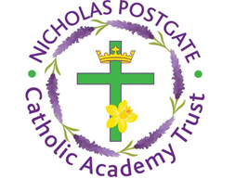

St. Edward’s Catholic Primary School,
a Catholic Voluntary Academy,
Eastbourne Road,
Middlesbrough,
Cleveland.
TS5 6QS

Tel: 01642 819507
Fax: 01642 811902

Email: enquiries@stedwards.npcat.org.uk
Website: www.stedwards.npcat.org.uk
Twitter: @SaintEdwardsRC

Headteacher: Mrs MD Brown B.Ed (Hons) NPQH

Prayer for Today

Today I’d like to start by sharing this thought Canon Turnham sent round the parish yesterday:

Also highly contagious is – kindness, patience, love, enthusiasm and a positive attitude.
Don’t wait to catch it from others, be the carrier.

Let us pray:

Help us Lord to use the gifts of the spirit at this time to help others in any way we can. Be with us in everything.

Amen








Nicholas Postgate Catholic Academy Trust, Company No. 09203984
Registered Address: Trinity Catholic College, Saltersgill Avenue, Middlesbrough. TS4 3JW

