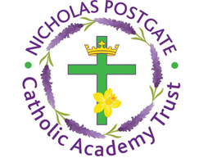

St. Edward’s Catholic Primary School,
a Catholic Voluntary Academy,
Eastbourne Road,
Middlesbrough,
Cleveland.
TS5 6QS

Tel: 01642 819507
Fax: 01642 811902

Email: enquiries@stedwards.npcat.org.uk
Website: www.stedwards.npcat.org.uk
Twitter: @SaintEdwardsRC

Headteacher: Mrs MD Brown B.Ed (Hons) NPQH

Prayer for Today

Dear all,

This morning our prayer was written by one of the year 4 pupils from St Augustine's:

Dear Father,

please pray for those who suffer. Pray for those who help those who suffer. We will be strong through this terrible time. To help each other stay at home.

Amen








Nicholas Postgate Catholic Academy Trust, Company No. 09203984
Registered Address: Trinity Catholic College, Saltersgill Avenue, Middlesbrough. TS4 3JW

