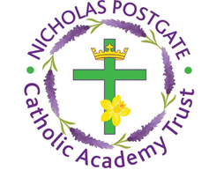

St. Edward’s Catholic Primary School,
a Catholic Voluntary Academy,
Eastbourne Road,
Middlesbrough,
Cleveland.
TS5 6QS

Tel: 01642 819507
Fax: 01642 811902

Email: enquiries@stedwards.npcat.org.uk
Website: www.stedwards.npcat.org.uk
Twitter: @SaintEdwardsRC

Headteacher: Mrs MD Brown B.Ed (Hons) NPQH

Prayer for Today

Dear all,

Today is the feast of St George, patron saint of England. Today we ask for his intercession for us at this difficult time for our country.

Heavenly Father, give us the bravery of St George to stand up for what we believe. Give us the strength to overcome the dragons in our lives and in the world. And where we see people in distress, give us the compassion to help them.

Amen.








Nicholas Postgate Catholic Academy Trust, Company No. 09203984
Registered Address: Trinity Catholic College, Saltersgill Avenue, Middlesbrough. TS4 3JW

