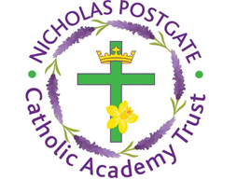

St. Edward’s Catholic Primary School,
a Catholic Voluntary Academy,
Eastbourne Road,
Middlesbrough,
Cleveland.
TS5 6QS

Tel: 01642 819507
Fax: 01642 811902

Email: enquiries@stedwards.npcat.org.uk
Website: www.stedwards.npcat.org.uk
Twitter: @SaintEdwardsRC

Headteacher: Mrs MD Brown B.Ed (Hons) NPQH

Prayer for Today

Dear all,

Today I'm sharing a prayer written by one of our pupils in Year 6 at St Edward's.

A Prayer for Unity

Dear Lord,
Thank you for giving us the strength to carry on through this time of stress and worry.
Please may you let out your call of relief and love to those around the world who have to stay by themselves.
May you let peace flow like a river and stay by everyone's side, even if they feel poorly, because they are no different to anyone else in the world and community.
Give others the ability to always see the positive side even when there seems to be no light at the end of the long and winding tunnel.
Help those who sin against you and others because they may be struggling throughout this period of our lives.
Bind us together with your love and forgiveness today.
Amen








Nicholas Postgate Catholic Academy Trust, Company No. 09203984
Registered Address: Trinity Catholic College, Saltersgill Avenue, Middlesbrough. TS4 3JW

