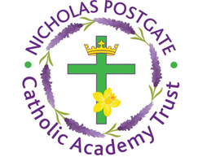
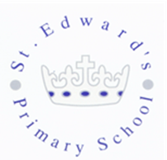
St. Edward’s Catholic Primary School,
a Catholic Voluntary Academy,
Eastbourne Road,
Middlesbrough,
Cleveland.
TS5 6QS

Tel: 01642 819507
Fax: 01642 811902

Email: enquiries@stedwards.npcat.org.uk
Website: www.stedwards.npcat.org.uk
Twitter: @SaintEdwardsRC

Headteacher: Mrs MD Brown B.Ed (Hons) NPQH

Prayer for Today

Dear all,

our prayer today is:
Lord God, You sent your Son into the world, and before his hour had come, He washed his disciples’ feet. You had given all things into his hands. He had come from you, and was going to you, and what did he do? He knelt down on the floor, and washed his friends’ feet. He was their teacher and their Lord, yet he washed their feet. Lord God, help us learn from his example; help us to do as he has done for us. The world will know we are his disciples if we love one another. Strengthen our hands and our wills for love and for service. Keep before our eyes the image of your Son, who, being God, became a Servant for our sake. All glory be to him who lives and reigns with you and the Holy Spirit, one God, now and forever.
Amen.






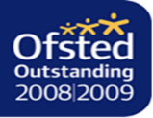

Nicholas Postgate Catholic Academy Trust, Company No. 09203984
Registered Address: Trinity Catholic College, Saltersgill Avenue, Middlesbrough. TS4 3JW

