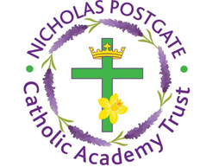
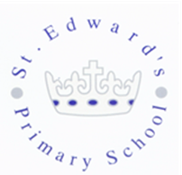
St. Edward’s Catholic Primary School,
a Catholic Voluntary Academy,
Eastbourne Road,
Middlesbrough,
Cleveland.
TS5 6QS

Tel: 01642 819507
Fax: 01642 811902

Email: enquiries@stedwards.npcat.org.uk
Website: www.stedwards.npcat.org.uk
Twitter: @SaintEdwardsRC

Headteacher: Mrs MD Brown B.Ed (Hons) NPQH

Prayer for Today
Dear all,

today I'd like to share a poem that a friend sent me over the weekend. I thought it was beautiful and a positive way to look at what's going on at the moment in our world.

I heard a little rumour,
I don't know if it's true,
that the world is going to be at peace
for at least a month or maybe two.

I heard that folk must stay at home,
and spend time with their kin,
slow down, relax and take a breath,
and find some peace within.

And though we may be worried,
about money, jobs and bills,
we will notice beauty everywhere,
blue skies, fresh lakes, green hills.

And when a month or two is over,
and we can all go back to our lives,
people will show their gratitude,
that their loved ones all survived.

Lord be with us today in all we think, do and say. Help us to stay positive when things seem difficult and help us to take pleasure in the simple things like listening to the birds or spending time together. Be with us always. Amen.

Take care and stay safe

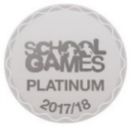



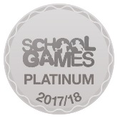
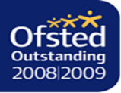

Nicholas Postgate Catholic Academy Trust, Company No. 09203984
Registered Address: Trinity Catholic College, Saltersgill Avenue, Middlesbrough. TS4 3JW

