Year A

Focus  Subject | Aut1  History  Teesside Treasures  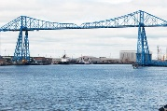 | Aut2  Geography  Celebrations around the world  (short topic leading into Christmas 3/4  weeks)  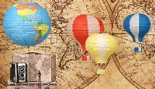 | Spr1  History  Time Travellers | Spr2  Geography  Explorers  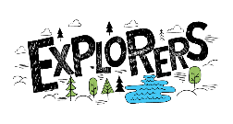 | Sum1  History  Kings and Conquerors  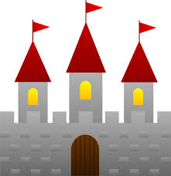  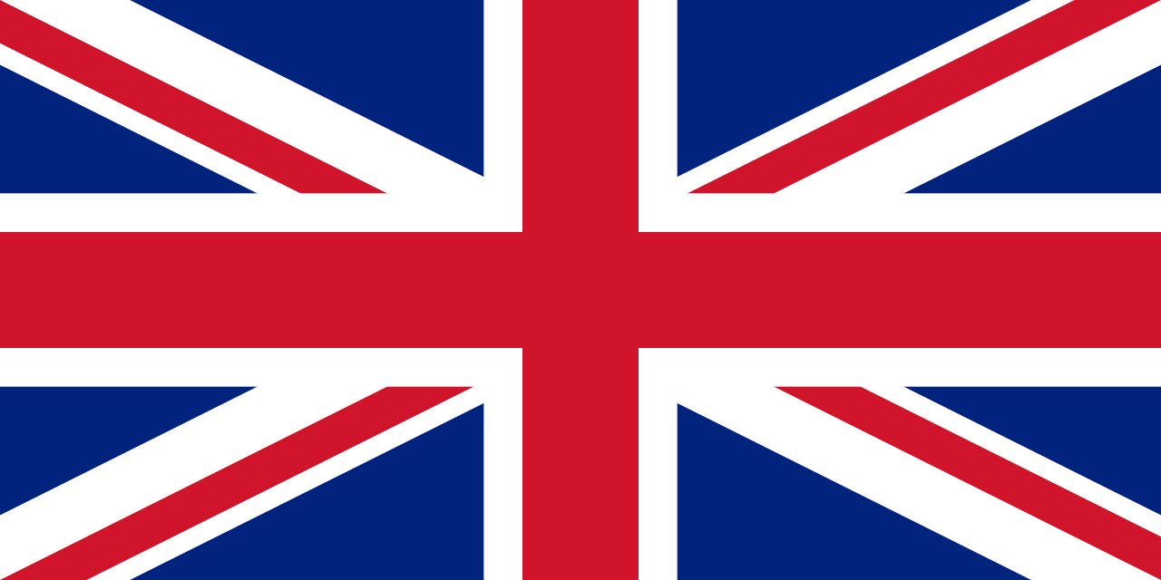 | Sum2  Geography  Going Global  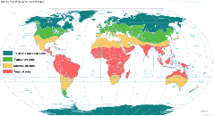  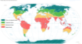  Global Goal-2 Zero hunger  13 Climate action
Experiences | EYFS - Museum visit in school  KS1 - Local Museum/Dorman  LKS2 – Preston Park museum  UKS2-Transporter Bridge/museum/Port | Christmas celebrations in school and in church | Whole school Time travel machine (room/area in school created)  Set up a museum in school from artefacts made-parent open day | EYFS-Pirate day/treasure hunts  KS1-Captain Cook museum  KS2-musuem visit | MP Visit  Whole school royal garden party/tea party  London trip/House of Parliament?  Focus British Values | Global goal campaigning across the school
Foundation | Why do you love me so much?  (My Family and Me)  (Local area of Acklam) | Shall we have a party?  (Festivals) | Can we have a pet dinosaur? | Where do pirates live? | Are dragons real?  (Fairytales/castles) | Why do zebras have stripes?  (Hot and cold animals)
Key Stage 1 | History of Middlesbrough – changes in living memory/Families  (link to Dorman’s museum) | Christmas around the World-European | Mary Anning-fossil hunter | Captain Cook – Life as a sailor on board a ship/at sea (CC Early life 1728-1767)  (Stewart’s Park museum) | Towers, Tunnels and Turrets  (Medieval castles & Royalty) | World’s Kitchen  (Where does our food come from? E.g. Africa linked to seasons and weather and climate)
Key Stage 2 | LKS2- Impact of Victorian era on Middlesbrough  (link to Preston Park museum Victorian street)  UKS2 – ‘Local history study’ on Middlesbrough port area (Transporter Bridge/Port present day and past) | LKS2 – St Lucia Festival of light (Norway, Finland and Sweden)  UKS2 – Christmas story of Babushka (Russia) | LKS2 - Romans  UKS2 - Egyptians | LKS2 – CC’s 1st voyage/2nd voyage 1768-1771/1772-1775  (Early career)  UKS2 - CC’s /3rd voyage 1776-1779  (Late career and death) | LKS2 - Saxons & Vikings  UKS2 - Mayans | LKS2 – Extreme Earth  (physical geography-earthquakes, floods, volcanoes and impact)  UKS2 – Trade and Economics (human geography-cities, growth, impact)
Local Links/Lessons | PD Ports  Rivershack (heritage river tours along R Tees)  Tees Barrage  McKenzie Thorpe  Local Parks  Roseberry Topping  Transporter Bridge museum  Teesside University  MIMA  Dorman Museum  MFC  Middlesbrough Archives  Preston Park Museum | Local Pantomime  Multi-cultural schools | Whitby Pannett Park museum-fossil collection/talk  Hancock Museum-Egyptians  Segedunum Roman Fort | Captain Cook Museum  Schoolroom Museum/cottage and church – Great Ayton  Staithes/Whitby CC Musuem | Raby Castle/Hemsley castle  Local libraries  Museums | Tesco/Morrisons – Farm to Fork

