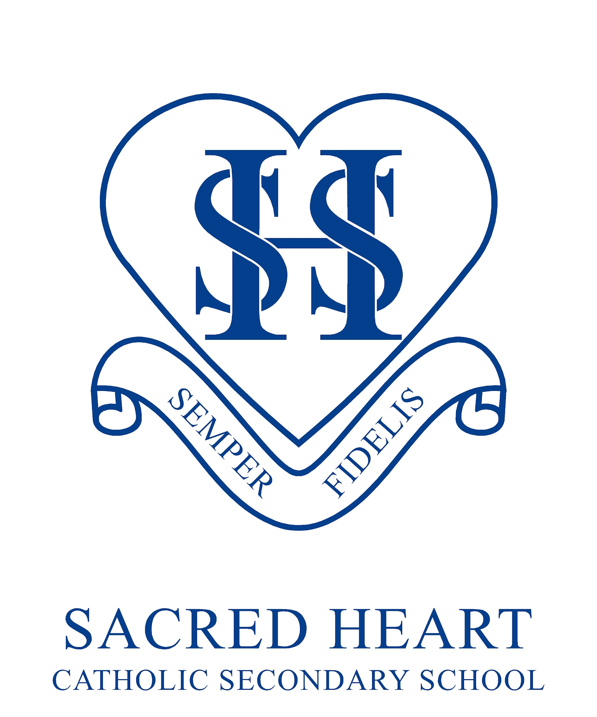

14th September 2022

Dear Parent/Carer

**Year 5/6 Meeting with Sacred Heart Catholic Secondary Headteacher**

We know how important choosing a secondary school is for you as a family and hope that you’re considering Sacred Heart Catholic Secondary for the next chapter in your child’s education.

Applications for Year 7 places are made through your local council and the application window runs from September to 31 October of Year 6.

We are keen to work with families from **both Year 5 and 6** and to provide as much information as early as possible, to help you make the right decision for your child’s secondary education.

We are hosting our annual Y5/6 Open Evening on **Tuesday 4 October, 5-7pm** to which you are all very welcome**.**

In advance of the evening, I am keen to meet with families from the Sacred Heart family of primary schools to outline my vision for Sacred Heart Catholic Secondary and answer personally, any questions you may have. I will be visiting St Benedict’s on:

**26th September 2022 at 9:00am**

To confirm your attendance, please contact [enquiries@stbenedicts.npcat.org.uk](mailto:enquiries@stbedes.npcat.org.uk). I look forward to meeting many of you in person on the day.

Yours faithfully

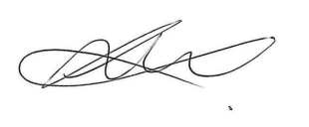  
Mrs L Dwyer  
Headteacher