Suggested Reception Enrichment
Term 1  All About Me, Autumn, Festivals | Term 2  Winter, Space, The Farm | Term 3  Growing & Changing, Summer
Trip  Visit Old People’s Home to deliver Christmas Cards  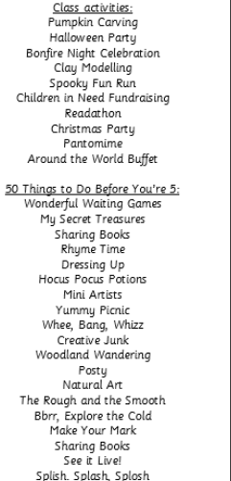 | Trip  Local Allotments  Church Visit  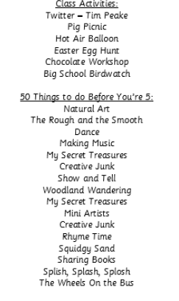 | Trip  The Beach  