Nursery Enrichment
Term 1  All About Me, Autumn, Festivals | Term 2  Winter, Space, Animal Adventures & Easter | Term 3  Growing & Changing, Spring, ,Seaside & Summer
Trip  Walk to local shops to buy stamps  Visit t Old People’s Home to deliver Christmas Cards  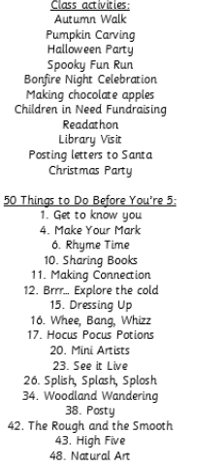 | Trip  Local Allotments  Church Visit  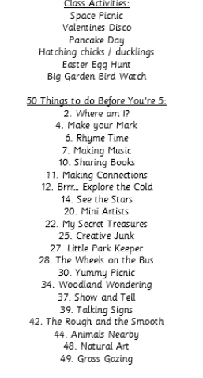 | Trip  The Beach  