
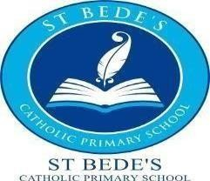

30 Hours Tax Free Childcare

Dear Parents and Carers,

St Bede’s Catholic Primary School is delighted to announce that we continue to offer 30 hours tax free childcare.
Eligibility is available for parents on the HMRC 30 hours free childcare website:
https://www.gov.uk/30-hours-free-childcare Please click on this link to check your eligibility.
If you are eligible, please follow the steps carefully and once completed, you will be given a
11-digit validation code.
You will then need to bring the validation code, your national insurance number and your
child’s birth certificate to the school office. Your eligibility will then be verified with the
Local Authority. Each child that qualifies is entitled to 30 hours per week tax free childcare.
Please note that we are only able to confirm the offer of a 30-hour place once we
(school) have verified the eligibility code provided by HMRC.
The 30 hours tax free childcare will be available for your child from the term after their 3rd
birthday.
The 30-hour session times do not include the lunchtime period and should you wish for your child to stay for lunch at school an additional cost will be incurred. (Currently £3.00 lunch cover per day and £2.20 per day should your child want a school dinner). Alternatively, you can provide your child with a healthy packed lunch. School lunches and lunchtime supervision needs to be paid in advance via Parent Pay.

If you have any queries, please do not hesitate to contact the school office by telephone
01642 485217 or through the school enquiries email: enquiries@stbedes.npcat.org.uk

Yours sincerely,

Mrs. White
Nursery Teacher & EYFS Lead

