Geography in the Early Years

Geography at Foundation Stage (Nursery and Reception) is covered in the ‘Understanding the World’ area of the EYFS Curriculum. It is introduced through activities that require the children to think about People, Culture and Communities. Planned ‘hooks’ and theme such as ‘Myself and My Community’, allow the children to develop their understanding of place as they learn about their town, their country and then compare these to other countries and continents.

This topic work allows the children to develop their geographical vocabulary as they learn about their immediate environment using knowledge from observations, discussions, stories, non-fiction texts and maps.

Early Years Geography also helps the children develop skills in the prime areas of the Foundation Stage Curriculum such as Communication and Language. Personal, Social and Emotional Development as they discuss aspects of their own lives and that of their families. They consider their place in the world and their place in relation to others and begin to develop an understanding of why places are special to them and why places may be special to other members of their community.

Our curriculum is driven by Laudato Si, care for the Common Home and in RE lessons, we are taught to love one another and to care for our world, our common home. The children in reception are taught about environmental geography and the importance of caring for our planet in a sustainable way to allow future generations to also enjoy our common home. This learning gives our youngest children a real sense of purpose and an understanding of the importance of our care for the world we live in.

The specific area of Literacy allows the children to learn about Geography through stories. Children learn to describe story settings and, in this way, explore geographical terms. They also work on story maps which allow them again to develop their understanding of places in relation to others.

Throughout their daily learning, children are encouraged to discuss and explore environments.

They are encouraged to ask questions and are encouraged to problem solve and to develop observational skills in their environment and to appreciate changes that occur.
Math’s activities allow the children to develop subject specific vocabulary as they learn about positional and directional language. The children’s developing skills prepare them for further Geography activities in their National Curriculum work in Year 1.
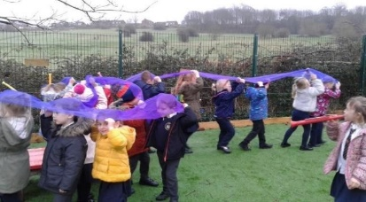
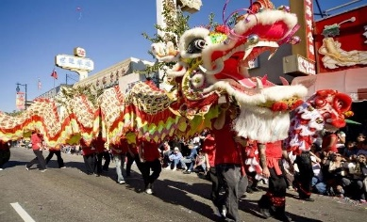
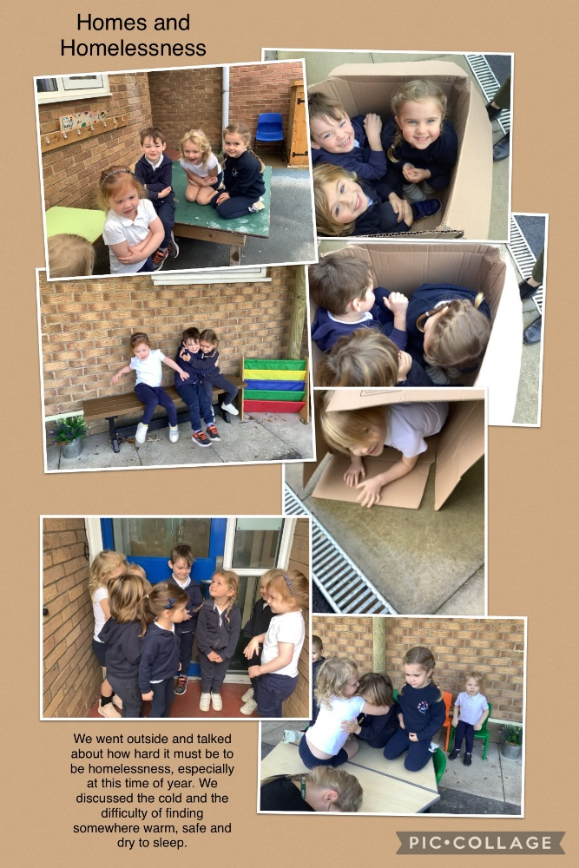
Creating a Dragon Dance as part of our work on Chinese New Year/
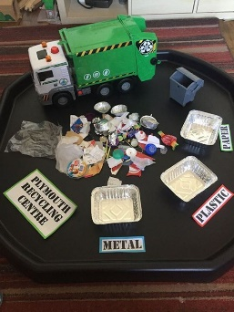
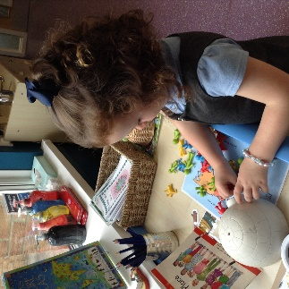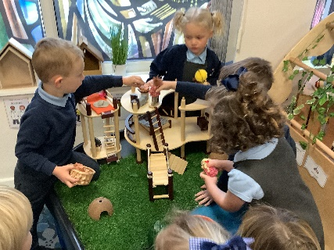
Children using atlases to refer to when learning about the parts of the world that animals come from.
Learning about environmental issues and the need to reduce, reuse and recycle….

