WHY DO WE STUDY GEOGRAPHY?
At St Bede’s, we believe that Geography helps to provoke and answer questions about the natural and human worlds, encouraging children to develop a greater understanding of their world and their place in it. We seek to inspire in children a curiosity and fascination about the world and its people which will remain with them for the rest of their lives. We aim to promote children’s interest and understanding about diverse places, people, resources and natural and human environments, together with a deep understanding of the Earth’s key physical and human processes. Geographical knowledge, understanding and skills provide the frameworks and approaches that explain how the Earth’s features at different scales are shaped, interconnected and change over time
INTENT
Geography at St Bede’s is taught in blocks throughout the year, so that children can achieve depth in their learning. Our long term planning documentation highlights the key knowledge and skills of each blocked topic and these are mapped across the school, ensuring that knowledge builds progressively and that children develop skills systematically.

Existing knowledge is checked at the beginning of each topic. This ensures that teaching is informed by the children’s starting points and that it takes account of pupil voice, incorporating children’s interests.

Tasks are selected and designed to provide appropriate challenge to all learners, in line with the school’s commitment to inclusion and pupils are assessed at the end of each lesson.
The Geography provision is well resourced and specific resources are mapped to specific year groups and topics to support effective teaching and learning. The local area is fully utilised to achieve the desired outcomes, with extensive opportunities for learning outside the classroom embedded in practice.

Geography is mapped effectively across the school to ensure full coverage of the National Curriculum Programme of Study for Geography.

KS2 Pupils will:
Locational Knowledge
- locate the world’s countries, using maps to focus on Europe (including the location of Russia) and North and South America, concentrating on their environmental regions, key physical and human characteristics, countries, and major cities
- name and locate counties and cities of the United Kingdom, geographical regions and their identifying human and physical characteristics, key topographical features (including hills, mountains, coasts and rivers), and land-use patterns; and understand how some of these aspects have changed over time
- identify the position and significance of latitude, longitude, Equator, Northern Hemisphere, Southern Hemisphere, the Tropics of Cancer and Capricorn, Arctic and Antarctic Circle, the Prime/Greenwich Meridian and time zones (including day and night)
Place knowledge
- understand geographical similarities and differences through the study of human and physical geography of a region of the United Kingdom, a region in a European country, and a region within North or South America
Human and physical geography - describe and understand key aspects of:
- physical geography, including: climate zones, biomes and vegetation belts, rivers, mountains, volcanoes and earthquakes, and the water cycle
- human geography, including: types of settlement and land use, economic activity including trade links, and the distribution of natural resources including energy, food, minerals and water
Geographical skills and fieldwork
- use maps, atlases, globes and digital/computer mapping to locate countries and describe features studied
- use the eight points of a compass, four and six-figure grid references, symbols and key (including the use of Ordnance Survey maps) to build their knowledge of the United Kingdom and the wider world
- use fieldwork to observe, measure, record and present the human and physical features in the local area using a range of methods, including sketch maps, plans and graphs, and digital technologies.

ESSENTIAL GEOGRAPHICAL VOCABULARY: Vocabulary is introduced, revisited and reinforced over time so that children become confident and articulate as they progress throughout the curriculum. As geographers our KS2 pupils will build upon existing knowledge and be exposed to a wide range of geographical vocabulary and will use basic geographical vocabulary to refer to key physical and human features including: Physical features: Climate Zones, Biomes, Water Cycle, Vegetation Belts, Volcanoes, Earthquakes, Human features: Settlement, Natural Resources, Food, Minerals, Land Use, Energy, Water
IMPLEMENTATION
Geography is taught at St Bede’s Primary school through themed ‘learning projects’, specifically planned to deliver the essential knowledge, skills and understanding for each year group. As children progress throughout the school, they develop a deep knowledge, understanding and appreciation of their local area and its place within the wider geographical context.
Geographical understanding, as well as children’s spiritual, moral, social and cultural development is further supported by the school’s global learning work. This aspect of the work of the school is also supported through specific drives. Children learn about careers related to geography from members of the local and wider community, with specialist skills and knowledge (for example during science week and CAFOD) and this ensures that they are well prepared for the next steps of their education.
Year 3 Learning Projects

Through the Ages | Rocks, Relics & Rumbles | Forces & Magnets | Ammonite | People & Places | Emperors & Empires |  | One planet, Our World
Year 4 Learning Projects
Invasion | Electrical Circuits & Conductors | States of Matter | Misty Mountain, Winding River |  | Vista |  | Interconnected World
Year 5 Learning Projects
Investigating Our World | Human Reproduction & Aging |  | Nature’s Art | Ground breaking Greeks |  | Sow, Grow & Farm |  | Eat the Seasons
Year 6 Learning Projects
Britain at War | Environmental Artists | Frozen Kingdoms | Innuit | Maafa | Our Changing World

Key Aspects of Geography Curriculum: The following aspects and ideas are mapped across the Geography curriculum to ensure pupils develop a rich and deep subject knowledge. Clear links are made between different aspects of their learning and pupils will learn within a coherent and progressive framework that is a sequential progression of their knowledge, understanding and skills.
Place:  World, UK, Location, Position, Maps | Humankind:  Human features and landmarks, Settlements and land use. | Investigation: Geographical resources, Data Analysis, Fieldwork | Materials: Natural and man-made materials | Change:  Geographical change | Nature:  Physical features, Environment. | Comparison:  Compare and Contrast | Processes:  Physical processes,  Climate and weather, | Significance:  Significant places

ENRICHMENT OPPORTUNITIES | Further enrichment opportunities are provided to deepen the pupils’ understanding and the interaction between physical and human processes and how this affects landscapes and environments.
Trips /visits: | We provide on and off-site subject/ topic related activities that allow pupils to use quality resources in and out of the classroom. | Outdoor Learning Week: | We hold specialist curriculum days and provide investigative and enquiry based learning opportunities through a focussed outdoor learning week
Environmental education/ eco issues/sustainability | Pupils are encouraged to:  - make a positive contribution to the school and local community  - explore ways of becoming an active citizen  - make choices about things that are important to them  - take part in democratic activities across the curriculum | Pupil ambassador’s: | Pupil ambassador’s will have the opportunity to:  - say what they like and dislike about their learning  - take part in age-appropriate discussions  - express their opinions on a range of different topics and issues  - promote whole school themes and initiatives
Knowledge Rich Projects: | KRPs focus on geography and make meaningful links with history and other subjects where appropriate to maximise children’s geographical or contextual understanding

IMPACT
Our Curriculum has been designed to deliver our principles, aims and entitlement whilst also covering all statutory requirements of the National Curriculum. Our long- term curriculum has been carefully mapped to ensure key skills and knowledge are taught in a clear sequence and provide progression across the school.
Pupils’ knowledge and understanding is assessed during geography lessons using signposts which reflect the learning intention and skills and knowledge required to meet the lesson objective. To support pupils’ in their long term memory retrieval and ability to retain ‘sticky knowledge’, the pupils will also:
- Begin each lesson with a revisit and review of the previous learning from the last lesson, last week and last term
- Where suitable, pupils will undertake an end of unit knowledge assessment/quiz which will test key vocabulary, images, and theories.
- Use a set of display words and a knowledge organiser to make it easy for pupils to use new vocabulary independently.

Pupil attainment is recorded at the end of each lesson through the use of our Geography knowledge and skills tracker on Curriculum Maestro. These results are tracked and monitored carefully to ensure pupils’ are progressing within the framework. The use of signposts ensures pupils’ will understand explicitly what is being taught and enables pupils to reflect on and evaluate their learning.
Impact of the Geography Curriculum in KS2
By the end of Key Stage 2, pupils are expected to know, apply and understand the matters, skills and processes specified in the Geography programme of study. Through the study of Geography at St Bede’s, we aim:
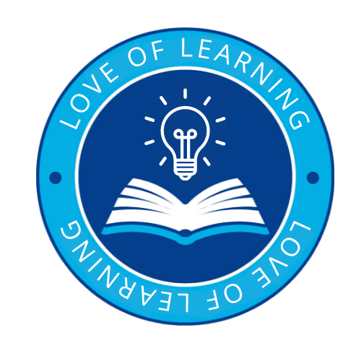 | Introduce a love of learning through:  - To nurture and enrich each individual child through providing a positive, happy and healthy environment in which all people within both our school community and the wider global community are valued and respected.  - To develop the pupils’ love for the world around them and inspiring in them the curiosity and fascination for the planet and their place in it.  - To provide our pupils with a broad and balanced curriculum that allows them to become motivated and fascinated with the world and environment.  - To encourage pupils to develop a passion for the subject by engaging in exciting learning experiences and creative lessons.
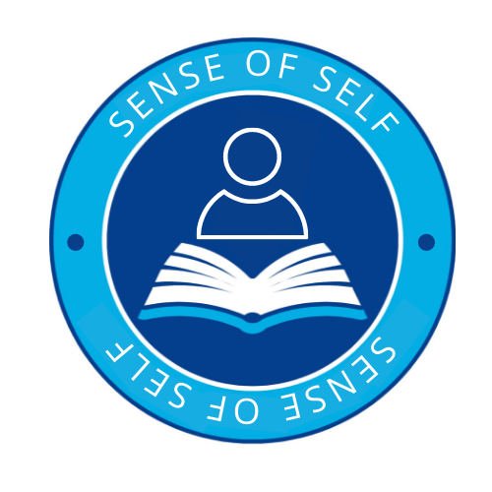 | A sense of self through:  - To inspire pupils to have a good understanding of the world and of their place in it.  - To encourage pupils to ask questions, think critically and develop their own sense of perspective of the world.  - To support pupils in communicating their learning in a variety of ways including sketch maps with a key and diagrams, tables, graphs and writing.  Under the UN Convention on the Rights of the Child- Article 13 (freedom of expression)  Every child must be free to express their thoughts and opinions and to access all kinds of information, as long as it is within the law.  - To help pupils make sense of their own surroundings through learning about their own locality, and the interaction between people and environment.  - To support pupils in developing knowledge and understanding of the human and physical processes which shape places  - To support pupils in appreciating similarities and differences in the world around them and respecting other peoples’ beliefs, attitudes and values.  - To inspire pupils be become creative, resourceful and work cooperatively with others.  - To enable pupils to enjoy learning about geography both inside and outside the classroom, including educational visits and fieldwork.
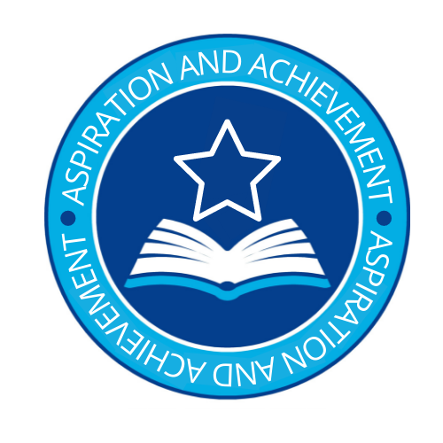 | Aspiration and Achievement:  - We seek to inspire in children a curiosity and fascination about the world and its people which will remain with them for the rest of their lives, equipping them well for further education and beyond.  - To use real world examples and first hand experiences to help explain current environmental issues and develop knowledge and understanding of the world around them.  - To develop interest and enjoyment of geographical experiences and build confidence and understanding.  - To recognise and understand issues concerning the environment and sustainable development.  - To have a greater understanding of their place in the world, and their rights and responsibilities to other people and the environment.  - To be able to use geographical vocabulary which is appropriate and accurate and which develops and evolves from EYFS to KS1 and through to KS2  - To develop the geographical skills necessary to carry out effective geographical enquiry.  - To formulate appropriate questions, develop research skills and evaluate material to inform opinions
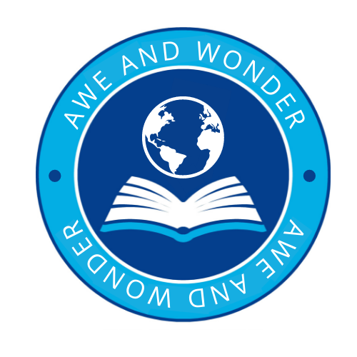 | Awe and Wonder:  - To develop a curiosity and fascination about the world and its people that will remain with them for the rest of their lives.  - To have sound Geographical knowledge, understanding and skills; providing the frameworks and approaches that explain how the Earth’s features at different scales are shaped, interconnected and change over time.  - To use a curiosity based learning approach to help embed key skills and knowledge and create memorable experiences.  - extend their interest, knowledge and understanding of contrasting localities in Britain, Europe and the World.

