WHY DO WE STUDY GEOGRAPHY?
At St Bede’s, we believe that Geography helps to provoke and answer questions about the natural and human worlds, encouraging pupils to develop a greater understanding of their world and their place in it. We seek to inspire in pupils a curiosity and fascination about the world and its people which will remain with them for the rest of their lives. We aim to promote pupils’ interest and understanding about diverse places, people, resources and natural and human environments, together with a deep understanding of the Earth’s key physical and human processes. Geographical knowledge, understanding and skills provide the frameworks and approaches that explain how the Earth’s features at different scales are shaped, interconnected and change over time
INTENT
Our intent, when teaching Geography, is to inspire in pupils a curiosity and fascination about the world and people within it. At St Bede’s Primary School, our Geography curriculum is designed to promote our school values whilst developing a love of learning, a sense of self, inspiration and achievement and awe and wonder.

Through our teaching at St Bede’s, we intend to provoke thought and questions and to encourage our pupils to discover answers to their own questions through exploration and research to enable them gain a greater understanding and knowledge of the world and their place in it.

The intention of our Geography curriculum is to inspire pupils’ curiosity and interest to explore the world that we live in and its people, which in turn will ignite a love of learning.

Our curriculum ensures clear knowledge and skills progression, and pupils growing knowledge about the world helps them to deepen their understanding of the interaction between physical process and of the formation and use of landscapes and environments.

Geographical knowledge, understanding and skills provide the framework and approaches that explain how the Earth’s features at different scales are shaped, interconnected and shaped over time.

Geography is mapped effectively across the school to ensure full coverage of the National Curriculum Programme of Study for Geography.
KS1 Pupils will:
Locational Knowledge
- Name and locate the world’s seven continents and five oceans
- Name, locate and identify characteristics of the four countries and capital cities of the United Kingdom and its surrounding seas
Place knowledge
- understand geographical similarities and differences through studying the human and physical geography of a small area of the United Kingdom, and of a small area in a contrasting non-European country
Human and physical geography
- Identify seasonal and daily weather patterns in the United Kingdom and the location of hot and cold areas of the world in relation to the Equator and the North and South Poles
- use basic geographical vocabulary
Geographical skills and fieldwork
- use world maps, atlases and globes to identify the United Kingdom and its countries, as well as the countries, continents and oceans studied at this key stage
- use simple compass directions and locational and directional language to describe the location of features and routes on a map
- use aerial photographs and plan perspectives to recognise landmarks and basic human and physical features; devise a simple map; and use and construct basic symbols in a key
- use simple fieldwork and observational skills to study the geography of their school and its ground and the key human and physical features of its surrounding environment
ESSENTIAL GEOGRAPHICAL VOCABULARY
Vocabulary is introduced, revisited and reinforced over time so that pupils become confident and articulate as they progress throughout the curriculum. As geographers our KS1 pupils will be exposed to a wide range of geographical vocabulary and will use basic geographical vocabulary to refer to key physical and human features including; Physical features: Beach, Cliff, Coast, Forest, Hill, Mountain, Sea, Ocean, River, Soil, Valley, Season, Vegetation, Weather
Human features: City, Town, Village, Factory, Farm, House, Office, Port, Harbour, Shop

IMPLEMENTATION
Geography is taught at St Bede’s school through themed ‘learning projects’, specifically planned to deliver the essential knowledge, skills and understanding for each year group.
Year 1 Learning Projects
Childhood | Our Wonderful World | Seasonal Changes |  | School Days |  | Bright Lights Big City |  | Taxi!
Year 2 Learning Projects
Use of Materials |  | Coastline | Beach Huts |  | Magnificent Monarchs |  | Let’s Explore the World

Key Aspects of Geography Curriculum: The following aspects and ideas are mapped across the Geography curriculum to ensure pupils develop a rich and deep subject knowledge. Clear links are made between different aspects of their learning and pupils will learn within a coherent and progressive framework that is a sequential progression of their knowledge, understanding and skills.
Place:  World, UK, Location, Position, Maps | Humankind:  Human features and landmarks, Settlements and land use. | Investigation: Geographical resources, Data Analysis, Fieldwork | Materials: Natural and man-made materials | Change:  Geographical change | Nature:  Physical features, Environment. | Comparison:  Compare and Contrast | Processes:  Physical processes,  Climate and weather, | Significance:  Significant places

ENRICHMENT OPPORTUNITIES | Further enrichment opportunities are provided to deepen the pupils’ understanding and the interaction between physical and human processes and how this affects landscapes and environments.
Trips /visits : | We provide on and off-site subject or topic related activities that allow pupils to use quality resources in and out of the classroom. | Outdoor Learning Week: | We hold specialist curriculum days or weeks and provide investigative and enquiry based learning opportunities through a focussed outdoor learning week
Environmental education/ eco issues/sustainability | Pupils are encouraged to:  - make a positive contribution to the school and local community  - explore ways of becoming an active citizen  - make choices about things that are important to them  - take part in democratic activities across the curriculum | Pupil ambassador’s: | Pupil ambassador’s will have the opportunity to:  - say what they like and dislike about their learning  - take part in age-appropriate discussions  - express their opinions on a range of different topics and issues  - promote whole school themes and initiatives
Knowledge Rich Projects : | KRPs focus on geography and make meaningful links with history and other subjects where appropriate to maximise pupils’ geographical or contextual understanding

IMPACT
Our Curriculum has been designed to deliver our principles, aims and entitlement whilst also covering all statutory requirements of the National Curriculum. Our long- term curriculum has been carefully mapped to ensure key skills and knowledge are taught in a clear sequence and provide progression across the school.
Pupils’ knowledge and understanding is assessed during geography lessons using signposts which reflect the learning intention and skills and knowledge required to meet the lesson objective. To support pupils’ in their long term memory retrieval and ability to retain ‘sticky knowledge’, the pupils will also:
- Begin each lesson with a revisit and review of the previous learning from the last lesson, last week and last term
- Where suitable, pupils will undertake an end of unit knowledge assessment/quiz which will test key vocabulary, images, and theories.
- Use a set of display words and a knowledge organiser to make it easy for pupils to use new vocabulary independently.

Pupil attainment is recorded at the end of each lesson through the use of our Geography knowledge and skills tracker on Curriculum Maestro. These results are tracked and monitored carefully to ensure pupils’ are progressing within the framework. The use of signposts ensures pupils’ will understand explicitly what is being taught and enables pupils to reflect on and evaluate their learning.
PHYSICAL FEATURES | HUMAN FEATURES | SKILLS & FIELDWORK | LOCATIONAL KNOWLEDGE | PLACE KNOWLEDGE | HUMAN PROCESSES | PHYSICAL PROCESSES
Impact of the Geography Curriculum
By the end of Key Stage 1, pupils are expected to know, apply and understand the matters, skills and processes specified in the Geography programme of study. Through the study of Geography at St Bede’s, we aim:
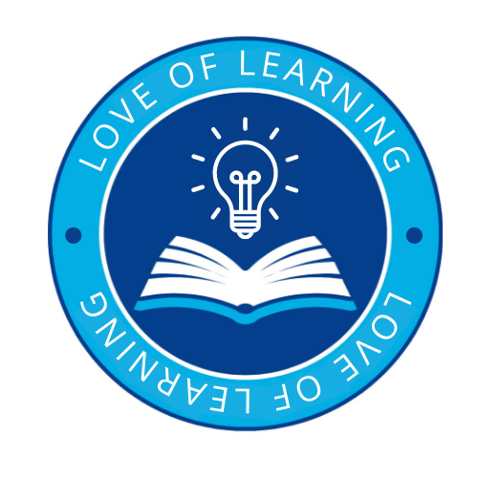 | Introduce a love of learning through:  - To nurture and enrich each individual child through providing a positive, happy and healthy environment in which all people within both our school community and the wider global community are valued and respected.  - To develop the pupils’ love for the world around them and inspiring in them the curiosity and fascination for the planet and their place in it.  - To provide our pupils with a broad and balanced curriculum that allows them to become motivated and fascinated with the world and environment.  - To encourage pupils to develop a passion for the subject by engaging in exciting learning experiences and creative lessons.
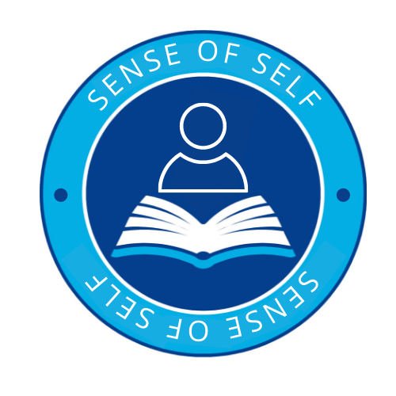 | A sense of self through:  - To inspire pupils to have a good understanding of the world and of their place in it.  - To encourage pupils to ask questions, think critically and develop their own sense of perspective of the world.  - To support pupils in communicating their learning in a variety of ways including sketch maps with a key and diagrams, tables, graphs and writing.  Under the UN Convention on the Rights of the Child- Article 13 (freedom of expression)  Every child must be free to express their thoughts and opinions and to access all kinds of information, as long as it is within the law.  - To help pupils make sense of their own surroundings through learning about their own locality, and the interaction between people and environment.  - To support pupils in developing knowledge and understanding of the human and physical processes which shape places  - To support pupils in appreciating similarities and differences in the world around them and respecting other peoples’ beliefs, attitudes and values.  - To inspire pupils be become creative, resourceful and work cooperatively with others.  - To enable pupils to enjoy learning about geography both inside and outside the classroom, including educational visits and fieldwork.
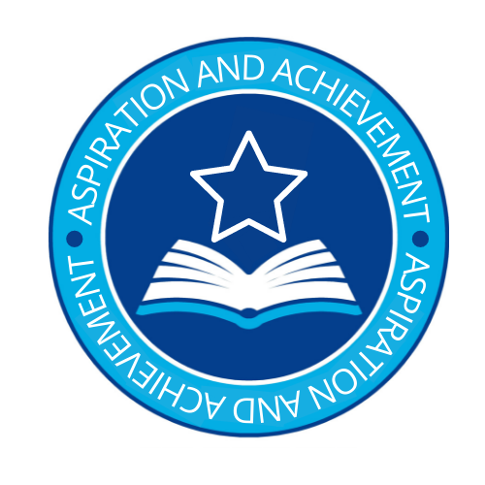 | Aspiration and Achievement:  - To use real world examples and first hand experiences to help explain current environmental issues and develop knowledge and understanding of the world around them.  - To develop interest and enjoyment of geographical experiences and build confidence and understanding.  - To recognise and understand issues concerning the environment and sustainable development.  - We seek to inspire in children a curiosity and fascination about the world and its people which will remain with them for the rest of their lives, equipping them well for further education and beyond.  - To have a greater understanding of their place in the world, and their rights and responsibilities to other people and the environment.
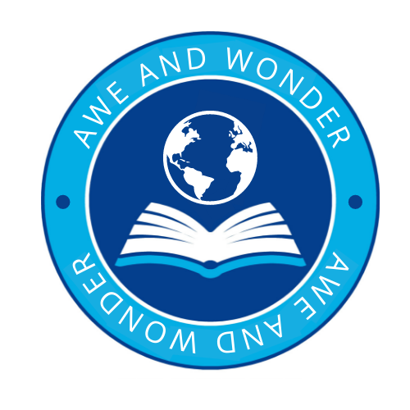 | Awe and Wonder:  - To develop a curiosity and fascination about the world and its people that will remain with them for the rest of their lives.  - To have sound Geographical knowledge, understanding and skills; providing the frameworks and approaches that explain how the Earth’s features at different scales are shaped, interconnected and change over time.  - To use a curiosity based learning approach to help embed key skills and knowledge and create memorable experiences.

