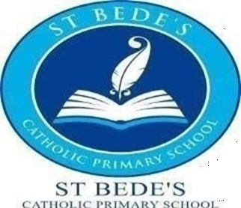
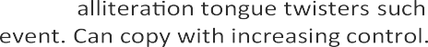Saint Bede’s Catholic Primary School
Class Plan—Nursery (Spring)

 | Starry Night Winter Wonderland | Dangerous Dinosaurs Puddles and Rainbows
Term | Spring 1 | Spring 2
Suggested Text | Peace At Last/ Whatever Next/ How to catch a Star
Intent
WOW starter
Innovate Challenge
Memorable experience |  | Museum visit.
Key Values (collective worship) |  | , Hope
Communication and Language |  | ,
Religious Education
Personal, social and emotional devel- opment |  | /
Physical Development |  | /
Literacy |  | /
Talk 4 writing Texts
Phonics
Maths

Saint Bede’s Catholic Primary School
Class Plan—Nursery (Spring)

Term | Spring 1 | Spring 2
The World: People, Cultures & Com- munities (Past & Present: History)
Expressive Arts & Design
Music

