Class Plan—Nursery (Autumn)
Me and My Community

Once Upon a Time

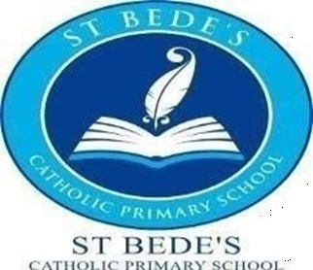
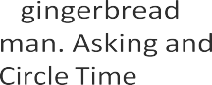
 | Exploring Autumn | Sparke and Shine  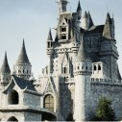
Term | Autumn 1 | Autumn 2
Suggested Text | Starting school, Once there were Giants, People that help us, Lost and Found, Leaf Man, | Traditional Tales/ The Three Little Wolves and the Big Bad Pig/ The True Story of the Three Little Pigs
Intent |  | This project supports children to develop a love of stories and reading. It encourages children to learn, retell and act out familiar and traditional tales. Sparkle and Shine- This project teaches children about the celebrations that take place during the autumn and winter seasons, and focus on the signifi-  cance and symbolism of light at this time of year.
WOW starter
Innovate Challenge | Helping Bear. [Exploring Autumn] - Making Leaf man books | A story for the king. [Sparkle and Shine] - Making tealight holders
Memorable experience
Key Values (collective worship) | Thoughtfulness
Communication and Language
Religious Education
Personal, social and emotional devel- opment | / | /
Physical Development |  | /
Literacy
Talk 4 writing Texts |  | The Gingerbread Man
Phonics
Maths

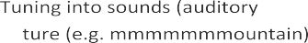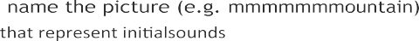

Class Plan—Nursery (Autumn)

Term | Autumn 1 | Autumn 2
The World: People, Cultures & Com- munities (Past & Present: History)
Expressive Arts & Design
Music

