CATEGORY | QUALITY TEXT | RHYMING/REPEATED REFRAIN | DIVERSE BOOKS | WELLBEING/ GROWTH MINDSET | TRADITIONAL TALE | MISC
QUALITY TEXT | Under the Same Sky by Britta Teckentrupp | Giraffes can’t Dance by Giles Andreae | Handa’s Surprise by Eileen Browne | Jabari Jumps by Gala Cornwall | The Little Red Hen | Commotion in the Ocean by Giles Andreae
BOOK COVER | 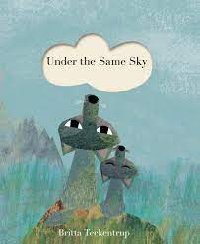 | 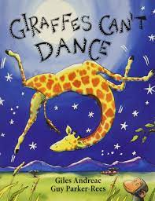 | 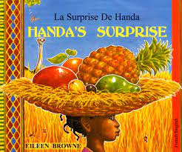 | 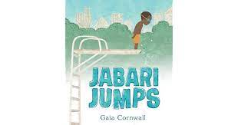 | 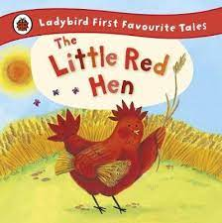 | 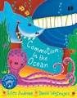
REASONING & PURPOSE | A great story to model and practise inference skills and predication. Vocabulary to explore and also the use of pictures to convey added meaning to text.  We sing the same songs, caught on the breeze... We sing the same songs, across the same seas.  Written and illustrated by the award-winning Britta Teckentrup, this beautiful and heart-warming book celebrates the closeness of the world's communities through their shared hopes and dreams. | This book has rhyme and a repeated refrain which encourages children to predict rhyme and join in.  An important story for teaching children about accepting that everyone is different, embracing their own differences, and building confidence and self-esteem. | Bright, bold, colourful pictures of a Kenyan village and animals which encourages chn to talk about the detail of what they see and to make connections with their own lives and experience.  Lots of opportunity to look at inference, prediction and empathy. | With themes of: overcoming fear, courage, family, water safety, positive affirmations, encouragement, patience and determination  A great story to model and practise inference skills and predication. Vocabulary to explore and also the use of pictures to convey added meaning to text. | Traditional tale to look at the structure of story, continuing the idea that one story can be retold differently each time.  Vehicle to link Helicopter stories and also the use of icons. Using diverse retelling to challenge children’s viewpoints. | This book has rhyme and a repeated refrain which encourages children to predict rhyme and join in.  A noisy, rhyming animal adventure with bold, colourful pictures.  This book offers readers the opportunity to dive into the depths of the ocean and discover some of the creatures lurking below.

