CATEGORY | QUALITY TEXT | RHYMING/REPEATED REFRAIN | DIVERSE BOOKS | WELLBEING/ GROWTH MINDSET | TRADITIONAL TALE | MISC
TITLE | The Tiny Seed by Eric Carle | The Foggy Foggy Forest by Nick Sharatt | A Friend for Henry by Jenn Bailey | Sully the Seahorse by Natalie Prichard | Jack & The Beanstalk | Night Monkey, Day Monkey by Julia Donaldson
BOOK COVER | 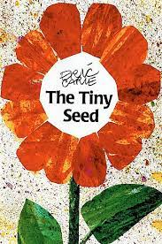 | 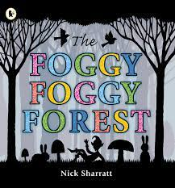 | 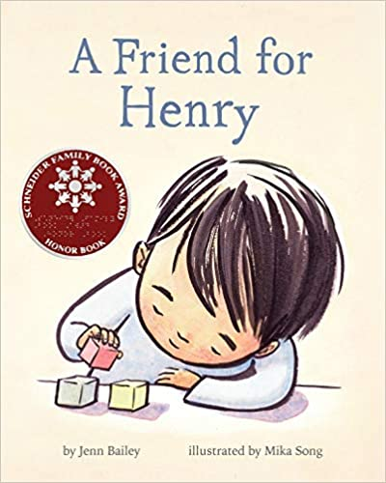 | 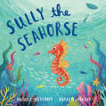 | 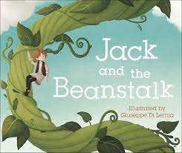 | 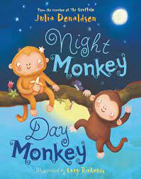
REASONING & PURPOSE | A great story to model and practise inference skills and predication. Vocabulary to explore and also the use of pictures to convey added meaning to text.  A wonderful book to use when teaching about the life cycle of a plant or flower.  Rhythmic text, linking in with seasons and change. | This book has rhyme and a repeated refrain which encourages children to predict rhyme and join in.  Who's lurking in the foggy forest? Look through the trees and guess the shapes to find out. Whether it's a fairy queen on a trampoline, three brown bears on picnic chairs, or an ogre doing yoga, children will love trying to guess what each foggy silhouette will be.  Chn will be able to re visit favourite fairy tale characters whilst using their imaginations and drawing on their knowledge of rhyme and alliteration. | An insightful and heartfelt story from the perspective of a boy on the autism spectrum which celebrates the everyday magic of friendship.  Lots of opportunities for discussing differences, acceptance and neuro diversity. Lots of opportunity to look at inference, prediction and empathy as well as making connections to own experiences and experiences. | A colourful and beautifully illustrated rhyming picture book which encourages children to believe in themselves and to be proud of who they are. (Self Esteem)  A great story to model and practise inference skills and predication. Vocabulary to explore and also the use of pictures to convey added meaning to text. | Traditional tale to look at the structure of story, continuing the idea that one story can be retold differently each time. Vehicle to link Helicopter stories and also the use of icons. Using diverse retelling to challenge children’s viewpoints. | This book has rhyme and a repeated refrain which encourages children to predict rhyme and join in.  It also carries an important message about diversity and acceptance.

