WHAT DOES THE EYFS AT ST BEDE’S LOOK LIKE?
In St Bede’s EYFS we strive to provide an exciting and engaging curriculum that inspires awe and wonder and a love of learning in all of our children, providing them with rich and memorable experiences which prepare them for their next stage of learning when they reach Year 1. There, they will have their skills built upon and progression made in a variety of new subjects. Therefore, the role of EYFS is imperative as it underpins all learning and lays the foundations to children’s skills and development in order for them to progress and achieve their maximum potential. We support each child in working towards year one readiness at the end of Reception through deliberately planning opportunities within direct teaching and purposeful provision alongside providing opportunities for children to follow their own interests and initiate their own learning.
Our curriculum is designed to follow the EYFS Statutory Framework curriculum 2021 and is further guided by the document ‘Development Matters’ that sets out the learning, development and assessment requirements for all children until the end of their reception year. Our committed early years practitioners deliver daily rich activities to support each child’s educational development across seven areas of learning. The EYFS framework has never prescribed a particular teaching approach and the new framework holds true to this value. Our philosophy of early year’s education remains the same with play and well-being at the heart of everything we do.
Through the implementation of our EYFS policy, we aim to:

• Give each child a happy and positive start to their school life in which they can establish a solid foundation for a love of learning.
• Enable each child to develop socially, physically, intellectually and emotionally.
• Encourage children to develop independence within a secure and friendly atmosphere.
• Support children in building relationships through the development of social skills such as cooperation and sharing.
• Work alongside parents to meet each child’s individual needs to ensure they reach their full potential.

INTENT
Intent
In our Early Years Foundation Stage our personalised and tailored curriculum provides all children with the in knowledge, skills and understanding they need to be confident, inquisitive, curious, independent learners and influence their wider thinking across all areas of the curriculum. We believe that providing an education that does all of this gives children the best chance to become well-rounded, happy individuals, ready to succeed in an ever-changing world.

We will make a positive difference to every child’s life. We recognise the importance of giving our children the best possible start to their education by planning and implementing teaching and learning opportunities that supports them in reaching their full potential and fulfilling their dreams. Children at St Bede’s experience the seven areas of learning through a balance of whole class/group teaching and play based learning. This is through the children’s interests, topics, themes, continuous provision activities, and phonics. Learning is carefully planned by the staff to support communication and language development; personal, social and emotional development; and physical development as well as literacy, mathematics, understanding of the world and expressive arts and design.
Here at St Bede’s, we put the children at the centre of everything we do and our main aim or intent is to help mould the children into independent, curious, lifelong learners. Our tailor made EYFS curriculum is based on the Statutory Framework for the EYFS (2021) and is flexible in content and theme depending on our children’s needs and interests. The non-statutory guidance from Development Matters document is also used to support the implementation of the requirements of the EYFS. Our curriculum has also been developed in line with the rest of the school. This ensures that learning over time is sequenced effectively and there is progression; within the EYFS and then on into Year 1.
We provide our children with a curriculum that is designed to be flexible, engaging and exciting so that their unique needs, passions and interests are embraced.
Every child is an exceptional individual and we celebrate and respect differences within our school community. The ability to learn is underpinned by the teaching of basic skills, knowledge and values that equips our children for their future successes. We inspire our children to become accomplished, happy individuals, ready to reach their full potential in an ever-changing world.

Our EYFS curriculum is driven to:
recognise children’s prior learning and experiences (influenced by their home and community),
provide first hand learning experiences (filling the gaps from pupils’ background),
allow the children to develop interpersonal skills,
build resilience through our ‘Growth Mindset’ approach and become critical and creative thinkers.

Our aims;
Work in partnership with our parents and carers to promote independent, confident and enthusiastic learners who thrive in school and make at least good progress from their various starting points. (We belong to a tightly knit community where we promote positive relationships and attitudes to learning where we enthuse aspiration for both children and their parents).
Plan for our children’s interests and provide opportunities throughout our EYFS curriculum to support learning, consolidate and deepen knowledge and ensure children meet their next steps.
Provide our children with a wide range of rich, first hand experiences to take the curriculum beyond the classroom.
Foster the development of each child’s character, personal development, health and wellbeing preparing them to make a valuable contribution to society.
Provide purposeful, enticing and well planned indoor and outdoor environments which supports learning in all areas of the curriculum.
Prepare children to reach the Early Learning goals at the end of the Foundation Stage and ensure children make at least good progress from their starting points.

IMPLEMENTATION
In Nursery and Reception, we meet the welfare requirements laid down in the Statutory Framework for the Early Years Foundation Stage. We actively safeguard and promote the welfare of all of our children. We recognise that children will learn most effectively when they are healthy, safe and secure, when their individual needs are met and when they have positive relationships with the adults who care for them. We aim to provide a setting that encompasses a safe and stimulating environment where children are able to enjoy learning and grow in confidence and independence.
Our themes are driven from child-centred topics based on providing our pupils with ‘enticing experiences’ which motivate the children, and are deeply rooted in the love of stories and reading.
At St Bede’s we recognize that the seven areas of learning and development outlined in the EYFS are important and inter-connected. Three areas are particularly crucial for igniting children’s curiosity and enthusiasm for learning, and for building their capacity to learn, form relationships and thrive.
These three areas are the prime areas:
- Communication and Language
- Physical Development
- Personal, Social and Emotional Development
Children are also supported through the four specific areas, through which the three prime areas are strengthened and applied.
The specific areas are:
- Literacy
- Mathematics
- Understanding the World
- Expressive Arts and Design

Prime areas
Communication and Language
At St Bede’s we understand that the development of children’s spoken language underpins all seven areas of learning and development. For this reason, at St Bede’s we prioritise the development of communication and language. Children’s back-and-forth interactions from an early age form the foundations for language and cognitive development. The number and quality of the conversations they have with adults and peers throughout the day in a language-rich environment is crucial. By commenting on what children are interested in or doing, and echoing back what they say with new vocabulary added, practitioners are able to build children’s language effectively. Reading frequently to children, and engaging them actively in stories, non-fiction, rhymes and poems, and then providing them with extensive opportunities to use and embed new words in a range of contexts, gives children the opportunity to thrive. Through conversation, story-telling and role play, where children share their ideas with support and modelling from staff, and sensitive questioning that invites them to elaborate, children become comfortable using a rich range of vocabulary and language structures.
English as an additional language
At St Bede’s we understand that speaking more than one language has lots of advantages for children, and that children will learn English from a strong foundation in their home language. For this reason, we encourage families to use their home language for linguistic as well as cultural reasons. Children learning English will typically go through a quiet phase when they do not say very much and may then use words in both languages in the same sentence. EYFS staff communicate with parents about what language they speak at home, try and learn key words and celebrate multilingualism.
At St Bede’s we use the Talk Boost Intervention to asses and support the development of pupils’ speech, language and reciprocal communication across the EYFS.

Personal, Social and Emotional Development
At St Bede’s we recognise that Children’s personal, social and emotional development (PSED) is crucial for children to lead healthy and happy lives, and is fundamental to their cognitive development. Underpinning their personal development are the important attachments that shape their social world. Strong, warm and supportive relationships with adults enable children to learn how to understand their own feelings and those of others. Children at St Bede’s are supported to manage emotions, develop a positive sense of self, set themselves simple goals, have confidence in their own abilities, to persist and wait for what they want and direct attention as necessary. Through adult modelling and guidance, children learn how to look after their bodies, including healthy eating, and managing their personal needs independently. Through supported interaction with other children they learn how to make good friendships, co-operate and resolve conflicts peaceably. These attributes will provide a secure platform from which children can achieve at school and in later life.
At St Bede’s we follow the Jigsaw whole school approach to support the teaching of PSED.

Physical Development
At St Bede’s we recognise that physical activity is vital in children’s all-round development, enabling them to pursue happy, healthy and active lives. Gross and fine motor experiences develop incrementally throughout early childhood, starting with sensory explorations and the development of a child’s strength, co-ordination and positional awareness. We use Squiggle Whilst You Wiggle, and Dough Gym activities where appropriate across the EYFS to develop gross and fine motor movements. By creating games and providing opportunities for play both indoors and outdoors, adults can support children to develop their core strength, stability, balance, spatial awareness, co-ordination and agility. Gross motor skills provide the foundation for developing healthy bodies and social and emotional well-being. Fine motor control and precision helps with hand-eye co-ordination which is later linked to early literacy. Repeated and varied opportunities to explore and play with small world activities, puzzles, arts and crafts and the practice of using small tools, with feedback and support from adults, allow our pupils to develop proficiency, control and confidence.
At St Bede’s we follow PE Passport program to deliver outstanding PE lessons.

Specific Areas
Literacy
At St Bede’s we believe that it is crucial for children to develop a life-long love of reading. We understand that reading consists of two dimensions: language comprehension and word reading. To develop language comprehension (necessary for both reading and writing) we regularly talk with children about the world around them and the books (stories and non-fiction) they read. We also enjoy rhymes, poems and songs together.
In Nursery children develop their phonological awareness through taking part in adult-led activities which promote listening skills. Through these activities’ pupils develop their auditory discrimination, and auditory memory. Activities to progress children’s phonological awareness and interest in sounds are embedded prior to the introduction of systematic phonics teaching in Reception. Phase 1 of Letters and Sounds is used alongside the Little Wandle Letters and Sounds Nursery guidance to support the teaching of phonological awareness.
Skilled word reading, taught in Reception, involves both the speedy working out of the pronunciation of unfamiliar printed words (decoding) and the speedy recognition of familiar printed words. Writing involves transcription (spelling and handwriting) and composition (articulating ideas and structuring them in speech, before writing). At St Bede’s we follow the Little Wandle Letters and Sounds phonics program to provide an explicit systematic approach to teaching children how to read and write.
Children across the EYFS receive at least one home reading book each week. All children choose a book from our EYFS lending library and once children are able to recognise letters and blend and segment they take home one of our phonetically decodable reading books which are closely matched to each child’s increasing knowledge of phonics and ‘tricky’ words. Pupils are encouraged to re-read their home reading books several times to develop their fluency and deepen their understanding of the book. Children are given access to a wide range of reading materials, such as books, poems, fiction and non-fiction reading materials to ignite their interest in books. Lending library books are designed to be shared between child and their families. Children have the option to change this book as often as they like, but they are all changed at least once a week.
Children will hear stories from the EYFS Repeated Text/Super Six collection read fluently and without interruption daily. These texts will be read repeatedly throughout the year to support the development of vocabulary, language structures and foster a passion for reading.
Please click below to see our Super Six coverage documents. Please note; these are subject to change and plans remain flexible depending on the interests of the cohort and needs of individual children. For more information, please see class pages.

At St Bede’s children mark make every day. Children are encouraged to develop a preference for a dominant hand and develop an appropriate grip. Our younger pupils take part in unstructured writing activities, such as drawing a picture of their choice. When children are ready to write they are encouraged to rehearse out loud what they want to say, before spelling the words using the graphemes and ‘tricky’ words they have learnt. Nursery pupils take part in ‘Squiggle Whilst You Wiggle’ activities to develop their fine and gross motor control for writing. Reception pupils practise handwriting every day during phonics lessons and learn correct letter formation. In the EYFS pupils write using print. Both the process and the product of children’s handwriting is monitored as we understand how these factors form the basis of a fluent handwriting style which is developed in KS1.

Mathematics
At St Bede’s we understand that developing a strong grounding in number is essential so that all children develop the necessary building blocks to excel mathematically.
At St Bede’s children are taught to count confidently. Pre-number work is covered in Nursery through nursery rhymes and stories, social counting and using numbers in play. Children develop an understanding of how-to-count using the following principles;
- The one-one principle
- The stable-order principle
- The cardinal principle
Once children have developed their understanding of how to count, they can develop their understanding of ‘what to count’ using the following principles;
- The abstraction principle
- The order irrelevance principle
Children in Reception then move on to develop a deep understanding of the numbers to 10 and beyond, the relationships between the numbers and the patterns within those numbers. For each number, pupils explore comparison, counting, composition and change. Children are provided with regular opportunities to revisit key mathematical concepts through the EYFS to embed learning.
By providing frequent and varied opportunities to build and apply this understanding, such as using manipulatives, children develop a secure base of knowledge and vocabulary from which mastery of mathematics is built.
Manipulatives used in EYFS;
- Numicon
- Counters
- Counting objects such as compare bears
- Multi-link/ Unifix cubes
- 10 frames
- Part- part- whole models
- Dice
- Real life objects
Our curriculum includes rich opportunities for children to develop their spatial reasoning skills across all areas of mathematics including shape, space and measures. We believe that is important that children develop positive attitudes and interests in mathematics, look for patterns and relationships, spot connections, ‘have a go’, talk to adults and peers about what they notice and not be afraid to make mistakes.
At St Bede’s children take part in daily structured maths group times. When teaching maths in the EYFS we use a ‘teaching to the top’ strategy and therefore pupils do not work in set ability groups. Lower ability pupils are supported by teaching staff and higher ability pupils with the lesson. Higher ability pupils are challenged through the use of questioning, demonstrating and reasoning.
In reception, we have used Number blocks and the National Centre for Excellence in the Teaching of Maths (NCTEM) alongside white rose maths supporting materials to plan and teach for mastery of maths.
Within each EYFS classroom there is an explicit Maths area which children can access independently during continuous provision. Resources within this area open ended and are frequently changed to tie in with children’s interests and reflect what pupils have been learning in the structured maths lessons. It is here where pupils will practise and apply the concepts which they have learnt during the structured maths lessons independently. This area also consists of resources to support previous learning, allowing pupils to revisit and recap previous mathematical learning. Maths is not however limited to this area of the classroom and is often discreetly embedded throughout other classroom areas such as sand and water play, play dough, role play, games and ICT. Staff encourage pupils to explore concepts, experiment and investigate to develop their mathematical understanding through play in a range of areas within the classroom.

Understanding of the World
This area of learning involves guiding children to make sense of their physical world and their community through opportunities to explore, observe and find out about people, places, technology and the environment. We firmly believe that our flexible, experience based curriculum reflects our diverse and ever-changing community and provides pupils with opportunities to learn about their own heritage alongside developing their understanding of other cultures and religions. Children are given opportunities to solve problems, investigate, make decisions and experiment. They learn about living things, their environment, the world around them and the people who are important in their lives. Children are also given opportunities to develop computing skills and to work with and use modern technology.
At St Bede’s we understand that the frequency and range of children’s personal experiences increases their knowledge and sense of the world around them. For this reason, our pupils experience high quality educational visits linked to areas of interest and topics of study wherever possible throughout the year. Pupils also have the opportunities to meet important members of society and throughout the year a number of visitors are invited into school to deepen pupils understanding of communities and culture.
Pupils at St Bede’s have regular opportunities to listen to a broad selection of stories, non-fiction, rhymes and poems that foster their understanding of our culturally, socially, technologically and ecologically diverse world. As well as building important knowledge, this extends their familiarity with words that support understanding across domains. Enriching and widening children’s vocabulary to later support reading comprehension
Our extensive grounds and forest school provide a wealth of opportunities for children to discover, explore and extend their natural talents. Here children learn first-hand about the riches of the natural environment whilst developing important life skills such as team work, problem solving and resilience.

Religious Education
Pupils in St Bede’s take part in the whole school Religious Education sessions, class liturgies and whole school worship and celebration throughout the week. During these time pupils are explicitly taught about our own faith, important religious festivals, catholic social teaching and a range of religions around the world. We use the Come and See and Life to the Full Religious Education Syllabus along with Development Matters (2021) to deliver a rich and diverse RE curriculum which enables our pupils to;
- Encounter religions and other world views through books, times, places and objects
- Meet special people and visit a place of worship.
- Develop their appreciation of and wonder at the natural world.
- Form an appreciation and value of human beings, enabling them to recognise and encounter diversity
- Express their own ideas and insights around questions of beliefs and meaning;
- Investigate and response to important questions for individuals and the wider community

Expressive Arts and Design
At St Bede’s we recognise that the development of children’s artistic and cultural awareness supports their imagination and creativity. It is important that children have regular opportunities to engage with the arts, enabling them to explore and play with a wide range of media and materials. The quality and variety of what children see, hear and participate in is crucial for developing their understanding, self-expression, vocabulary and ability to communicate through the arts. The frequency, repetition and depth of their experiences are fundamental to their progress in interpreting and appreciating what they hear, respond to and observe.
We provide opportunities for all children to explore and share their thoughts, ideas and feelings through a variety of art, design, technology, music, drama. movement, dance and imaginative play activities. Children are given opportunities to make paintings, drawings, collages, models and use musical instruments. Children also learn new songs and rhymes and enjoy singing them with each other. Through various times during the year children are given the opportunity to participate in school performances and assemblies.

Characteristics of Effective Learning
In planning and guiding what children learn, practitioners reflect on the different rates at which children are developing and adjust their practice appropriately. The characteristics of effective teaching and learning are:
- Playing and exploring – children investigate and experience things, and ‘have a go’
- Active learning – children concentrate and keep on trying if they encounter difficulties, and enjoy achievements
- creating and thinking critically – children have and develop their own ideas, make links between ideas, and develop strategies for doing things

-A range of educational visits/experiences (including our local community) bring ‘learning to life’.
-Subject knowledge of the EYFS curriculum is strong among all practitioners and is used to plan a broad, balanced and progressive learning environment and curriculum for all of our pupils.
-Effective continuous provision, practise and principles support our children to develop key life skills such as independence, innovation, creativity, enquiry, analysis and problem solving. During the school day, children will have an opportunity to work independently, work collaboratively with their friends and with members of staff.
-We provide regular opportunities for parents and carers to come into school and support their child, share their learning and celebrate successes.

EYFS Learning Projects
Me and My Community | Exploring  Autumn | Once Upon a Time | Sparkle & Shine | Starry Night | Winter Wonderland | Dangerous Dinosaurs | Puddles and Rainbows | Sunshine & Sunflowers | Shadows & Reflections | Big Wide World | Splash

There are 4 key principles that underpin our practice in the EYFS at St Bede’s Catholic Primary School:
A Unique Child  We recognise that all children are different. We identify and celebrate their strengths and support their areas for development. | Positive Relationships  Our pupils interact well with each other and with the adults in the school. We encourage parents to be involved with their child’s education. | Enabling Environments  Our indoor and outdoor areas encourage exploration, investigation, and independent learning. Our displays and resources are well maintained and reflect current learning. | Learning and Development  Pupils achieve well and make good progress from their starting points. Learning is playful, practical, and purposeful and builds upon prior attainment. Our children enjoy coming to school.

ENRICHMENT OPPORTUNITIES | - We plan a wide variety of enrichment experiences for our children. Sometimes these are based on their current interests (to extend learning) and sometimes they are based on igniting new interests (introducing new learning). These include:
Trips /visits: | - Visits from Matthew the Policeman, learning about keeping safe (and developing interest in the role of the police)  - Visits from the fire service with the fire engine, learning about fire safety (supporting interest in ‘People Who Help Us’ and vehicles)  - Cooking activities; making fruit salad, porridge, pancakes; developing sense of family/group and learning about different foods.  - Learning about nature and seasons through our outdoor area  - Observing changes in tadpole as they grow in to frogs  - Links with St Bede’s Church – regular visits from Fr Dereck and support in delivering new topics and helping them ‘come to life’ e.g. ‘Welcome’ - Baptism  - Christmas party, decorating the tree, singing and nativity play for parents, celebration and community involvement  - Special Days – obstacle courses, dressing up days, Easter Hunts, stay and play and stay and play sessions – involving parents in learning  Library visits | Diversity/ Celebration Days/ Weeks: | - Cultural Diversity celebration days  - Diwali celebration  - Chinese new year celebration  - Eid celebration  - Charity awareness days  - Global learning days  - Church visits/ mass/ liturgies  - Celebration of Christmas, Easter, Pentecost
These activities provide a different dimension to children’ s usual experiences, whilst also providing a vehicle to strengthen links with parents

IMPACT
Our children have varied starting points. Therefore, we have high expectations to ensure that all children make ‘strong progress’ across all of the areas of the EYFS curriculum. Progress is evident in learning journals, books and data and through classroom observation.
We strive for children to reach the Early Learning Goals at the end of Reception and to be at least in line with National Expectations. We have exceeded this in the past few years.

We measure the percentage of on track and not on track throughout the academic year and put supportive interventions in place if and when needed. Class teachers use observations to make assessments which inform future planning and ensure that all children build on their current knowledge and skills at a good pace. Summative assessment compares children’s attainment to age related expectations to see whether they are on track or not on track at different points in the school year. This is tracked termly using our academy wide school’s data system to ensure rates of progress are at least good for all children, including vulnerable groups such as those with SEND, Pupil Premium or EAL children. Our assessment judgements have been moderated both in school and externally with local schools. We also partake in local authority moderation which has validated our school judgements.

The impact of our curriculum is also measured by how effectively it helps our children develop into well rounded individuals who embody our school values and carry with them the knowledge, skills and attitudes which will make them lifelong learners and valuable future citizens. We endeavour for our children to be ‘Reception Ready’ and ‘Year One Ready’.

Our children make strong progress academically, emotionally, creatively, socially and physically. Knowledge, understanding and skills are secured and embedded so that children attain highly and are fully prepared for their new year group.

At the end of EYFS our children;
• have strong communication skills, both written and verbal. Our children also listen respectfully and with tolerance to the views of others,
• take pride in all that they do, always striving to do their best,
• demonstrate emotional resilience and the ability to persevere when they encounter challenge,
• develop a sense of self-awareness and become confident in their own abilities,
• are kind, respectful and honest, demonstrate inclusive attitudes and have a sense of their role in our wider society.

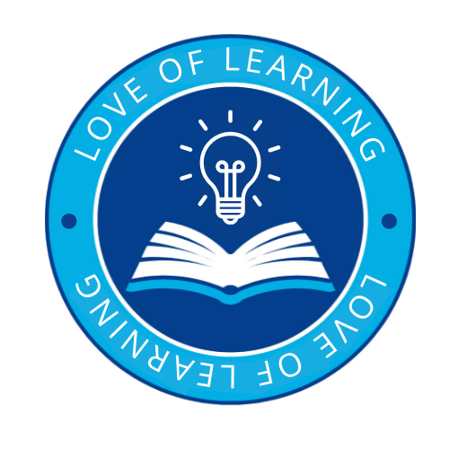 | Introduce a love of learning through:  - Ensuring that children feel happy, safe, secure, valued and loved  - Providing first hand experiential learning through play  - Exploring the environment  - Following children’s interests  - Encouraging exploration  - Embedding a culture of positive can do attitudes and an environment where pupils are not afraid to make mistakes and are supported in recognising that this is part of learning  - Helping pupils develop self-regulation, personal, social and emotional skills and resilience to aid them in their journey through their school life and beyond  - Providing a rich, stimulating, enabling environment with experienced staff who can facilitate learning and who value each individual  - Encourage creativity. Give children opportunities to create in any way they like. ...  - Making learning meaningful  - Creating an atmosphere of respect and tolerance where similarities are shared and differences are celebrated
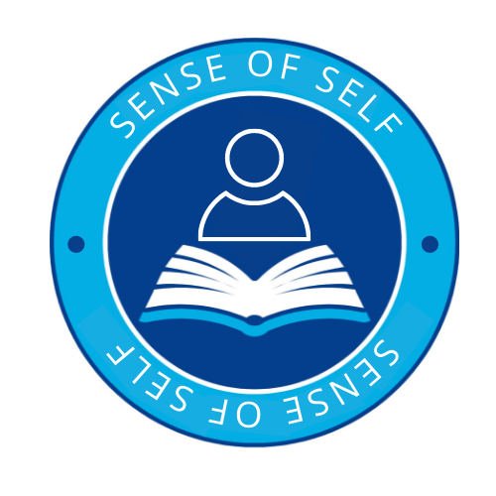 | A sense of self through:  - Ensuring that all members of the school community feel valued and understood  - Supporting pupils in making relationships and developing social skills  - Helping pupils to recognise and name different feelings and emotions and modelling ways to regulate these emotions  - Helping pupils to talk about their feelings and emotions and to recognises that it is ‘okay not to be okay’  - Developing an environment and culture of mutual respect and tolerance – supporting pupils to understand diversity  - Exposing pupils to a diverse range of experiences throughout the curriculum  - Supporting pupils to make their own choices and therefore develop their confidence  - Planning a learning environment that reflects the children’s interests  - Encouraging pupils to explore their own potential to discover new things and develop their knowledge and interests  - Talking about current/ global issues and encouraging pupils to see themselves as citizens of the world  - Regular high quality PSHE sessions  - Teaching about British Values  - Celebrating individuals gifts and talents
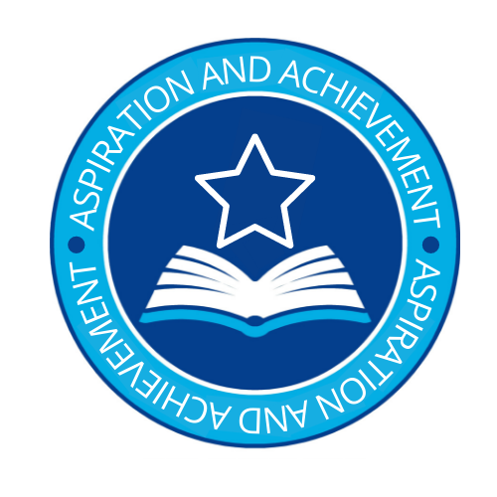 | Aspiration and Achievement through:  - At St Bede’s children learn to believe in themselves and be proud of their local community. They understand the importance of their actions and the part they play in the diverse wider world. Through a strong self-belief leading to a positive physical and mental well-being our children are equipped to take risks and overcome any challenges they may face. Children will leave Early Years as compassionate individuals with a developing understanding that everyone should be valued and respected therefore preparing them for life in modern Britain.  - Broadening children’s horizons through exposure to different scenarios, cultures, religions, beliefs  - Ensuring that pupils realise that anything is possible  - Helping pupils to work towards creating a more just and united world through global learning, pshe and instilling in them the gospel values  - Supporting pupils in realising that we are all capable of change  - Planning a curriculum and an environment that supports the message that we are stronger united  - Helping celebrate gifts and talents and encourage interests through a carefully planned environment so that pupils see that we can all achieve our goals  - Through our personalised and tailored curriculum, children in Early Years are taught to be responsible, resilient citizens who embrace challenge and feel success. Memorable learning experiences allow our children to retain knowledge, apply skills and develop links in their understanding. In turn, children leave Early Years with a developing independence.  - Children at St Bede’s dare to dream knowing no boundaries. Through the experiences our curriculum offers, our children’s ambitions and aspirations are unlocked. These experiences allow them as individuals to develop their own passions and interests and become invested in their learning leading to a sense of drive and motivation which allows them to reach their potential and achieve their dreams.
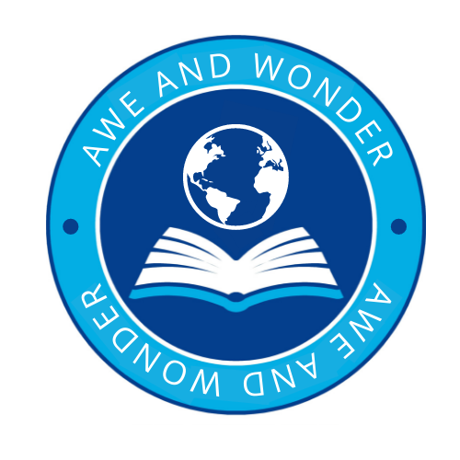 | Awe and Wonder through:  - Spending time in nature (including: Forest School sessions)  - Following child led interests  - Ensuring a rich, stimulating and purposeful enabling environment  - Incorporating a curiosity based approach into learning  - Providing first hand experiences (planting and growing), animals, people in the community.)  - Planning high quality practitioner led experiences - Popcorn over a fire bowl, transient art and loose parts  - Encouraging curiosity and fascination in all of God’s creations  - Ensuring that diversity and difference is embraced and celebrated  - Helping pupils to realise their responsibility as global citizens  - Encouraging generosity for the planet and its people

