Phonics: Phase 1
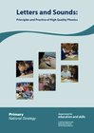Based on Letters and Sounds, Twinkl

Phase 1 Phonics Term 1
Wk1 | Phase 1 Aspect 1  General sound discrimination- Environmental Sounds.  Intent: Getting to know you week,  Learning to listen and follow instructions. | 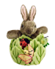  Implementation: Getting settled, feeling part of a learning team, following instructions. Meeting the phonics class toy/teddy.
Wk2&3 | Phase 1 Aspect 1  Environmental Sounds Tuning into sounds (auditory discrimination).  Intent: To develop children’s listening skills and awareness of sounds in the environment.  NB See twinkl for some great sensory sounds ideas  .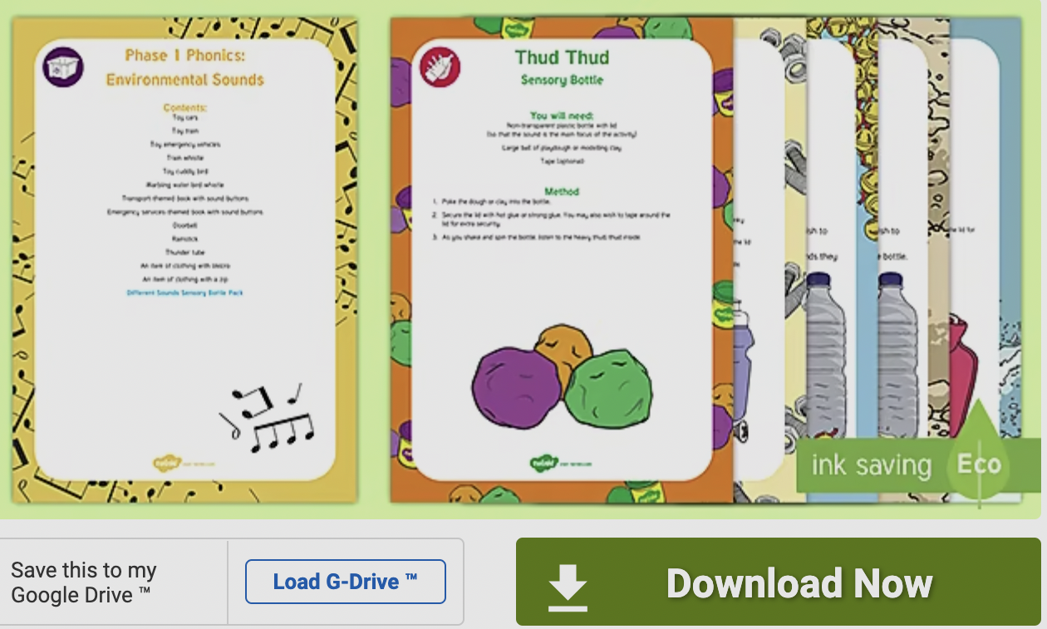 | Implementation:  I am a good listener - Talk about the importance of becoming a good listener. Listen to the teacher's voice, keeping quiet, ears and eyes ready. Switch them on. (Jack Hartman's whole body listener song.) https://www.youtube.com/watch?v=pQ77Nr6TgZo  Listening moment in class -Recap on what a whole-body listener looks like. Encourage children to have super power hearing. (Teacher could sprinkle some superpower dust over children’s’ ears.) Encourage children to keep very quiet for as long as the sand in the timer takes to go down and to listen to all the sounds they can hear in the classroom. The children can be asked what real sounds they heard? Did anyone hear any imaginary sound?  Listening Walk - Teacher tells children they are going on a phonics walk to test out their superpower hearing. Ask in advance about the different sounds they may expect to hear. Use ‘cupped ears’ or make big ears on headbands to wear especially for the occasion. The walk could be recorded on an iPad. Discuss afterwards.  Find ‘teddy’ - Our phonics teddy wants to play hide and seek with us. A pair of children could look away, be blindfolded or scooch down in the quiet area whilst the toy is hidden. The pair then try to find Teddy and the teacher/children try to support them by saying ‘hot’ or ‘cold’ or ‘yes’ or ‘no’ or shaking a tambourine when they are nearer.  Drumming walk - Talk about hitting loudly and softly, fast and slow. Give each child a type of drumstick. Tap and stroking items around them. Ask what their favourite sound is. The activity could be recorded and/or photographed. Could inspire them by watching: - https://www.youtube.com/watch?v=4x2itRawdTU  Listen for the cheeky sound - Sit the children in a circle. Tell them the item you have chosen is sometimes a little cheeky and likes to be noisy, but we are going to try to pass the item so carefully that nothing will be heard. One child is chosen to sit in the middle of the circle with their eyes closed. The others then pass around a noisy object e.g. a tambourine or bunch of keys, trying to be as quiet as possible. The child in the centre listens carefully for the noise and if they hear it point to the location of the sound. They then choose someone else to sit in the centre and the game begins again.  Mimic Me - Go over four different actions that can be heard. The children then face the opposite direction to the teacher and the teacher makes an obvious noise such as a clap or a leg tap or a stamp or playing a shaker that the child may have next to them. The children then mimic the sound that they thought the teacher made. A child could then be chosen to make a sound for others to guess and to mimic.  Magic sounds - Play some magical sounds for the children and ask them how it makes them feel or what it is making them think about in their head. Such as fantasy gliss 9 on https://soundscrate.com/magical.html
Wk4&5 | Phase 1 Aspect 1 Environmental Sounds Listening and remembering sounds (auditory memory and sequencing).  Intent: Further development of vocabulary and children’s identification and recollection of the difference between sounds. | Implementation:  Drum walk recall - Phonics Teddy wants to drum for the children, remind the children about their drumming walk last week. Teddy has three items he will drum on; the children need to guess which item he is drumming on that is hidden behind the magic box/sheet?  Sound lotto/story - What can we hear on the audio/sound lotto? Say the order of the first three items. https://www.youtube.com/watch?v=h0Kp_J9kvNM  Little puppy (Mrs Browning) has a toy - Little puppy has been busy collecting things from around the house to play with and hiding them under a cushion. Choose three items. (Keys, crisp packet, squeaky toy). Teacher sings “Little puppy has hidden a toy ee igh ee igh oh…” to the tune of Old MacDonald. Children listen and guess the toy by the sound it makes. Hide the items again under a pot and ask the children to see if they remember the order of the three items.  Describe and find it - Set up a model farmyard. Teacher chooses one of the animals and describes it. Children guess and make the noise of the animal.  Animal line up - Sing “We are going on a lion hunt - what do we see” Line up three animals that you may see on the walk and create the sounds they make, hide the animals and children repeat the sounds from memory. Line up three different animals.  Kitchen sounds - Making Milkshake sequence - Ask children to think about what sounds they may hear in a kitchen if someone was making milkshake? Open the fridge, pour the milk, scooping ice-cream, plopping it in, turn on the mixer, pour into the class. Gurgling milkshake being drank. You could use picture cards to recap the sounds.  Whose feet? - Is it the giant’s heavy steps, the fairy flutter steps or the rabbits bouncing bunny hops? After asking the children’s opinion of how to recreate these footsteps sounds and practising them, ask children to take off their shoes or use boxes to recreate the sounds for their friends to guess which one they have decided to pretend to be. Now put them in a sequence.  The wheels on the bus - Full of sounds to create. Children guess which sound the teacher is going to play next by the action and/or the sound and then children sing together.
Wk6&7 | Phase 1 Aspect Environmental sounds Talking about sounds (developing vocabulary and language comprehension).  Intent: To make up simple sentences and talk in greater detail about sounds. | Implementation:  Favourite sounds - Listen to some sounds on an audio recording. On a whiteboard or on paper, talk about what sounds make them happy or make them afraid and draw them in cartoon or symbol form.  What’s inside the Jar? Phonics Teddy has some magical guessing jars she likes to store things in. They are playing peepo under a cloth. The children guess what is in each jar, such as keys, shells, coins and rice.  Enlivening stories - Involve the children in songs and stories, enlivened by role play, props and repeated sounds, for example acting out: Humpty Dumpty sat on a wall, Humpty Dumpty had a great fall (bump, crash, bang!) All the King’s horses and all the King’s men (gallop, gallop, gallop) Couldn’t put Humpty together again (boo, hoo, boo, hoo, boo, hoo).  Sounds carry meaning - Teacher makes or plays a variety of sounds such as school bell, whistle, fire alarm and a Disney opening title or TV title they may know. and asks - if you hear nee nah, what might that be? If you hear woof woof, what might that be? If you hear ‘shhh’, what would that mean? Then children think of a sound to make and question the teacher. Ask them what they think about when they hear one of these.  Teddy is going on a sound journey - Let’s go with teddy on the noisy sound journey. Get on the bus, bus beeps, bus stops at the airport, get on the plane...etc. Can include sounds from nature such as sploshing through mud.  The Noisy Book - Choose a familiar book and say you are going to make it into a class audio book of sounds. You could point to a particular page and ask them ‘what might we hear on this page?’ Emphasise that there is no right or wrong!  Fairy story characters - (Beauty and the beast)- choose some objects such as a candle stick, teapot, tea cup, clock and a feather duster and give them a gentle tap. Now ask the children if we spread some magic fairy dust on them what might they say or sound like?  Plop in the water - What sounds can they identify with water noises? Rain, stones sploshing, bubbles, whales crashing on the surface, gurgles down the drain. Discuss and maybe show some examples. You could even discuss the fact that sounds differ underwater.
Wk8 | Phase 1 Aspect 2 -General Sound Discrimination - Instrumental Sounds. Tuning into sounds (auditory discrimination).  Intent: Become more familiar with the language and sequence of Nursery rhymes. | Implementation:  Learning about Nursery Rhymes Day 1-3 - Incy Wincey, Twinkle Twinkle and Baa Baa Black Sheep, practised words in sequence. Use a bag of objects that link to the rhymes, books and interactive songs on the whiteboard.  Learning the actions for Nursery rhymes - Alongside the words.  New endings - Take a song or rhyme the children know well and invent new words to suit the purpose and the children’s interests. Use percussion instruments to accompany the new lyrics. Twinkle Twinkle Chocolate bar.
Wk9&10 | Phase 1 Aspect 2 Instrumental Sounds Tuning into sounds (auditory discrimination).  Intent: To experience and develop awareness of sounds made with instruments and noise makers. | Implementation:  Learn the instrument’s name - Ask the children what they know about any musical instruments. Learn the names of a few different instruments. Teacher plays and then passes the instruments round the circle. Ask a child to try to remember the name of the instrument that they are playing. Play it quietly, play it loudly. https://youtu.be/rHQmPY7r02E  Talk about the way the instrument is played – Learn the vocabulary tap, play, strum, stroke pluck, shake. Ask the child to talk about their body movement as they play an instrument.  Play fast and play it slowly - Explore the instruments. Understand start and stop.  High pitch/tone, low pitch/tone - Sing along with the instruments creating high notes and low notes. Could sing a nursery rhyme in a high pitch and a low pitch. (NB singing and playing simultaneously is quite a challenge and part of bilateral coordination plus remembering a sequence of words).  Which instruments? - Have three pairs of instruments such as two drums, triangles and shakers. Play each one. Now a chosen child hides with a set of instruments and the others have to guess which instrument the child is playing. Extend with singing rhymes as the child plays.  Adjust the volume - Two children sit opposite each other with identical instruments. Ask them to copy each other making loud sounds and quiet sounds. It may be necessary to demonstrate with two adults copying each other first. Then try the activity with an adult with one child. Use cards giving picture or symbol cues to represent loud or quiet (e.g. a megaphone, puppet of a lion, a finger on the lips, puppet of a mouse). https://www.phonicsplay.co.uk/resources/phase/1/sound-starters  Grandmother’s footsteps - Link two or three instruments to a movement such as drum=stomp, tambourine`= running and shaker could be to crawl like a snake. Teacher starts off as Grandmother and children try to get closer to her as she plays the different instruments. Then a child takes the role.  Make a shaker - Children create their own shaker and learn to play it quietly and loudly.  Unusual instruments - Find different and unusual items in the class to tap, stroke, blow and shake  Review together - Review the names of instruments, what playing loudly, quietly, slowly and fast means and the actions you use to play them.
Wk11 | Phase 1 Aspect 2 Instrumental Sounds Listening and remembering sounds (auditory memory and sequencing).  Intent: To listen to and appreciate the difference between sounds made with instruments. | Implementation:  Matching sound makers - What’s in the feely bag? Find and match the sound to one of the instruments in the centre of the circle.  Learn how to create a rhythm - such as 1,1,1 or 1 2, 1 2, 1 2 or 1-2 3, 1-2 3. Children follow the teacher’s rhythm through clapping and then using an instrument and word.  Copy a rhythm - Pass the rhythm and instrument around the circle remembering the sequence of the rhythm and the words.  Sing three notes from a nursery rhyme - Using the shaker you made and pass it on to a partner to copy.  Unusual sound Play. Use three unusual musical instruments to play, children try to remember the order you play them in.
Wk12&13 | Phase 1 Aspect 2 Instrumental Sounds Talking about sounds (developing vocabulary and language comprehension).  Intent: To use a wide vocabulary to talk about the sounds instruments make. | Implementation:  Recap on playing instrument actions - Remember what stop and start means. Can they remember the key words? Such as tap, play, strum, stroke pluck, shake. Recap on what part of our body we are channelling to create the sound. Are there other items around the class that we could demonstrate these actions on, or ones that have little effect after an action?  Story sounds - As you read or tell stories, encourage the children to play their instruments in different ways (e.g., Make this instrument sound like giant’s footsteps, a fairy fluttering, a cat pouncing, an elephant stamping).  Invite them to make their own suggestions for different characters (e.g., How might Jack’s feet sound as he tiptoes by the sleeping giant? And what about when he runs fast to escape down the beanstalk?). As the children become familiar with the pattern of the story, each child could be responsible for a different sound.  Animal sounds - Provide a variety of animal puppets or toys and a range of instruments. Encourage the children to play with the instruments and the animals. Discuss matching sounds to the animals. Give a choice of two instruments to represent a child’s chosen animal and ask the children to choose which sound is the better fit: Which one sounds most like a mouse? What do you think, David?  Hidden instruments - Hide the instruments around the setting, indoors or outdoors, before the children arrive. Ask the children to look for the instruments. As each instrument is discovered, the finder plays it and the rest of the group run to join the finder and play their instrument with them. Continue until all the instruments are found to make an orchestra.  Invite a musician - Have a few professional musicians or junior musicians higher up the school to demonstrate how to hold and play musical instruments successfully. Children could ask for their favourite musical piece to be played.  Old, new and foreign musical instruments. Talk about the past and future of sounds.  Musical Show and Tell - Invite groups of children to perform short instrumental music for others. The others are asked to say what they liked about the music. (They will need a selection of instruments or sound makers and some rehearsal time.)

Phase 1 Phonics Term 2
Wk1 | Phase 1 Aspect 3 General Sound Discrimination - Body Percussion (Also quick recap of Environmental sounds for class and newcomers to term 2 throughout the week)..  Tuning into sounds:  Intent: To develop awareness of sounds and rhythms. | Implementation:  Action songs - Let’s sing some action songs, practise singing and moving simultaneously and at the correct time to the words.  Listen to the Music - Play an action song on the IWB and get the children to join in. Talk about how it makes them feel. https://www.youtube.com/embed/VsgpUHUYuJI  Roly Poly - Pop ribbons tied on to scrunchies around your wrists and have fun with “Roly poly ever so slowly (going slowly) roly poly faster (speed up)” Do the same for stomping and wiggling etc.  This is the way - (sing along to the tune of ‘Here we go round the mulberry bush’) This is the way we clap our hands, pat our legs, pop like a fish lips…
Wk 2 | Phase 1 Aspect 3 Body Percussion Listening and remembering sounds.  Intent: To distinguish between sounds and to remember patterns of sound and to distinguish musical instruments from voice sounds. | Implementation:  Follow the Sound - Body percussion sequence passed around by each child in a circle. Did it stay the same, change, speed up, slow down?  Follow the sound with claps and cups - Learn to use cups and claps to create a simple rhythm.  Noisy Neighbour Bear - All the children pretend to sleep to a sleeping song and we say good night. They then listen to the sound being made by noisy Teddy bear in the morning. They sit up when the teacher says wake up and guess if the noisy bear crunched cornflakes, poured some water, put a lid on a pan, tapped the knife and fork together.  Missing sound - Use three different items to create a sequence, such as tub patting, keys in a jar shaking and squeaky toy. Play a few times and then say the sound thief has come to take a sound away, omit one of the sounds. Children have to guess which sound the sound thief has taken and is now missing.  Sing with me - Children copy three musical notes sung by a funny puppet, such as doh re mi repeating after the puppet. They can increase difficulty by adding in a body percussion action.
Wk 3 | Speech Detection (Essex Works Ultimate Guide) Talking about sounds  Intent: To understand speech sounds as distinct from other environmental sounds and to recognise that sentences are made up of individual words. | Implementation:  Speech jumping game - The aim of the activity could be to move from one end of the spots to the other. The adult/child selects a picture and generates a short sentence related to it - for example 'he is running'. The child then jumps along the spots making one jump for each word saying the words as he jumps. The child may need support to generate/remember the sentence. He/she may also need support to make one jump for each word initially.  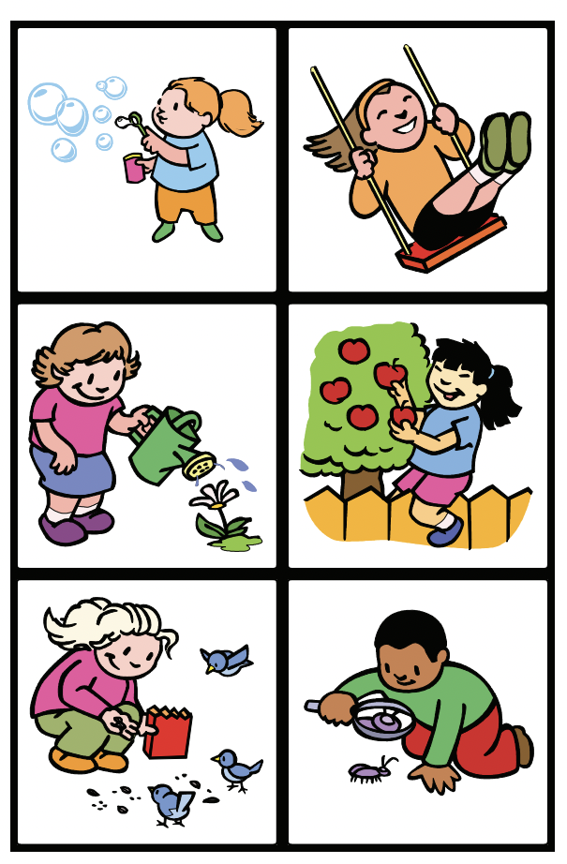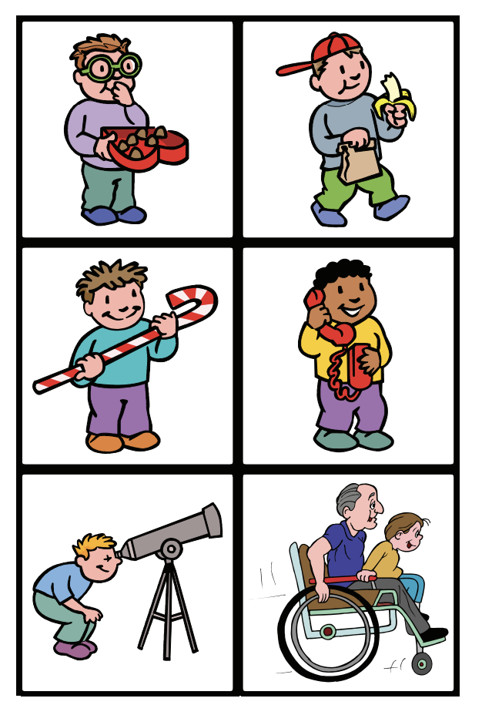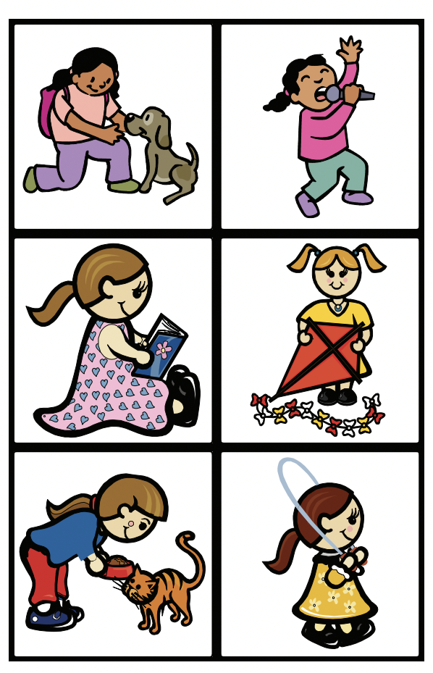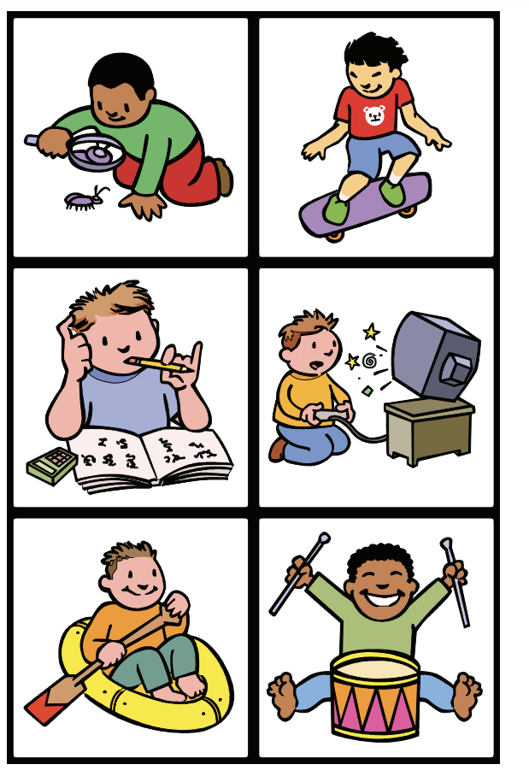  Mr Noisy’s sentence - Ask children to think of a very quiet, peaceful and still place and when Mr Noisy teddy bear, who is also very expressive, comes along and begins to shout out...what might he say? Teacher models three words and uses the body to separate the three words, such as jumping three times to Mr Noisy shouting out “I want tea” or shaking his fists to “I love unicorns”. Ask them to count the words we used.  Noisy Neighbour 2 - Our Noisy neighbour bear takes us on an adventure by spreading magical dust on us, we fly about pretending to go around the school and beyond. As you go on the pretend journey, we can help Mr Noisy bear learn about where it is good to be noisy or quiet. Make whispering and then louder noises with the same tapping, nodding or arm shaking actions as yesterday to reinforce sentence breakdown. “Be quiet here” “Read quietly here”, “Be loud here”.  Opposite sounds - Phonics Teddy wants us to play the opposite game. In her special little tin she has some pictures… Using picture cards, choose a card and describe what they see, such as a person shouting, a horse running, a soldier standing still, a windmill not moving; they have to do the actions for the opposite and add in the words plus sentence segmenting actions such as nodding such as “My arms are moving”, “I am marching”  The Pied Piper - Read the story of the pied piper and then follow the teacher around the indoor and outdoor space, we are hopping, we are skipping, we are jumping, we are marching and use loud, quiet, fast and slow voices with these actions.
Wk4 | Syllable Awareness taken from Essex Works Ultimate Guide.  (Pre Aspect 4 Letters and sounds rhyme and rhythm)  Intent: To develop awareness of the syllable structure of words.  1. My turn, together, your turn – the clapping/stamping/moving to mark the syllables in words are modelled by the adult, practised together and then given by the child.  2. Together, your turn – the adult and child mark the syllables together and the child then does this independently.  3. Child led – child marks the syllables using physical means e.g. clapping but independently. Syllable sorting – this is a separate skill which builds on level three. It involves counting skills, which need to be well established for the child to be successful.  4. Internalisation – the child can identify the number of syllables in a word without talking. | Implementation:  Syllable segmenting - Learn to clap out a syllable such as those in their name. Next play a game where a child takes a turn to collect a picture or object. The child hears and breaks down the syllables of the picture with support. As each syllable is said a counter is placed on a piece of paper or plate. Initially, the adult and the child would say the word and the adult would support the child in placing the counter. Next the aim would be for the child to say the word and place the counters independently.  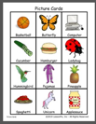  Syllable tracking - Using a blank track the children take turns to turn over a picture and move the counter along the track according to the syllable structure. Initially, the adult would say the word and support the child to move the counter along the track. Next, the child would say the word and move the counter according to the syllable structure. For instance, ru ler would move the counter on two paces. Finally, the aim would be for the child to move the counter along the track without saying the word.  Syllable snap - This could be done with matching cards with the same amount of syllables or through matching objects and popping them inside three different hoops such as cat and phone = 1 syllable, carrot and basket =2syllables and banana and unicorn=3 syllables https://www.yesataretelearningtrust.net/Portals/0/The_Ultimate_Guide_.pdf click on link for more sorting syllable cards.  Syllable halves - Oh no, the syllables have been cut in half and only a part of the word is there now (show the divided picture.) Teacher or child chooses a half and everyone says and claps the first bit, such as Zeb- children then suggest latter half that is missing (-ra) and you identify the missing picture on a separate tray. Once together you can clap the syllables to make the word ‘Zeb-ra’.  .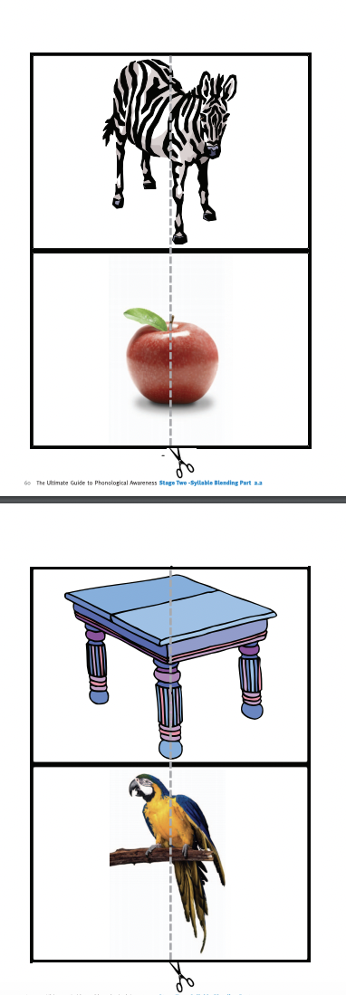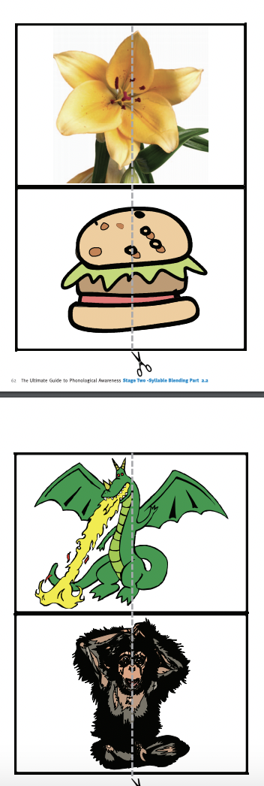  Syllable deletion - Oh dear part of the word has been deleted, what can it be? Showing them several items on a tray and ask the children to guess what the word is by saying a part of the word such as drag...which object could it be? Yes that’s right the dragon.
Wk5 | Essex Works Ultimate guide: Onset and rime.  The 'onset' of a syllable is its initial consonant(s) and the 'rime' is the vowel and any following consonants in the syllable e.g. in 'cat' the onset is the consonant /c/ and the rime is -at.  Intent: To identify a target onset when provided orally by the adult. This activity is similar to initial sound recognition but comes before initial sound identification as the adult will be giving the child the word already broken into onset and rime.  (NB Onset refers to all the sounds in the syllable that come before the first vowel. Therefore, whilst in a word like 'cat' the onset is the same as initial sound - /c/, in the word 'stop' the onset is 'st' whereas the initial sound is /s/. ) | Implementation:  Onset posting (long initial sound emphasis) - Lay the selection of cards or objects on the table. Tell the child they are going to try to find the special word we are thinking of by listening to the onset sound (these are words with a long initial sound to allow emphasis) and post them in the box/ tin/ basket/Kangaroo pouch (Think of something exciting) The adult then says a selection of the words, shown on the cards, in an onset and rime format e.g. mmmmmmm-ap. The child then posts the word if they think it has the target sound at the beginning. Picture vocabulary included: Zebra, spoon, rake, window, lion, ring, sink, swing, zip, snake, fan, shell, van, lipstick, moon, microphone, rain, fox, vase, snowman, shoe, ladder, rabbit, ship  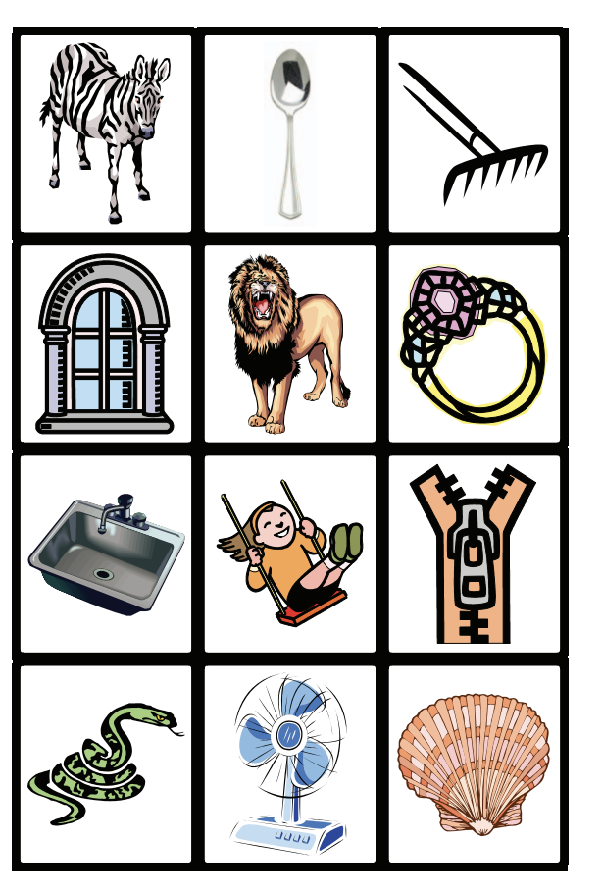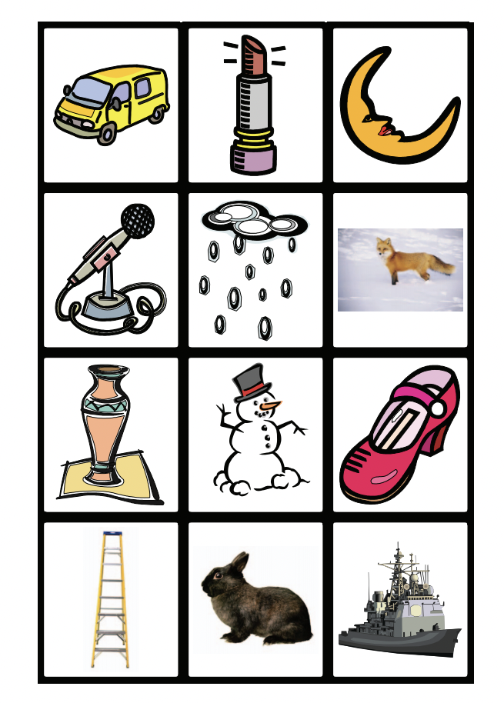  Onset and rime silly voice detective - Lay a selection of single syllable pictures on the table. Explain to the child that you are going to tell them a word and you want them to find the picture, but you are going to say it in a funny way. Model the way you will say the words using onset and rime e.g. d-og and ask the child to find the correct picture. This could be posted into a box or collected in a pile. Picture vocabulary included: Cat, fish, cup, house, chain, shell, chair, dog, bed, plate, pan, car, snail, bear, key, spoon, star, fan, snake, pig, book, rain, sun, kick.  Onset exploring outdoors - Take a basket and pick up some items from a walk outside that the children can then sit together somewhere comfortable to say the onset and rime of their chosen item in the basket. Such as sh ell or st one, or l eaf. They could even take a photo of something with the iPad and could share the photo they took with a group saying the onset and rime.  Compound word building - To use two one syllable words to make a two syllable word. Lay the compound word cards out on the table. Ask the child to name all of the pictures. Compound words:  Talk about how some words can be put together to make a longer word. Model this to the child. The symbols for 'plus' and 'equals' can be used if the child is familiar with these. Show the child a compound word and ask them if they can find the two-word pictures that make the one longer word. E.g. lipstick is lip + stick.  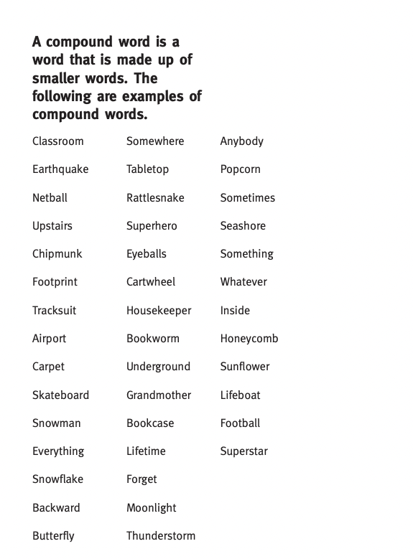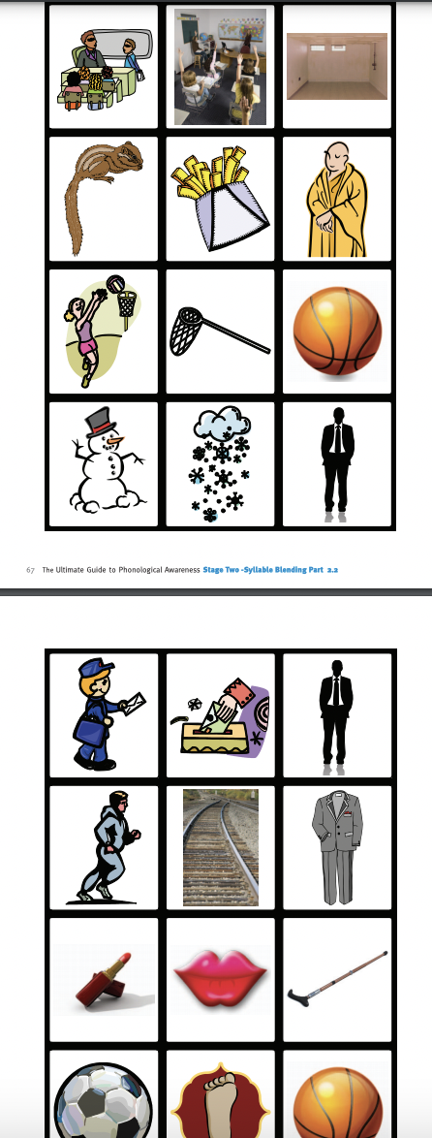
Wk6&7 | Phase 1 Aspect 4 Rhyme and Rhythm  Tuning into sounds  Intent: To experience and appreciate rhythm and rhyme and to develop awareness of rhythm and rhyme in speech.  Check the twinkl resource:-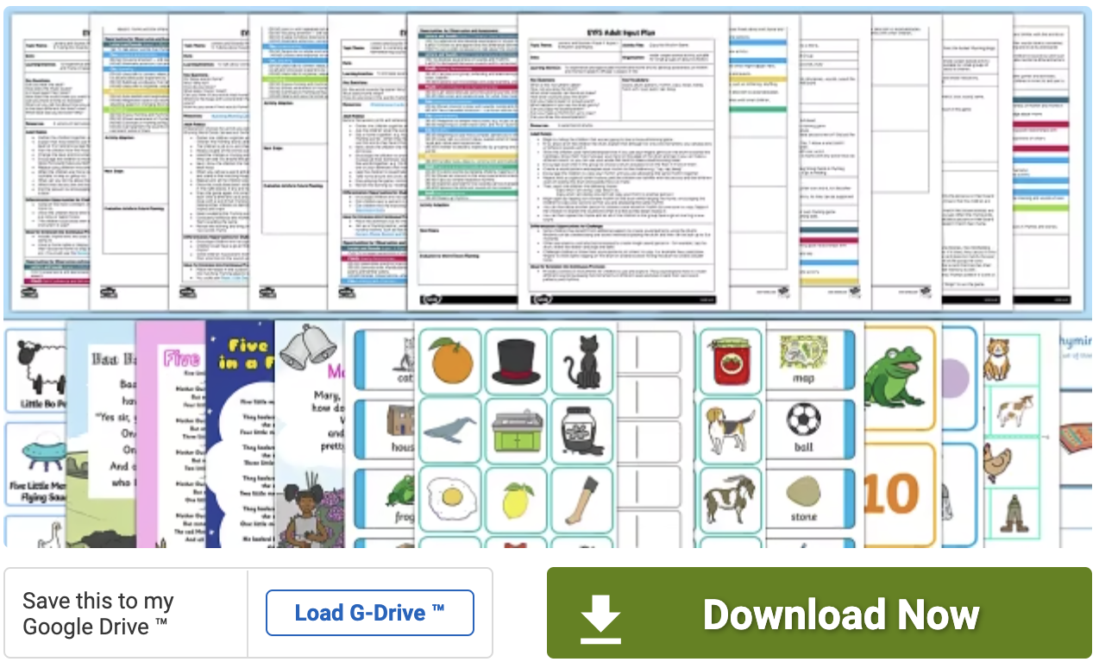 | Implementation:  What’s rhyming all about? - Ask the children if they know anything about rhyming. Get all cosy with the Phonics Teddy and read a simple but special poem for them to hear the rhyming at the end.  Learning songs and rhymes - Poem’s rhyme, songs can rhyme - let’s learn a new song that does rhyme and a song that does not rhyme.  Songs, rhythm and syllables - Sing Jack and Jill rhyme in monotone without its rhythm, ask the children to notice what the ‘issue’ is. Now sing together with its rhythm. Talk about short words such as Jack and long words such as tumbling. Clap the syllables for both and ask children what they can hear?  Rhyming books - Gingerbread man, notice the repetition of the rhyme, children join in. “Run, run, as fast as you can, you can’t catch me, I’m the Gingerbread Man.” Wherever possible make the activity multi-sensory to intensify learning  and enjoyment.  Rhyming books with Julia Donaldson - Choose a book by Julia Donaldson and read it together. Ask the children if they hear/notice words that rhyme.  Listen to the beat - Choose a couple of pieces of music with different rhythms for the children to dance to such as Carnival of the Animals by Camille Saint Saens. How does it make them feel? Does it seem happy, sad, scary etc. How can they tell which animal it may be?  Poem of the day - Such as: -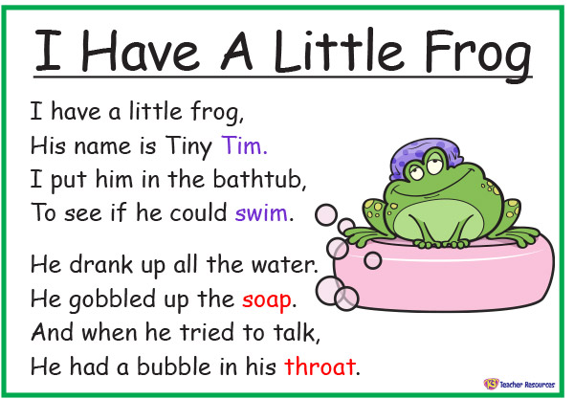  Rhyming Book - Such as Chicka Boom Boom or Duck in the Truck hear the rhyme.  Rhyming puppets - Teach a finger rhyme to the Phonics Teddy or you could use puppets for this.  Our favourite bag of rhymes - Circle time. Dress up as a nursery rhyme character for the day and choose a special toy out of the nursery rhyming bag that reminds you of a nursery rhyme that you can sing together.
Wk8 | Phase 1 Aspect 4 Rhyme and Rhythm Tuning into sounds  Intent: To experience and appreciate rhythm and rhyme and to develop awareness of rhythm and rhyme in speech.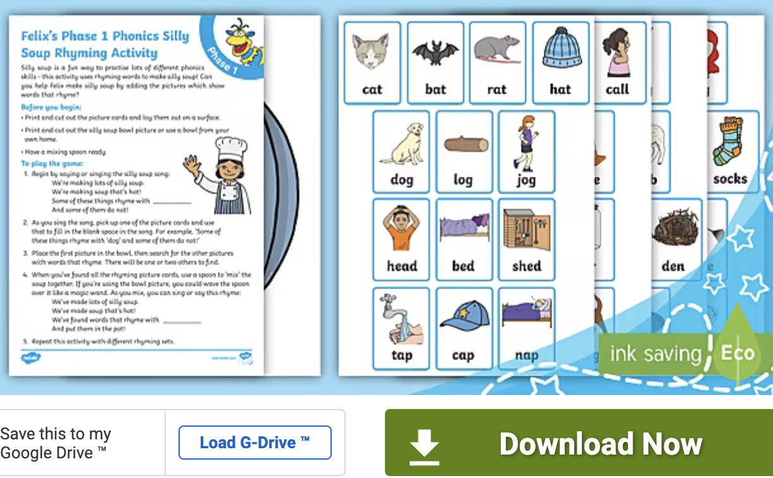 | Implementation:  Rhyming soup -Ask a small group to sit in a circle so they can see a selection of rhyming objects (e.g.rat, hat, cat) placed on the floor. Use a bowl and spoon as props to act out the song. Invite the children, in turn, to choose an object to put into the soup and place it in the bowl. After each turn, stir the soup and sing the following song to recite the growing list of things that end up in the soup. Sing the first part of the song to the tune of ‘Pop Goes the Weasel’:  I’m making lots of silly soup, I’m making soup that’s silly, I’m going to cook it in the fridge, To make it nice and chilly In goes... a fox... a box... some socks...  Rhyming Bingo - One set of cards is given to a small group of children and it’s rhyming pair is put into a bag. This could be a card or an object that rhymes. As a child draws out an object from the bag it gets given to the corresponding rhyming word card owner.  Rhyming Lotto - Each player takes a turn to select a lotto card; the children then look at the lotto boards to decide if they have a picture that rhymes with the card selected and it is placed on the board. The game ends either when one child has filled their board or when all the boards are full. At first, the words should be articulated but the aim is that the children are able to match the rhyming words without having to articulate them.  Playing with words - Gather a set of familiar objects with names that have varying syllable patterns (e.g., pencil, umbrella, camera, xylophone). Show the objects to the children, name them and talk about what they are used for. Wait for the children to share some of their experiences of the objects; for instance, some of them will have used a camera. Then encourage them to think about how the name of the object sounds and feels as they say it. Think about the syllables and clap them out as you say each word. Then clap the syllables for a word without saying it and ask: What object could that be? As children gain confidence try some long words like binoculars, telephone, dinosaur.  Rhyming Story - I like myself! 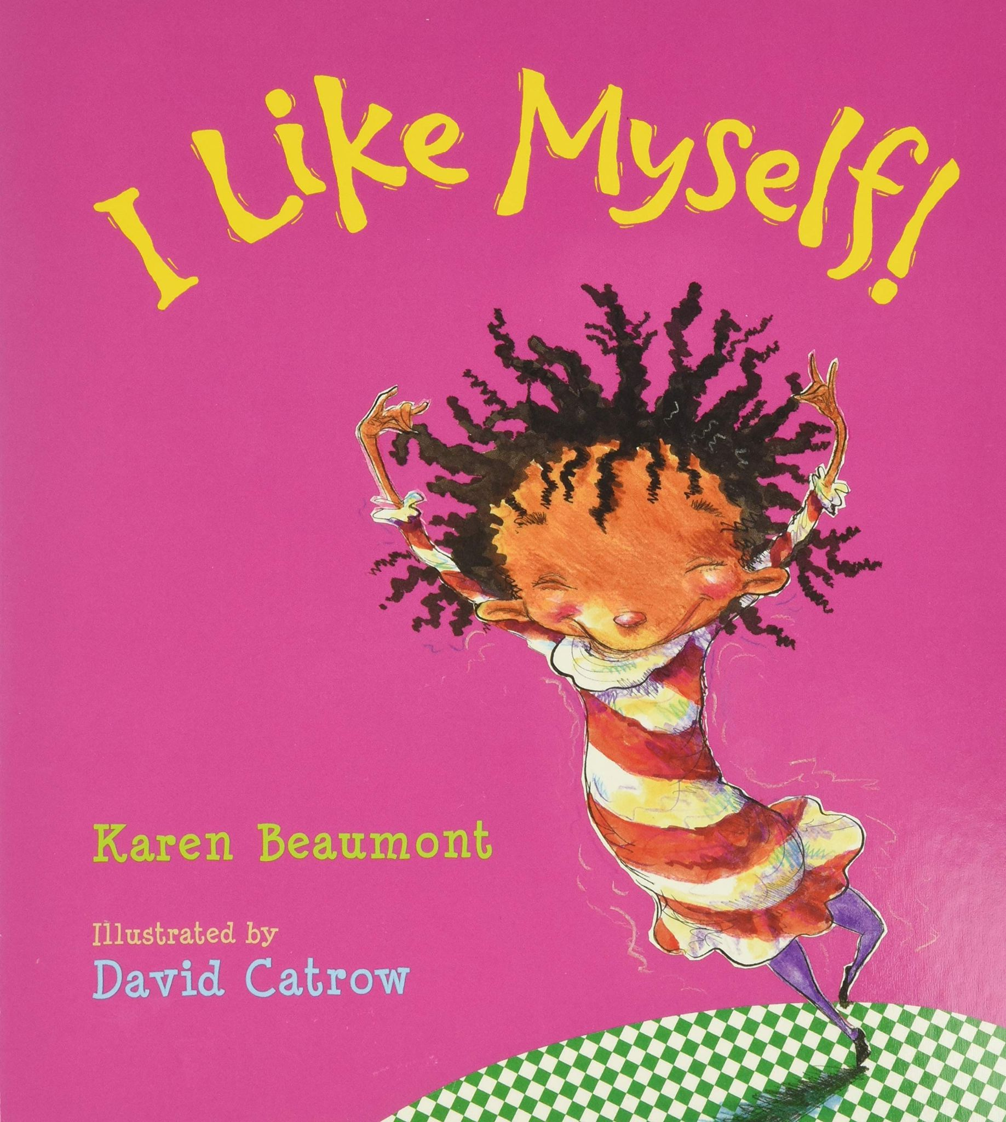
Wk9 | Phase 1 Aspect 4 Rhyme and Rhythm Listening and remembering Sounds  Intent: To increase awareness of words that rhyme and to develop knowledge about rhyme.  Rhyme and Rhythm Talking about sounds  Intent: To talk about words that rhyme and to produce rhyming words. | 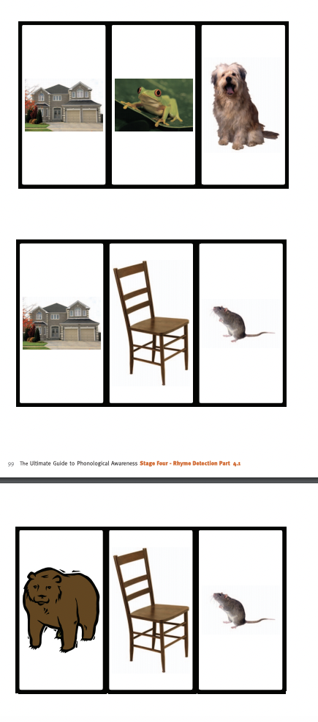  Implementation:  Rhyming pairs - Set out the cards face down on the table. Take turns to pick two cards each and turn them over. Say the words aloud and decide whether they rhyme. If the words are a rhyming pair, the player keeps the cards. If not, they are turned back over and play passes to the next player.  Rhyming odd one out - Identify a picture. Talk to the child about the picture and provide two other pictures, one which rhymes with the original. Ask the child to try and match the picture with another that rhymes with it. This can be done silently if the child is moving towards internalisation of the skill  Rhyming on Phonics play - interactive game  Finish the rhyme - Use books with predictable rhymes that children are familiar with and then stop as you come to the final word in the rhyme. Invite children to complete it. Use plenty of intonation and expression as the story or rhyme is recounted.  Happy families Rhyming strings. Organise four rhyming pictures from a rhyming string. There needs to be one string for each person playing. Shuffle the cards and share between the players. The object of the game is to collect a set of words that rhyme. The first player identifies a set they want to make and asks another player 'Do you have a card that rhymes with…?' If the player has the card, they pass it to the person that asked. Play continues round the circle until one player has the full set. Picture vocabulary included: Happy families rain, chain, plane, train. eye, fly, cry, tie. shoe, two, glue, blue. book, cook, look, hook. chair, hair, bear, pear. tea, tree, key, bee. cat, hat, fat, mat. pan, fan, man, van. sun, bun, run, one. drink, sink, think, wink. knock, sock, clock, rock. frog, log, dog, jog. pin, bin, thin, spin. sing, ring, swing, wing. nail, snail, sail, tail. stick, brick, lick, kick. ball, tall, fall, wall. snake, cake, rake, lake.
Wk10 | Phase 1 Aspect 6 Voice sounds  Tuning into sounds:  Intent: To distinguish between the differences in vocal sounds, (including oral blending and segmenting - saved this for later along with metal Mike!)  Intent: Listening and remembering sounds  To explore speech sounds.  Intent: Talking about Sounds  To talk about the different sounds that we can make with our voices.  Twinkl support: -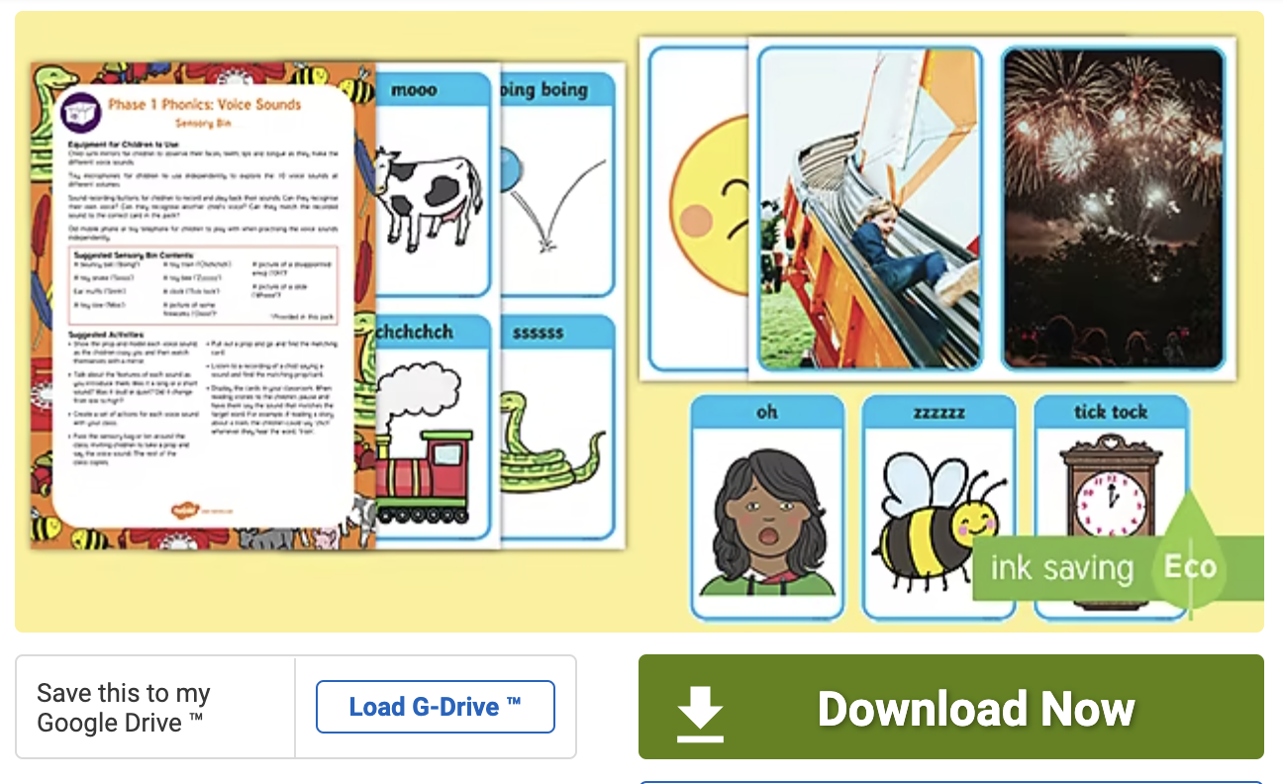 | Implementation:  Mouth movements with mirrors - Explore different mouth movements with children – blowing, sucking, tongue stretching and wiggling. Practising these movements regularly to music can be fun and helps children with their articulation.  Making a trumpet - Make amplifiers (trumpet shapes) from simple cones of paper or lightweight card and experiment by making different noises through the cones. Model sounds for the children: the up and down wail of a siren, the honk of a foghorn, a peep, peep, peep of a bird. Contrast loud and soft sounds. Invite the children to share their favourite sound for the rest of the group to copy. Use the trumpets to sound out phonemes that begin each child’s name.  Chain games - Working with a small group of children, an adult makes a long sound with their voice, varying the pitch (e.g., eeeeeee). The next person repeats the sound and continues as the next joins in, to form a chain. The sound gets passed as far round the circle as possible. Start again when the chain is broken.  Target sounds - Give each child a target sound to put into a story when they hear a particular word or character (e.g. make a ‘ch’ sound when they hear the word ‘train’).  Start with a single sound that the small group of children can make together when they hear a target word. Be prepared to prompt initially and leave pauses in your reading to make it obvious where the sounds are required.  Sound story time - Discuss with the children how they can use their voices to add sounds to stories such as Bear Hunt, Chicken Licken or The Three Billy Goats Gruff. Repeat favourite rhymes and poems in different voices together (e.g. whispering, growling, shouting, squeaking) and discuss the differences.
Wk11 | Essex works ultimate guide: Initial sounds.  Correct pronunciation is vital. No ‘uh’ or err at the end of a phoneme. See Little Learners for some help on this https://www.youtube.com/watch?v=yVyry9jpVjI  At this stage, the terminology 'beginning' and 'start' become important as the child needs to begin to isolate the sound on demand. It is important to note that the development of this skill does not rely on knowledge of matching letters to sounds but is purely about oral discrimination and separating the sound from the rest of the word.  Initial sound awareness develops in the following stages:  1. Adult led - The child requires full adult support to identify the initial sound. 2. Adult intervention - Words with long initial sounds are used. The adult says the word emphasising the initial sound. The child is then able to sort the words. 3. Child led - The child is able to sort pictures after saying the sounds. 4. Internalisation - The child is able to sort pictures silently.  Intent: To recognise an initial sound. To know that words can begin with the same sound. | Implementation:  Sound bubbles/buttons game 1. The child or the adult turns over a picture from the pile. The child and adult together segment the sounds - e.g. c-a-t. 2. Next, the adult segments the sounds and for each one a counter is placed on the bubbles. 3. Then the child segments the sounds pointing at each counter. 4. Next the adult takes away the first counter and asks the child what sound is missing. As the child develops the skill steps 1-3 can be withdrawn.  Same sounds in the basket - 1. The child or the adult turns over a picture from the pile. 2. Next, the child places the card in the box that matches the initial sound of the picture. 3. The activity continues until all the pictures are in the boxes.  Matching sound pairs - The cards are placed face down and the children take it in turns to turn over two cards. (The rules are the same as for pelmanism). The adult and/or the child says the word and decides if the initial sound is the same. If they match, the pair is kept. The game continues until all the pairs have been collected. The goal is that the child can match initial sound pairs without having to articulate the words. Picture vocabulary included: Mouse/monkey, shell/shirt, snake/saw, run/rabbit, fish/foot, lips/lolly, van/vase, zebra/zip, house/hat, nail/net, moon/man, yellow/yoghurt.  Odd one out - The child and/or the adult says the three words that the pictures represent and the child decides which one does not 'go' and says why. E.g. the cake does not go because the other two begin with /f/ and the cake begins with /c/. If the child is not quite able to do this, it may help to start off finding 2 pictures that go 'together'. The goal is that the child can identify the odd one out without having to articulate the words. Picture vocabulary included: Fish/fly/sun, sock/tap/saw, lion/frog/four, house/cake/cup, shoe/ship/bin, sand/saw/duck, flower/cake/fox, window/lion/leg, fat/frog/mouse, bed/book/rabbit, mouse/monkey/star, pear/dog/pig, table/dinosaur/door, vase/van/wing, shell/ship/sock, chips/snail/sad.  Sound Corner Run - Children run to the corner where a s for snake is sitting when you say a word or pick out an object from the bag (or even inside an Easter egg if it is around that time…) beginning with a s or to the teddy corner if you say a word beginning with ‘t’.  Super Smoothie - Phonics play https://www.phonicsplay.co.uk/resources/phase/1/super-smoothie
Wk12 | More Initial sound ideas. | 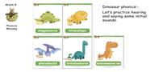  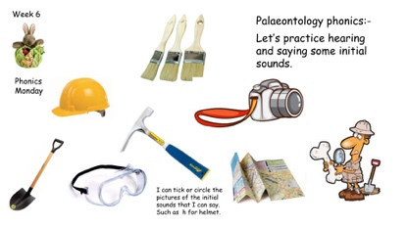  Dinosaur initial sound - Hide the dinosaurs in the garden and ask them the initial sound of several of them.  Palaeontology Phonics - Say the initial sounds of the items a palaeontologist may use.  Objects in the ice - Choose a couple of initial sounds and freeze some objects in ice. Children can explore the ice and when it melts you can talk about which ones have the same initial sound.

Phase 1 Phonics Term 3
Wk1 | Phase 1 Aspect 5 Alliteration tuning into sounds.  Intent: To develop understanding of alliteration.  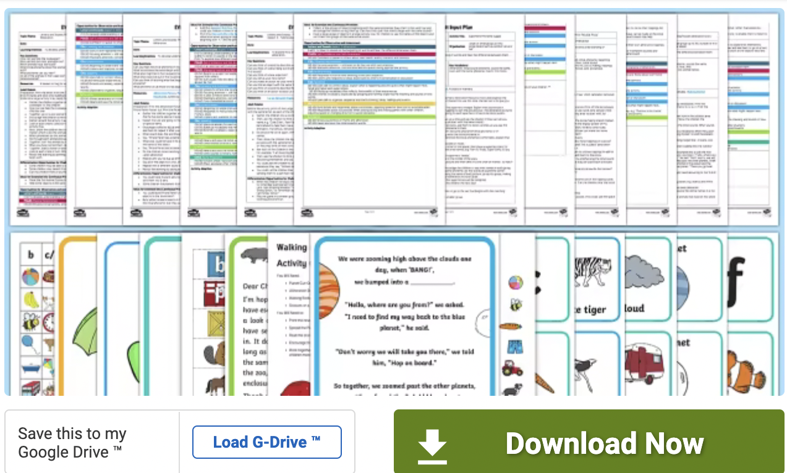 | Implementation:  I spy names - With a small group of children sitting in a circle, start the game by saying I spy someone whose name begins with... and give the sound of the first letter, for example ‘s’ for Satish. Then ask: Who can it be? Satish stands up, everyone says his name and he carries on the game, saying I spy someone whose name begins with..., and so on. If any children call out the name before the child with that name, still let the child whose name it is take the next turn.  If the children find separating out the first sound too hard in the early stages, the adult can continue to be the caller until they get the hang of it.  Sounds around /Peter Piper  Make sure that word play with initial sounds is commonplace. Include lots of simple tongue twisters to ensure that children enjoy experimenting with words that are alliterative. Use opportunities as they occur incidentally to make up tongue twisters by using children’s names, or objects that are of particular personal interest to them (e.g. David’s dangerous dinosaur, Millie’s marvellous, magic mittens). This Peter Piper version is fun https://www.youtube.com/watch?v=7lPv3LdUiyc  Making aliens - Before the activity begins, think of some strange names for alien creatures. The alien names must be strings of non-words with the same initial sound, for example: Ping pang poo pop, Mig mog mully mo, Fo fi fandle fee. Write them down as a reminder.  Talk to the children about the names and help them to imagine what the strange creatures might look like. Provide creative or construction materials for the children to make their own alien.  Comment as the children go about shaping the aliens and use the aliens’ strange names. Invite the children to display their aliens along with the aliens’ names. Make the pattern clearer by emphasising the initial sound of an alien’s name. Draw the children’s attention to the way you start each word with the shape of your lips, teeth and tongue.  Digging for treasure  Collect two sets of objects suitable for use in the sand tray. Each set of objects must have names beginning with the same initial sound. Choose initial sounds for each set that sound very different from one another. Bury the objects in preparation for the session. As the children uncover the treasure, group the objects by initial sound and each time another is added recite the content of that set: Wow! You’ve found a car. Now we have a cup, a cow, a candle and a car.  Bertha goes to the zoo  Set up a small toy zoo and join the children as they play with it. Use a toy bus and a bag of animal toys with names starting with the same sound (e.g. a lion, a lizard, a leopard, a llama and a lobster) to act out this story. Chant the following rhyme and allow each child in turn to draw an animal out of the bag and add an animal name to the list of animals spotted at the zoo.  Bertha the bus is going to the zoo, Who does she see as she passes through? ... a pig, a panda, a parrot and a polar bear.
Wk 2 | Phase 1 Aspect 5 Alliteration Listening and remembering sounds  Intent: To listen to sounds at the beginning of words and hear the differences between them. | Implementation:  Tony the train’s busy day - Use a toy train and selection of objects starting with the same sound. A small group of children sits in a circle or facing the front so they can see objects placed on the floor. Use the props to act out a story with the train.  It was going to be a busy day for Tony. He had lots to do before bedtime. So many packages to deliver and so many passengers to carry. He set out very early, leaving all the other engines at the station, and hurried off down the track, clackedy clack down the track, clackedy clack down the track...  But he hadn’t gone very far when...!!! He saw something up ahead lying on the tracks. ‘Oh no!’ yelled Tony. ‘I must s – t – o – p.’ And he did stop, just in time. To Tony’s surprise there on the track lay a big brown bear, fast asleep. ‘I had better warn the others,’ thought Tony and so he hurried back to the station, clackedy clack going back, clackedy clack going back. Tony arrived at the station quite out of puff. ‘Whatever is the matter?’ said the other engines. ‘Toot, toot, mind the...big, brown bear’ panted Thomas. ‘He’s fast asleep on the track.’ ‘Thank you,’ said the others, ‘We certainly will.’  Continue with the whole object set and encourage the children to join in with saying the growing list of objects. Remember to give emphasis to the initial sound.  The aim is to have the group chant along with you as you recite the growing list of objects that Tony finds lying on the track. Make up your own story using the props and ask: What do you think happens next?  Musical corners - Put a chair in each corner of the room, or outdoors. Collect four sets of objects, each set containing objects with names that start with the same sound. (Four different initial sounds are represented.) Keep back one object from each set and place the remaining sets on each of the four chairs.  At first, the children sit in a circle or facing you. Name each of the four sets of objects, giving emphasis to the initial sound.  Explain that now there will be music to move around or dance to and that when the music stops the children are to listen. You will show them an object and they should go to the corner where they think it belongs.  Our sound box/bag - Make collections of objects with names beginning with the same sound. Create a song, such as ‘What have we got in our sound box today?’ and then show the objects one at a time. Emphasise the initial sound (e.g. s-s-s-snake, s-s-s-sock, s-s-s-sausage)  Build a Park - Go into the playground and check out all the equipment they really enjoy playing with. Note what initial sound it starts with and that some share the same initial sound, such as swing, slide, sandpit, shovel. Can they recreate their fantasy playground with playdough or bricks or cardboard tubes and loose parts and specifically think about the initial sounds and any two items they created that share the same initial sound?  Hidden in the sand, water or dangling from the bushes - Small items or laminated cards with same sounds (not the graphemes). They could be wrapped in old used paper or throw away fabric pieces to add in a PD element and make it more fun. Children go on a sound hunt.
Wk3 | Phase 1 Aspect 5 Alliteration - Talking about sounds  Intent: To explore how different sounds are articulated, and to extend understanding of alliteration and to generate words that begin with the same sound as the stimulus word. | Implementation:  I went to the shop - How to play: In a small group, the children stand or sit in a circle and a player or supporting adult starts off with 'I went to the shop and bought a cake'. The next child then has to say 'I went to the shop and bought a cake and a candle' for example. The play continues until no more words can be added and then a new initial sound is used.  I spy games - For putting on IWB from Twinkl 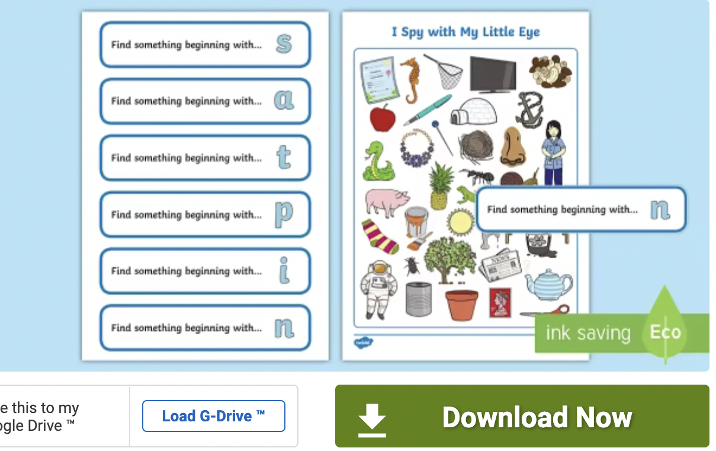  Name Play - Call out a child’s name and make up a fun sentence starting with the name (e.g. Ben has a big, bouncy ball, Kulvinder keeps kippers in the kitchen, Tim has ten, tickly toes, Fiona found a fine, fat frog). Ask the children to think up similar sentences for their own names to share with others.  Mirror Play 2 - This could relate to finding a magic mirror and the children talking about Snow White, some cheap mirrors could be bought and the children could bedazzle them… Otherwise, provide a mirror for each child or one large enough for the group to gather in front of. Play at making faces and copying movements of the lips and tongue. Introduce sound making in the mirror and discuss the way lips move, for example, when sounding out ‘p’ and ‘b’, the way that tongues poke out for ‘th’, the way teeth and lips touch for ‘f’ and the way lips shape the sounds ‘sh’ and ‘m’. You could also talk about the way professional singers warm up with facial movements.  Silly Soup - Provide the children with a selection of items with names that begin with the same sound. Show them how you can make some ‘silly soup’ by putting ‘ingredients’ (e.g. a banana, bumble bee and bug) into a pan in the role-play area. Allow the children to play and concoct their own recipes. Play alongside them without influencing their choices. Commentate and congratulate the children on their silly recipes. Recite each child’s list of chosen ingredients. Make the pattern clear by emphasising the initial sound. By observing mouth movements draw the children’s attention to the way we start each word and form sounds.
Wk4&5 | Phase 1 Aspect 7 Oral blending and segmenting  Tuning into sounds  Intent: To develop oral blending and segmenting of sounds in words.  Oral blending - It is important that the children have plenty of experience of listening to adults modelling oral blending before they are introduced to grapheme–phoneme correspondences. For example, when giving children instructions or asking questions the adult can segment the last word into separate phonemes and then immediately blend the sounds together to say the word (e.g. It’s time to get your c-oa-t, coat! or Touch your t-oe-s, toes! Who can touch their f-ee-t, feet?) Use only single-syllable words for oral blending. Oral blending can also be modelled from time to time when books are being shared, particularly rhyming books where the last word in a rhyming couplet could be segmented into separate sounds and then blended by the adult. | Implementation:  Metal Mike does segmenting and blending - Create a picture of the robot and paste it onto the side of a large pan with a glass lid. Tell them it is metal Mike and he has a funny robot voice. Have ready a bag of pictures or objects (e.g. cat, dog, mug, sock) A child chooses an object from the bag and Metal mike segments/sounds the object out when you pop it in his pan tummy in a very robotic voice. You can then show the children how to be a robot with their arms and sound out the object again.  Blend a story - Twinkl - 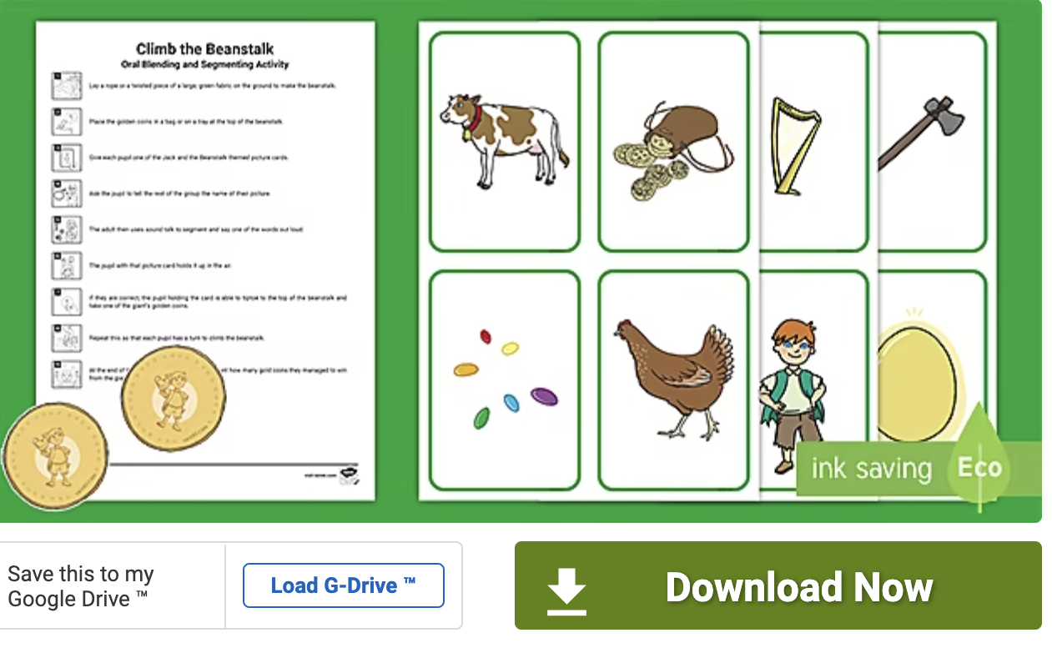  Toy Talk - Introduce to the children a soft toy that can only speak in ‘sound-talk’. The children see the toy whispering in the adult’s ear. To add to the activity, as the toy whispers the adult repeats the sounds, looks puzzled and then says the word straight afterwards. For example: What would Charlie like for tea today? The toy speaks silently in the adult’s ear and the adult repeats ‘ch-ee-se’ looking puzzled and then, says with relief ‘cheese!’ Now invite the children to see if they can speak like the toy: Do you think you could try to toy talk? Say ch-ee-se: (the children repeat ‘ch-ee-se’). Ask the toy again What else would you like? Be careful to think of items with names of only single syllables (e.g. fish, cake, pie, soup). Use different scenarios: What does the toy like to do in the playground? (Hop, skip, jump, run, etc.). As the children become more confident, make some errors – blend ‘skim’ for ‘skip’, for example, and ask them to catch you out by giving the correct blend. Encourage the children to ask the toy questions with yes/no answers (e.g. Can you sing? Y-e-s/N-o). Or ask the toy the colour of his bike, his bedroom walls, his jumper, etc. and the toy will answer r-e-d, b-l-ue, g-r-ee-n, m-au-ve.  Clapping sounds - Think of words using the letters ‘s, a, t, p, i, n’ (e.g. sat, pin, nip, pat, tap, pit, pip) and sound them out, clapping each phoneme with the children in unison, then blend the phonemes to make the whole word orally. As children’s confidence develops, ask individuals to demonstrate this activity to others.  Which one - Hang some pictures or real and familiar objects with names that contain three phonemes (e.g. leaf, sheep, soap, fish, sock, bus on a washing line. Check that all the children can recognise each object. Bring out the sound-talking toy and ask the children to listen carefully while it says the names of one of the objects in sound-talk so they can help it to put the sounds together and say the word. The toy then sound-talks the word, leaving a short gap between each sound. Encourage the children to say the word and identify the object. All the children can then repeat the sounds and blend them together – it is important that they do this and don’t simply listen to the adult doing so.  Cross the river - Choose a selection of objects with two or three phonemes as above. There can be more than one of the same object. Make a river across the floor or ground outside with chalk or ropes. Give each child or pair of children an object and check that all the children know the names of the objects. The toy calls out the name of an object in sound-talk (e.g. p-e-g). The children who have that object blend the sounds to make the word and cross the river.  I spy - Place on the floor or on a table a selection of objects with names containing two or three phonemes (e.g. zip, hat, comb, cup, chain, boat, tap, ball). Check that all the children know the names of the objects. The toy says I spy with my little eye a z-i-p. Then invite a child to say the name of the object and hold it up. All the children can then say the individual phonemes and blend them together ‘z-i-p, zip’. When the children have become familiar with this game use objects with names that start with the same initial phoneme (e.g. cat, cap, cup, cot, comb, kite). This will really encourage the children to listen and then blend right through the word, rather than relying on the initial sound.  Silly soup segmenting - With objects already in and we are taking them out socks fox, fan man, hat cat to segment, blend and match  Seggy rhyme - Let the children know it is time for phonics and ask what they have been learning recently. Ask them if they remember any words that they can segment. Get a pig, wig, fig and a zip on a plate under a bowl. Reveal the plate and ask the children what they see. They may not know the names for fig and wig so explain what these are. They may or may not identify the zip as the odd one out and you can go on to segment the items together and finally point out that three rhyme but one is the odd one out.  Basket guess - Get three fancy baskets with lids or boxes and let the child know that there are words inside waiting to be segmented. Their matching partner that also rhymes is waiting to meet their friend. Hen pen, cog dog bat and a hat. Choose one of the rhyming partners to go in the basket and the other one to wait in a random line up. Child chooses one of the baskets to take out an object. Everyone segments and the child matches it.
Wk6 | Phase 1 Aspect 7 Oral blending and segmenting Listening and remembering sounds  Intent: To listen to phonemes within words and to remember them in the order in which they occur. | Implementation:  Segmenting - Invite a small group of children to come and talk to the toy in sound-talk, for example just before dinner time: Let’s tell the toy what we eat our dinner with. Discuss with the children and agree that we use a knife and fork. Then tell the toy in sound-talk which the children repeat. Continue with: Let’s tell the toy what we drink out of. Confer and agree on ‘cup’. Repeat in sound-talk for the toy to listen and then invite the children to do the same.  Ask the children to think of other scenarios in which they could tell the toy or let them give him instructions. Then model the sound-talk for the children to repeat. This is teaching the children to segment words into their separate sounds or phonemes and is the reverse of blending. The children will soon begin to start the segmenting themselves.  Leave the sound-talk toy freely available to the children for them to practise and experiment with sound-talk. On special occasions, weekends or holidays, the toy may go on adventures or go to stay at the children’s homes. When he returns, he will have lots to tell the children about his escapades – in sound-talk.  Say the sounds - When the children are used to hearing the toy say words in sound-talk and blending the individual sounds to make words, you may be able to ask some children to see whether they can speak in sound-talk. Choose some objects with three-phoneme names that you are sure the children know and hide them in a box or bag. Allow one of the children to see an object, and then ask them to try to say the separate sounds in the name of the object, just like the toy does (e.g. d-u-ck). The other children then blend the sounds together to make the word. The child can then reveal the object to show whether the other children are right.  Swampy soup - Phonics teddy has made a bowl of swampy segmenting soup. The children can use a sieve to take out the items to segment and blend together.  Target practise - Have a few bins/buckets or hoops with a picture of CVC a/e/i/o/u words on them the children choose the bucket, segment and blend the picture on it and throw the bean bag in.  Teach your parent - Your parents might not know how to segment and blend using robot talk. Can you think of a word you know how to segment that you could show them? Write a pretend note to remind yourself.
Wk7 + | Phase 1 Aspect 7 Oral blending and segmenting Talking about sounds  Intent: To talk about the different phonemes that make up words.  Review and recap after assessing gaps.  Personal view! Go over Segmenting and blending and initial sounds, rhyming and alliteration, learning actions for Jolly phonics letters and looking at phoneme grapheme correspondence for anyone showing keen interest. (Kids love Mr Thorne does phonics with Geraldine Giraffe)  Also - not sure if this has to be the whole class every time or in small groups or differentiated groups at phase 1 level so seek expert advice about that one! | Implementation:  When children are used to oral blending and can readily blend two and three phonemes to make words, introduce the idea of counting how many phonemes they can hear. For example: p-i-g, pig. If we say the phonemes in that word one by one, how many phonemes can we hear? Let’s use our fingers to help us: p-i-g, one, two, three phonemes.

