St Bede’s Catholic Primary School

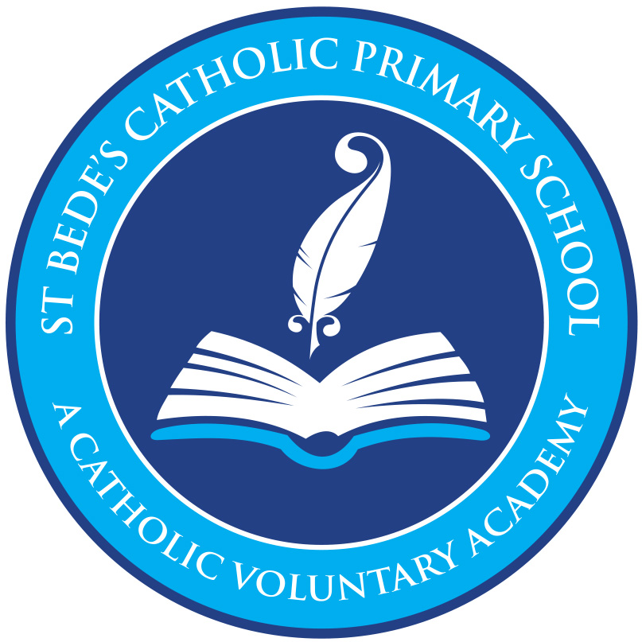
EYFS Policy & Philosophy

Intent
At St Bede’s Catholic Primary School, we believe in providing a secure foundation for future learning and development for our children. Our EYFS curriculum allows children to develop interpersonal skills, build resilience and become creative thinkers. We aim to provide a fun, secure, challenging and rich educational environment that enables each individual to thrive!

We place a strong emphasis on the religious, spiritual, moral and cultural development of all our pupils and learning at St Bede’s is Values-based. We have six School Values; WELCOME – We welcome everyone into our school family through our kind words and caring actions, LOVE – We let the love of God shine in everything we do, INSPIRE – We inspire each other to achieve our very best, RESPECT – We respect each unique member of our family, PATIENCE – We show patience and tolerance towards each other, COMMUNITY – We work together to serve our community with love.

Our values shape how we behave, what we say, how we build relationships and how we learn. They are incorporated in every aspect of life at St Bede’s. Every child is recognised as a unique individual. We celebrate and welcome the differences within our school community

At St Bede’s we intend for all our children to acquire the knowledge, skills and understanding to be effective, inquisitive and independent learners. The principles and purpose of our curriculum are driven by developing the following:
A love for learning
A sense of self
Awe and Wonder
Aspiration and Achievement
and Entitlement and Enrichment

Our hope is that all our children believe in their own abilities, which will allow them to develop resilience along with becoming successful in their own school journey and beyond.
In order to facilitate this, children in EYFS will have experience of the seven areas of learning. The areas are managed and delivered through balanced whole class/group teaching and play based learning.
We intend our EYFS curriculum to be ambitious, endeavouring to give our children the best start in life. We are passionate at St Bede’s about creating opportunities for children to express themselves and to thrive through developing their language and communication skills at a very early age. We place a great emphasis on the development of children as individuals which will prepare them for the challenges beyond the EYFS curriculum. In doing this we build strong foundations rooted in academic success, encompassing the children’s wellbeing along with their spiritual and moral development, whilst also ensuring that they are happy and curious life-long learners.

At St Bede’s, all teaching staff deliver an EYFS curriculum through immersion in high quality teaching alongside an enriched environment.
Our philosophy is to nurture every child’s curiosity and enthusiasm for learning, developing both skills and confidence as they take their first steps on their own unique journey of lifelong learning.

“The education of even a very small child does not aim at preparing him for school but for life”
Maria Montessori, 1967
The intent for our children is to enter the next stage of their education ready to tackle new challenges with confidence and a positive mindset.
Through our planning and philosophy we:
ENGAGE our pupils in a stimulating environment led by the children yet carefully organised and managed by adults. Providing a curriculum responsive to individual starting points and needs.
DEVELOP high levels of engagement, curiosity, collaboration and cooperation. Highly adept at managing their own behaviour in the classroom and in social situations.
INNOVATE our children to take the lead in their own learning, encouraging confidence to explore new ideas, think about problems, take risks, make links and seek challenge.
EXPRESS themselves with confidence in a meaningful way. Respecting the opinions and values of themselves and others.

Implementation
Our approach is influenced by the work of themed educationalists, researchers, psychologists and practitioners who have guided our knowledge of how young children learn and how adults can support their learning. “Knowledgeable practitioners appreciate that adult-led learning offers a child something different from, but complementary to, child led learning and it is one without the other that leads to an impoverished educational experience.” Fisher, 2016. At St Bede’s provision is underpinned by a complementary relationship between adult led, adult-initiated and child led learning. We are ambitious in our approach using a continuous cycle of observation and assessment, planning/teaching, alongside structured and systematic lessons and guided group work.
The St Bede’s EYFS curriculum is designed to develop the characteristics of effective learning:
● Creating and thinking critically – children have and develop their own ideas, make links between ideas, and develop strategies for doing things.
● Active learning – children keep on trying if they encounter difficulties, and enjoy their achievements.
● Playing and exploring – children investigate and experience things, and ‘have a go’.

We use a Growth Mindset approach to promote positive attitudes to learning which reflect the values and skills needed to promote responsibility for learning and future success.

Community involvement is an essential part of our curriculum as we celebrate local traditions, learning new skills to enable the children to take an active role in events throughout the year.

The EYFS framework includes 7 areas of learning and development that are equally important and inter-connected. However, 3 areas known as the prime areas are seen as particularly important for igniting curiosity and enthusiasm for learning, and for building children’s capacity to learn.

The St Bede’s EYFS Curriculum engages all children and ensures that all children make good progress from their starting points. A number of key resources are used to support the development of the curriculum including Development Matters, The Cornerstones Maestro Curriculum, White Rose Maths, Little Wandle Letters and Sounds, Come and See, ‘The Way, The Truth, The Life’ and Talk Boost.

Where possible the children’s own interests are used by the adults to engage the children in higher level thinking and deeper learning. Child initiated learning is valued and encouraged. Each area of learning and development is implemented through planned, purposeful play, and through a mix of adult- led and child-initiated activities. At St Bede’s Primary School, we believe that the whole curriculum can be covered in a well-planned outdoor environment, and that there is some learning that can only take place outdoors. The children have the right to the outdoor environment all the year round and access to the area is available daily throughout the session with constant adult supervision and interaction.

Our EYFS curriculum recognises prior knowledge by providing first hand learning experiences along with having a child-centred approach.
At St Bede’s, we ensure that we are aware of each child’s individual interests in order to support their learning.
Each area is planned to ensure that there is a broad, balanced and progressive learning environment and curriculum.
Planning is flexible allowing children to use and to develop their skills.
Children develop their independence along with their enquiry and problem-solving skills through working independently and collaboratively with their friends and members of staff.
Observations and discussions allow staff to identify next steps to ensure that progress is evident.
Stimulating environments both inside and outside of the classroom provide engaging activities which children can access independently.

At St Bede’s we use all environments to ensure each child’s needs are met through continuous and enhanced provision and each child’s interests.
“Young children learn from those they trust and with those who foster enthusiasm for learning.”
Trevarthen, 2002
Linked provision
Each day begins with an opening short session of linked provision. This session is activity based, active and fun.
“provision that you link to a need that had been identified by observation or assessment. Everyone is engaged in activities that are around the identified need. The same activities are repeated every day for a week and the children get to experience and repeat all of them.” Alistair Bryce Clegg, 2013
See below - the structure of a typical day
(this changes throughout the year, dependent upon the children’s’ needs)
Morning | Organisation
 | Welcome at the door
Linked provision (based upon children’s next steps)

Welcome & Register
 | Shared reading (phonics focus)
Adult led groups

Literacy Input (class read- reading/writing development)
 | Continuous Provision balance of focussed, child initiated and independent within indoor and outdoor environment. May also include adult led, small group activities.
 | Phonics & Shared Story Time
 | Lunchtime
Afternoon | Organisation
 | Maths Input
 | Continuous Provision - balance of focussed, child initiated and independent within indoor and outdoor environment. May also include adult led, small group activities.
 | Tidy Up
 | Shared Storytime/ song focus/ PSHE/ Celebration of Independent Learning
 | Home time

Shared Input
Depending on the age of the children, their needs and the time of year, shared input takes place two to three times a day as a whole class covering the specific areas of literacy, math’s and phonics objectives. Using the New EYFS Framework, White Rose Maths and curriculum documents ‘Development Matters’ 2021 alongside ‘Little Wandle Letters and Sounds’.

Adult led focused groups
As the year progresses, short focused groups are planned for writing, reading and maths in Reception and immediately follow a shared input. These sessions are planned with care, meeting the needs of all children, using prior knowledge of the child’s learning experiences and guidance from the EYFS document ‘Development Matters’, 2021.

Continuous Provision
Indoors and outdoors resources are organised to develop children’s skills in personal interaction and exploration and are linked to current assessment data. Resources are carefully selected to meet the development needs of the children in order to enhance potential for new learning and consolidate prior learning. Resources are dressed/displayed to reflect children’s interests – discover, experiment and explore are key themes.
“To continue the provision for learning in the absence of an adult.”
Alistair Bryce-Clegg, 2013
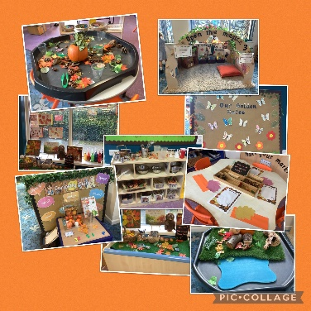
Continuous provision transcends all areas of learning and provides children with the opportunity to demonstrate the three characteristics of effective learning. Children are given the freedom to make independent choices and are encouraged to be active learners and take control of their own learning.

Assessment
“High-level attainment comes from high-level engagement.”
Alistair Bryce-Clegg, 2015

Within continuous provision our assessment strategy is 3-fold.

- Observation
Throughout ‘continuous provision’ observation forms a fundamental aspect of the pedagogy of EYFS at St Bede’s Primary School.

“Young children demonstrate language, mathematics, science, creativity, physicality – sometimes all within one activity – and the task of the practitioner is to make sense of what is seen, to recognise any significant steps in learning that may have taken place and to identify where help and support are needed to make further progress”
Jan Dubiel, 2014

Observation and responding to children’s thinking inform our planning of experiences and opportunities, how we create our environment for thinking, the strategies the adults use to extend learning (modelling, scaffolding, questioning, discussion, shared sustained thinking) and how we capitalise knowledge of children’s interests to ensure high levels of engagement.
All adults record ‘Wow!’ moments – when a child does or says something that demonstrates progress or skill in a particular area.

- The Leuven scales
Alongside the use of observation as an assessment tool we also rely upon the pioneering work of Professor Ferre Laevers (1980s) to understand how focused and comfortable the children are in our setting.
The scales of well-being and involvement act as a measure of deep learning and of the effectiveness of the learning environment. This has an empowering impact on our planning and can help to develop the huge potential of the children.
The 5-point scale measures:
Well Being refers to feeling at ease, being spontaneous and free of emotional tensions and is crucial to good mental health. It is linked to self-confidence, a good degree of self-esteem and resilience.
Involvement refers to being intensely engaged in activities and is a necessary condition for deep level learning and development.

A continuous cycle of observation, assessment and planning is embedded throughout our EYFS provision.

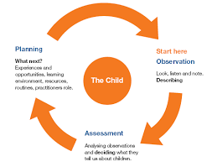

Summative Assessments
In addition to the continuous cycle of observation and formative assessment which informs each child’s next steps, summative assessments are carried out for phonic development, the stable order principle in number and an assessment of each child’s stage of development for each of the 7 areas of learning. These take place termly and informs planning of subsequent teaching and learning.
“One of the most powerful influences on development is what happens between people.” Hobson, 2002

The role of the adult
Interact, don’t interfere.

Research shows that progress will be significantly enhanced by the effective support and role models of adults within a high-quality learning environment.
At St Bede’s the role of the adult particularly during continuous provision is based upon the work of Marion Dowling and her book on supporting sustained shared thinking (2005).
Within our setting interactions between children and adults will look like this:
- Tuning in to what is happening or a child’s thinking.
- Showing genuine interest.
- Respecting children’s own decisions and choices.
- Inviting children to elaborate.
- Recapping on what has happened so far.
- Offering personal experience
- Clarifying ideas.
- Reminding.
- Using specific praise e.g. that is a good idea because…
- Offering an alternative viewpoint.
- Speculating/ using ‘I wonder if…’

The definition of teaching in the Early Years as stated by OFSTED (2015);
Teaching should not be taken to imply a ‘top down’ or formal way of working. It is a broad term which covers the many ways in which adults help young children learn. It includes their interactions with children during planned and child-initiated play and activities:
communicating and modelling language, showing, explaining, demonstrating, exploring ideas, encouraging, questioning, recalling, providing a narrative for what they are doing, facilitating and setting challenges.
It takes account of the equipment they provide and the attention to the physical environment as well as the structure and routines of the day that establish expectations. Integral to teaching is how practitioners assess what children know, understand and can do as well as take account of their interests and dispositions to learning (characteristics of effective learning), and use this information to plan children’s next steps in learning and monitor their progress.
“A key role of the early childhood educator is to sustain children’s thinking and follow the momentum of their learning.” Julie Fisher, 2016.

The role of the environment
The importance of each adult to support progression is crucial however, we equally understand that in times when a child is on their own independent learning journey the environment plays a significant role in development.
“When it comes to what we have and where we have it, then nothing should be left to chance” Alistair Bryce-Clegg, 2015.
At St Bede’s each area of the classroom is informed by assessment. As the needs of the children change, as they grow and develop, so does their learning space.
Using resources that are open ended encourage creativity, imagination and high order thinking skills. For example, the craft area may contain ribbon, lace, pinecones or lolly sticks. Outside role play is deconstructed with access to logs, planks, sheets and tyres. These resources can become anything and have unlimited potential.
Our timetable allows for long uninterrupted periods of continuous provision that allow the children time to reach a deep level of involvement as they engage, play, investigate and talk.

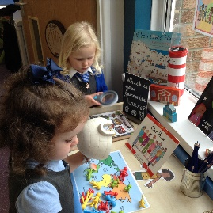
Early Years Curriculum
At St Bede’s we follow the new EYFS framework (2021). Within this framework there are four guiding principles which shape are practice.
These are:
- Every child is a unique child, who is constantly learning and can be resilient, capable, confident, and self-assured.
- Children learn to be strong and independent through positive relationships.
- Children learn and develop well in enabling environments with teaching and support from adults, who respond to their individual interests and needs and help them to build their learning over time. Children benefit from a strong partnership between practitioners and parents and/or carers.
- Children develop and learn at different rates. The framework covers the education and care of all children in early years provision, including children with special educational needs and disabilities (SEND).

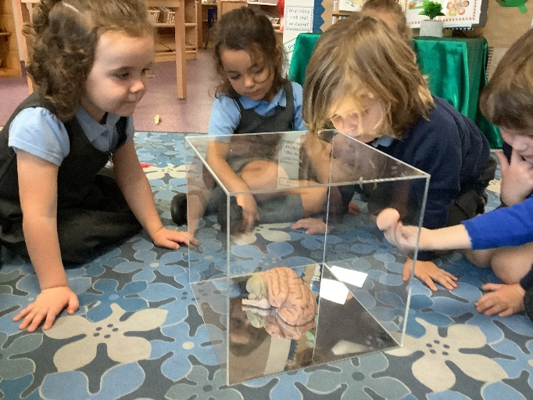
‘the best learning machines in the universe’
Alison Gopnik

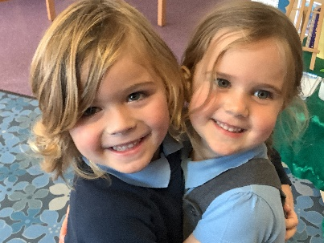
EYFS learning and development requirements
In EYFS we strive to provide an exciting and engaging curriculum that inspires awe and wonder and a love of learning in all of our children, providing them with rich and memorable experiences which prepare them for their next stage of learning when they reach Year 1. There, they will have their skills built upon and progression made in a variety of new subjects. Therefore, the role of EYFS is imperative as it underpins all learning and lays the foundations to children’s skills and development in order for them to progress and achieve their maximum potential. We support each child in working towards year one readiness at the end of Reception through deliberately planning opportunities within direct teaching and purposeful provision alongside providing opportunities for children to follow their own interests and initiate their own learning.
Our tailor made EYFS curriculum is based on the Statutory Framework for the EYFS (2021) and is flexible in content and theme depending on our children’s needs and interests. The non-statutory guidance from Development Matters document is also used to support the implementation of the requirements of the EYFS. Our curriculum has also been developed in line with the rest of the school. This ensures that learning over time is sequenced effectively and there is progression; within the EYFS and then on into Year 1.
Our curriculum encompasses seven areas of learning and development. All areas of learning and development are important and inter-connected.
Three areas are particularly important for building a foundation for igniting children’s curiosity and enthusiasm for learning, forming relationships, and thriving.
These are called the prime areas:
• communication and language
• physical development
• personal, social, and emotional development.
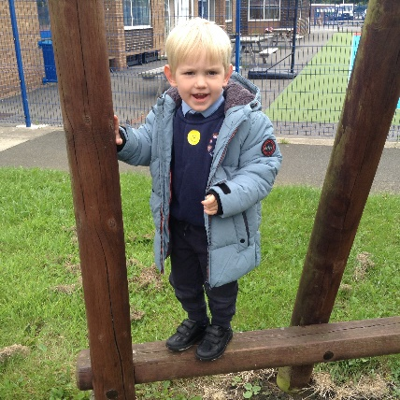

Four areas help children to strengthen and apply the prime areas.
These are called the specific areas:
• literacy
• mathematics understanding the world
• expressive arts and design
Throughout their time in the EYFS, our children partake in an ambitious curriculum which is designed in a sequential way to ensure progress towards the end of reception goals. These goals are defined as Early Learning Goals (ELGs).
As previously outlined our curriculum incorporates learning through play, learning by adults modelling, by observing each other and through guided learning and direct teaching. It is also important to highlight that our plans are flexible to allow us to respond quickly to children’s new interests and/or needs.
Weaving throughout the EYFS curriculum at St Bede’s are three Characteristics of Effective Learning.
- playing and exploring - children investigate and experience things, and ‘have a go’
- active learning - children concentrate and keep on trying if they encounter difficulties, and enjoy achievements
- creating and thinking critically - children have and develop their own ideas, make links between ideas, and develop strategies for doing things
These elements underpin how we reflect on each child’s development and adjust our practice accordingly. Supporting children in their individual learning behaviour and observing the context of children’s play is essential.
‘What children learn is important, but how children learn is even more important if they are to become learners in today’s society.’
Helen Moylett
How Children Learn, Nancy Stewart (2011)
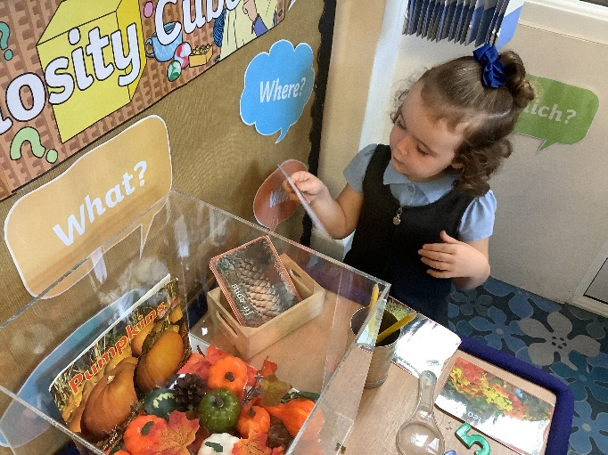

Personal, Social and Emotional Development
At St Bede’s we recognise that Children’s personal, social and emotional development (PSED) is crucial for children to lead healthy and happy lives, and is fundamental to their cognitive development. Underpinning their personal development are the important attachments that shape their social world. Strong, warm and supportive relationships with adults enable children to learn how to understand their own feelings and those of others. Children at St Bede’s are supported to manage emotions, develop a positive sense of self, set themselves simple goals, have confidence in their own abilities, to persist and wait for what they want and direct attention as necessary. Through adult modelling and guidance, children learn how to look after their bodies, including healthy eating, and managing their personal needs independently. Through supported interaction with other children they learn how to make good friendships, co-operate and resolve conflicts peaceably. These attributes will provide a secure platform from which children can achieve at school and in later life.
At St Bede’s we follow the Jigsaw whole school approach to support the teaching of PSED.

Physical Development
At St Bede’s we recognise that physical activity is vital in children’s all-round development, enabling them to pursue happy, healthy and active lives. Gross and fine motor experiences develop incrementally throughout early childhood, starting with sensory explorations and the development of a child’s strength, co-ordination and positional awareness. We use Squiggle Whilst You Wiggle, and Dough Gym activities where appropriate across the EYFS to develop gross and fine motor movements. By creating games and providing opportunities for play both indoors and outdoors, adults can support children to develop their core strength, stability, balance, spatial awareness, co-ordination and agility. Gross motor skills provide the foundation for developing healthy bodies and social and emotional well-being. Fine motor control and precision helps with hand-eye co-ordination which is later linked to early literacy. Repeated and varied opportunities to explore and play with small world activities, puzzles, arts and crafts and the practice of using small tools, with feedback and support from adults, allow our pupils to develop proficiency, control and confidence.
At St Bede’s we follow PE Passport program to deliver outstanding PE lessons.

Literacy
At St Bede’s we believe that it is crucial for children to develop a life-long love of reading. We understand that reading consists of two dimensions: language comprehension and word reading. To develop language comprehension (necessary for both reading and writing) we regularly talk with children about the world around them and the books (stories and non-fiction) they read. We also enjoy rhymes, poems and songs together.
In Nursery children develop their phonological awareness through taking part in adult-led activities which promote listening skills. Through these activities’ pupils develop their auditory discrimination, and auditory memory. Activities to progress children’s phonological awareness and interest in sounds are embedded prior to the introduction of systematic phonics teaching in Reception. Phase 1 of Letters and Sounds is used alongside the Little Wandle Letters and Sounds Nursery guidance to support the teaching of phonological awareness.
Skilled word reading, taught in Reception, involves both the speedy working out of the pronunciation of unfamiliar printed words (decoding) and the speedy recognition of familiar printed words. Writing involves transcription (spelling and handwriting) and composition (articulating ideas and structuring them in speech, before writing). At St Bede’s we follow the Little Wandle Letters and Sounds phonics program to provide an explicit systematic approach to teaching children how to read and write.

Reading at St Bede’s
Reading and oracy is at the heart of our curriculum. Phonics is taught on a daily basis. The children’s reading books reflect the phonics stage that they are at. Children are encouraged to read aloud each day and to identify letters/signs in their learning environments. Displays and role play areas are language and number rich to invite each child to work with their peers to include reading during their independent play. Our inclusive approach means that all children learn, play and progress together.

Phonics
Systematic synthetic phonics is taught using the document ‘Little Wandl Letters and Sounds’ (2021). Whole class or small group teaching takes place daily. Phase 1 is taught continuously throughout EYFS and is the main focus throughout the children’s time in Nursery. In Phase 1 phonics, children are taught about:
• Environmental sounds
• Instrumental sounds
Body percussion (e.g. clapping and stamping)
• Rhythm and rhyme
• Alliteration
• Voice sounds
• Oral blending and segmenting (e.g. hearing that d-o-g makes ‘dog’)
Typical activities for teaching Phase 1 phonics include 'listening' walks, playing and identifying instruments, action songs, learning rhymes and playing games like I Spy. This phase is intended to develop children’s listening, vocabulary and speaking skills.
Phase 2 begins at the end of Nursery and when all pupils start in Reception. Pupils move through Phase 2 and 3 throughout the year and where ready they begin phase 4. Every phonics lesson incorporates the reading and writing of common exception and high frequency words (where appropriate)

Revisit | Teach | Practice | Apply
In this stage of the lesson children are asked to participate in an activity that allows children to recall something previously taught. | New learning takes place- not necessarily a new phoneme/grapheme | Activities in this part of the lesson enable children to practise their new learning | The children as individuals use this part of the lesson to use new skills independently. If this stage is based on the new learning in Teach, it will need to be revisited before making any summative judgements.
Key word spellings  Previously taught phonemes/graphemes (should link with Teach planning)  Games & songs | Key word spelling  New grapheme/phoneme  New rule for previously taught phoneme/graphemClass investigations  Teacher modelling  Use of Alphabetic Code Card | Handwriting  Spelling/Independent work  Blending/Reading together as a group  Teacher modelling  Class investigations  Use of Alphabetic Code Card | Class read  Games  Dictation  Individual  Key word spelling in independent writing  Independent use of Alphabetic Code Card
Each part of the lesson should be linked and made as specific as possible (specific phoneme/grapheme/ key word etc).
Phonics lesson structure

Throughout their time in the EYFS children are taught how to segment words into syllables and then how to segment and blend each syllable using actions.
Formative assessment takes place during all phonics lessons, quickly identifying who has and has not understood a new phoneme or grapheme or common exception word, informing future planning. Summative assessment takes place half-termly. Knowledge of each sound is checked, as well as the child being able to apply this when reading words. Pupils who are making slow progress are identified quickly and intervention is immediately put into place, alongside the usual phonics teaching.
Each phonics session is 15-20 minutes in duration and follows a teaching sequence which is implemented throughout the school ensuring transition to Key Stage 1 is seamless.

Shared exploration of language
Communication and Language
“it is through others that we develop into ourselves”
Lev Vygotsky, 1981
At St Bede’s we understand that the development of children’s spoken language underpins all seven areas of learning and development. For this reason, at St Bede’s we prioritise the development of communication and language. Children’s back-and-forth interactions from an early age form the foundations for language and cognitive development. The number and quality of the conversations they have with adults and peers throughout the day in a language-rich environment is crucial. By commenting on what children are interested in or doing, and echoing back what they say with new vocabulary added, practitioners are able to build children’s language effectively. Reading frequently to children, and engaging them actively in stories, non-fiction, rhymes and poems, and then providing them with extensive opportunities to use and embed new words in a range of contexts, gives children the opportunity to thrive. Through conversation, story-telling and role play, where children share their ideas with support and modelling from staff, and sensitive questioning that invites them to elaborate, children become comfortable using a rich range of vocabulary and language structures.
At St Bede’s, we believe the key to success in reading is communication. Research clearly shows that the level of development in language and communication is the greatest predictor of success in later life.

Within the EYFS communication and language development is a prime area of learning.
At school children use language to:
• Build strong relationships.
• Communicate their ideas and their feelings.
• Think creatively and critically.
• As a tool for learning.
• Become confident with the written word.
(Julie Fisher, 2016)
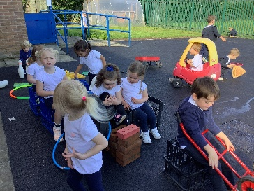
The development of a young child’s communication and language comes primarily from tuning in to conversations that are meaningful to the child.
The preparation for all aspects of written language develops through one to one conversation with a responsive adult.
Alongside quality interactions, rich and varied experiences ensure language provides the foundation of thinking and learning.
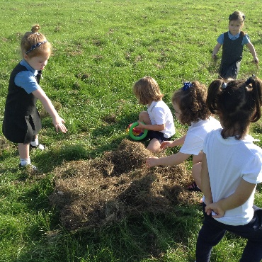
Improving young children’s vocabulary is paramount. Exploring and extending pupils’ vocabulary is part of everyday teaching. Lessons are planned to enrich vocabulary and incidental opportunities are exploited. Vocabulary is discussed with the intention of building background knowledge so pupils can comprehend the content of a text.
Our EYFS classroom has vocabulary displayed which is used, referred to and added to in partnership with the children. All staff discuss the etymology and morphology of words in reading sessions, and across the curriculum, to establish links to spelling.
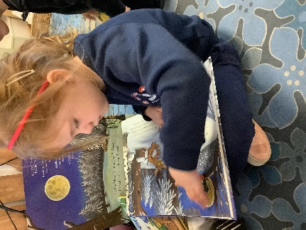
English as an additional language
At St Bede’s we understand that speaking more than one language has lots of advantages for children, and that children will learn English from a strong foundation in their home language. For this reason, we encourage families to use their home language for linguistic as well as cultural reasons. Children learning English will typically go through a quiet phase when they do not say very much and may then use words in both languages in the same sentence. EYFS staff communicate with parents about what language they speak at home, try and learn key words and celebrate multilingualism.
At St Bede’s we use the Talk Boost Intervention to asses and support the development of pupils’ speech, language and reciprocal communication across the EYFS.

Shared reading
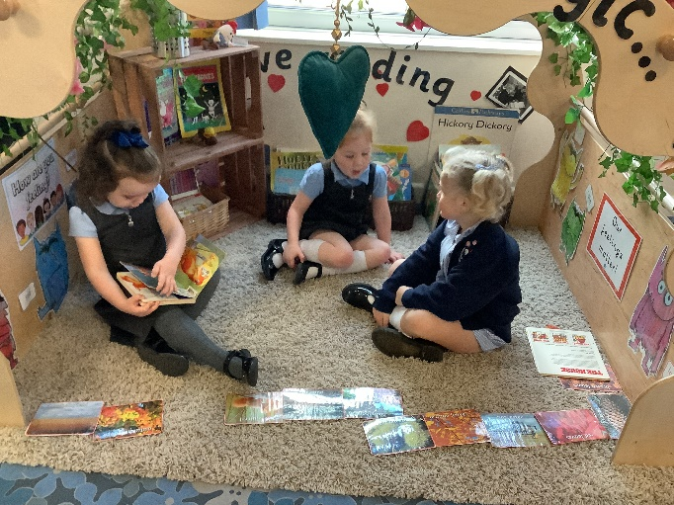

Texts are shared as a whole class daily. ‘Shared Reading’ is a recognised strategy for teaching reading in which pupils and teacher read a text together with a focus on a specific aspect. Through experiencing a variety of texts, fiction and nonfiction, children will become aware of the range of strategies required when reading for different purposes.
The million-word gap
Young children who are read five books a day by the age of 5 have heard about 1.4 million more words than children who were never read to.
Ohio State University, 2019
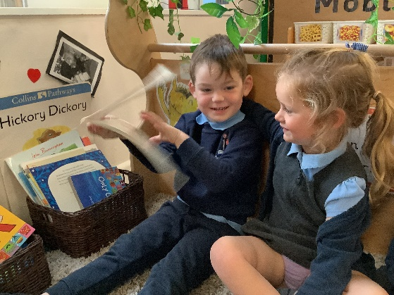
3 a day
In St Bede’s EYFS, children are read to at least 3 times a day at school in addition to books provided for home reading. We share books with children for many reasons: enjoying stories together, linking with personal experiences, vocabulary building, developing imagination and language, learning about books. Listening to stories being read and re read helps children to gain insights into meaning and story structure.

Guided reading
As the year progresses, short group reading sessions take place several times a week in Reception and texts are carefully chosen by staff to match the phonemes pupils are learning or about to learn.

Individual reading
Encouraging reading for pleasure is part of our school vision to create learners for life. All children have their own individual reading books; for all of our EY children- a book selected from our learning library and for older pupils and those who are ready; one phonetically decodable linked to their stage in phonics learning and one lending library book. Children select books from a wide range of genres including picture books, non-fiction information books and poetry. If needed, staff will guide pupils towards a suitable selection of a home reading book. Reading progress is monitored and class reading challenges are frequently set.

Writing at St Bede’s
Mark Making
At St Bede’s children mark make every day. Children are encouraged to develop a preference for a dominant hand and develop an appropriate grip. Our younger pupils take part in unstructured writing activities, such as drawing a picture of their choice. When children are ready to write they are encouraged to rehearse out loud what they want to say, before spelling the words using the graphemes and ‘tricky’ words they have learnt. Nursery pupils take part in ‘Dough Disco’ and ‘Squiggle Whilst You Wiggle’ activities to develop their fine and gross motor control for writing. Reception pupils practise handwriting every day during phonics lessons and learn correct letter formation. In the EYFS pupils write using print. Both the process and the product of children’s handwriting is monitored as we understand how these factors form the basis of a fluent handwriting style which is developed in KS1.

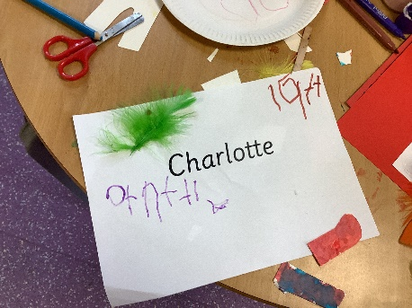
Mark making and speech provide children with powerful tools for thinking, reasoning and problem solving.
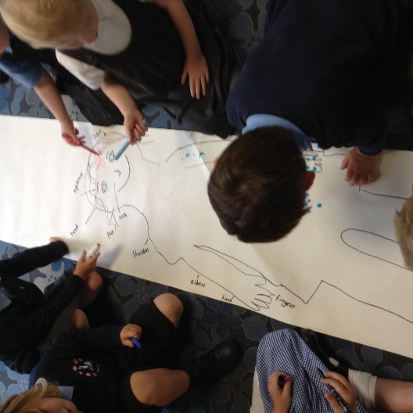
Time, space and attention is given to children’s mark making, mathematical graphics, drawing and writing experiences. Throughout each day, children have opportunities for spontaneous mark making, drawing and writing in both the indoor and outdoor environment. Resources are carefully chosen, well organised and attractively presented, so that the children can decide independently how they want to represent their ideas and which medium would best suit their purpose. High value is placed upon imagination, ideas and self-expression demonstrated by the children, these are reflected by the adults and used as starting points for planning.
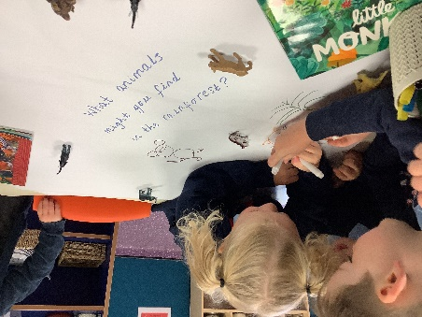

Story scribing – Continuous provision time
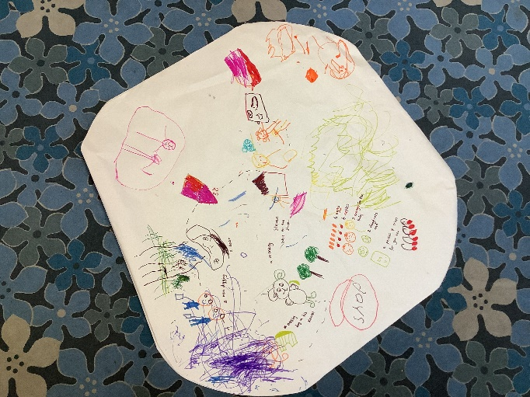
‘Storytelling is an intrinsically human thing to do.’ Haven, 2007

In every classroom there are ‘story tellers, picture makers and paper cutters, watching, listening and sounding forth’ (Paley, 1990) and capturing a child’s story idea is an essential part of becoming a writer.
Children have an innate desire to dictate a story and all adults are always on hand to listen and record their ideas. Inspired by the work of Vivian Gussin Paley children are encouraged to act out their stories during shared carpet times. Each story is valued and precious.
In Nursery, we encourage children to see themselves as independent story tellers. Language and communication and imagination is fostered, modelled and celebrated. Children are encouraged to make up songs, stories and poems and an adult act as scribe. These are then shared with friends and peers during carpet time.
“squiggles are products of systematic investigation, rather than haphazard actions’
John Matthews, 1999
On entry to the Reception, children will often still require much support in recording their story ideas. Anna Ephgrave (2011) details the process of story scribing as follows:
1. Adults are dictated to by the child, the adult says each word as it is written, pointing out gaps and punctuation. Re-reading and scanning and checking writing.
2. The children realise groups of letters make up a word and a group of words make sentences. The children then begin to write the initial sound of a word or a CVC word and the adult continues to write the other parts of the story.
3. Next more phonetically correct words are written by child along with common words, such as ‘the’.
4. Gradually children take the pen more and more, until eventually they are writing complete phrases.

Talk for writing – Shared writing time
A fun and creative approach developed by author, Pie Corbett to teach writing.
Talk for writing is split into 3 distinct learning parts. Starting with the ‘Imitate’ stage and the enjoyment of sharing stories. A pictorial story map is created, and the children learn to retell the story by heart using the story map, expression and actions for support. Next the children ‘Innovate’ the story, make it their own e.g. changing the character or the setting. Finally, the children re-write the story in the ‘Invention’ stage writing their own version independently.

Handwriting
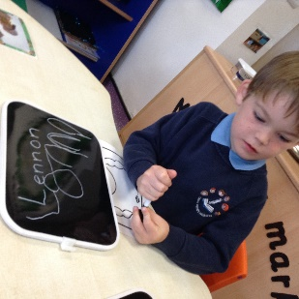
Handwriting development in our EYFS includes a wide variety of activities planned to develop the fine motor skills required for the correct pencil grip. ‘Funky Finger’ activities may include threading, using tweezers, dough gym, spiders in jelly, cardboard weaving. The list is endless!
As pupils fine motor control develops we practise correct letter formation through squiggle whilst you wiggle, air writing and use of wipe boards and pens with adults modelling and using rhymes to support learning.

Maths at St Bede’s
Our approach to Maths has been driven by ensuring the curriculum is fulfilled and by research from the NCETM and the White Rose Maths Hub. We endeavour to make our maths teaching dynamic and exciting, linked to problem solving and the application of knowledge, skills and understanding to a wide range of contexts and across all subjects.

We want all pupils to enjoy learning and exploring mathematics, and become confident mathematicians, through a carefully structured mastery approach to the subject.

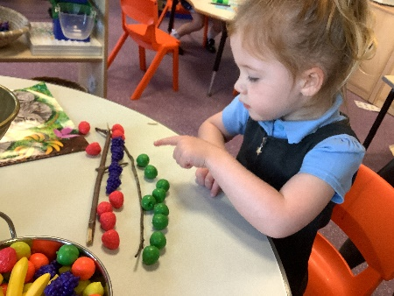

At St Bede’s we understand that developing a strong grounding in number is essential so that all children develop the necessary building blocks to excel mathematically.
Our children are taught to count confidently. Pre-number work is covered in Nursery through nursery rhymes and stories, social counting and using numbers in play. Children develop an understanding of how-to-count using the following principles;
- The one-one principle
- The stable-order principle
- The cardinal principle
Once children have developed their understanding of how to count, they can develop their understanding of ‘what to count’ using the following principles;
- The abstraction principle
- The order irrelevance principle
Children in Reception then move on to develop a deep understanding of the numbers to 10 and beyond, the relationships between the numbers and the patterns within those numbers. For each number, pupils explore comparison, counting, composition and change. Children are provided with regular opportunities to revisit key mathematical concepts through the EYFS to embed learning.
By providing frequent and varied opportunities to build and apply this understanding, such as using manipulatives, children develop a secure base of knowledge and vocabulary from which mastery of mathematics is built.
Manipulatives used in EYFS;
- Numicon
- Counters
- Counting objects such as compare bears
- Multi-link/ Unifix cubes
- 10 frames
- Part- part- whole models
- Dice
- Real life objects
Our curriculum includes rich opportunities for children to develop their spatial reasoning skills across all areas of mathematics including shape, space and measures. We believe that is important that children develop positive attitudes and interests in mathematics, look for patterns and relationships, spot connections, ‘have a go’, talk to adults and peers about what they notice and not be afraid to make mistakes.
At St Bede’s children take part in daily structured maths group times. When teaching maths in the EYFS we use a ‘teaching to the top’ strategy and therefore pupils do not work in set ability groups. Lower ability pupils are supported by teaching staff and higher ability pupils with the lesson. Higher ability pupils are challenged through the use of questioning, demonstrating and reasoning.
In reception, we have used Numberblocks and the National Centre for Excellence in the Teaching of Maths (NCTEM) alongside white rose maths supporting materials to plan and teach for mastery of maths.
Within each EYFS classroom there is an explicit Maths area which children can access independently during continuous provision. Resources within this area open ended and are frequently changed to tie in with children’s interests and reflect what pupils have been learning in the structured maths lessons. It is here where pupils will practise and apply the concepts which they have learnt during the structured maths lessons independently. This area also consists of resources to support previous learning, allowing pupils to revisit and recap previous mathematical learning. Maths is not however limited to this area of the classroom and is often discreetly embedded throughout other classroom areas such as sand and water play, play dough, role play, games and ICT. Staff encourage pupils to explore concepts, experiment and investigate to develop their mathematical understanding through play in a range of areas within the classroom.
High quality learning environments and meaningful interactions with adults, support children in developing mathematical thinking and discussion. Pupils learn through games and tasks using concrete manipulatives and pictorial structures and representations which are then rehearsed applied and recorded within their own child-led exploration. Children in Reception have daily, ‘Math’s Meeting’ to develop fluency, revisit key concepts and address misconceptions.
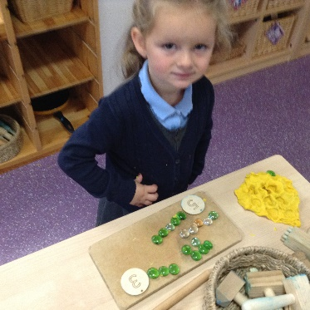

In Nursery, children develop a love of math’s through games, songs, rhymes, and play using concrete manipulatives. There is a focus on the following counting principles; one to one correspondence, stable order and cardinal principle. Children’s fine manipulative skills are a focus to develop 1-1 correspondence so children count each object only once.
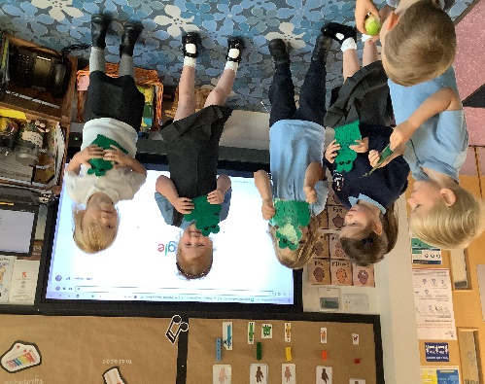
There’s more to maths than counting!
Children learn about maths through play and their daily experiences. And the more meaningful to them and hands on it is, the better.
Our setting is full of mathematical opportunities for children to explore, sort, compare, count, calculate and describe. Providing a safe environment to be creative, critical thinkers, problem solvers and to have a go.
Mathematics is identified as one of the specific areas of learning, alongside expressive arts and design, literacy, and understanding the world.
Our objective is to ensure that all children develop firm mathematical foundations in a way that is engaging, and appropriate for their age. This means actively learning using resources and activities provided in the environment.
In addition, maths is explicitly taught daily as short whole class sessions and followed up with small group work within the environment.

Concrete – Pictorial – Abstract
Mastery of mathematical concepts in the EYFS takes the following approach:
Concrete – children use concrete objects and manipulatives to help them understand what they are doing.
Pictorial – children build on this concrete approach by using pictorial representations. These representations can then be used to reason and solve problems.
Abstract – with the foundations firmly laid, children move to an abstract approach using numbers and key concepts with confidence.

Maths is everywhere!
Here are a few examples of how our environment promotes mathematical development:
• Sand & Water can develop mathematical concepts and language, e.g. heavy, light, empty, full, big, little.
• Malleable – dough can develop mathematical language – short, long, fat, thin. Children can make shapes of different dimensions – flat shapes, 3-d shapes.
• Imaginative play - set the table for dinner can develop counting skills. Sorting clothes into different colours, or different types of clothes, e.g. t-shirts and socks will develop knowledge of shapes and colours.
• Physical play can develop fine motor skills e.g. Sorting out a jigsaw, threading beads. Block play or playing with toy cars can help to develop sequencing according to size, colour. Playing with different sized blocks can help to develop an understanding of weight and dimensions. Tidying toys allows children to sort into different sizes and colours. It can also develop mathematical language – first, second, third, how many are blue, which is largest / smallest.
• Outdoors – Children may plant seeds this can develop understanding of time and the life cycle of plants. As the plants grow children use measures and develop mathematical language of size.
• Books & Rhymes - Enjoying stories and rhymes with a mathematical element, e.g. “One-two buckle my shoe” can develop number concepts, knowing direction that the print reads from left to right.

Parent Engagement
Parents are the first and most important influence on their child’s development and future outcomes.
Children have two main educators in their lives – their parents and their teachers. Therefore, the school and the parents all have crucial roles to play. The impact on a child’s education is greater if parents and schools work in partnership.
At St Bede’s, parents are invited to be involved in every step of a child’s journey in education. Beginning with a pre- starting school meeting, followed up with home visits and the invitation for their child to attend ‘transition’ sessions before the Autumn term commences.
We use an online learning journal, ‘Tapestry’ to record, track and celebrate progress made by each child.
Tapestry enhances this special time in a child’s life and captures children's experiences as well as monitors development and learning.
Parents are encouraged to use WOW certificates, notes, email images and videos to share learning and experiences from home – any form possible to help build a picture of their child as a whole and to celebrate the interests, talents and achievements.
Throughout the year families are invited to ‘Stay and Play’ and ‘stay and pray’ sessions in the EYFS classroom along with many whole school events e.g. parent café, art exhibitions, family fun nights, school fayre’s.
We pride ourselves on building positive relationships with the families of St Bede’s. Creating a ‘triangle of trust’ (Elfer et al.) between children, parents and practitioners. We understand that when parents relinquish part of the care and teaching of their child to the staff in our setting it is a big step.
We create an environment that is conducive to interactions where all feelings can be taken into account.
A warm welcome each day often leads to a deeper knowledge and understanding of each child and their family.
As stated earlier,
‘it is knowing the child and family that opens up endless possibilities for interactions that deepen the emotional bonds between a practitioner and a child, and lead, in turn, to educational opportunities to support and extend learning.’ (Fisher, 2016)

Impact
The most recent statistics show 76% of our children left the EYFS with a Good Level of Development (GLD). This is in line with the National expectation in the UK.
Children enter Key Stage One ready to begin the next chapter of the educational journey. They are equipped with a broad range of knowledge and skills that provide the right foundation for future progress through school and life.
In 2017, a ‘Study of Early Education and Development: Good Practice in Early Education’ was published which outlined 3 themes that underpin effective practice that are aligned with our ethos and development.
At St Bede’s we;
- Tailor practice to the needs of the children - the child is at the centre of our practice. We have a clear vision of what we want to achieve for the children in our care, and these clear goals inform all areas of our practice.
- Invest in skilled and experienced staff - that support children to reach their full potential.
- Operate an open and reflective culture – our culture is driven by continuous improvement. We seek out other settings and professionals to learn from, share and reflect practice. We recognise the knowledge and expertise of our own staff and value open discussion and staff consultation; and embedded within our school is a culture of self-evaluation as a means of driving continuous improvement.

Appendix

The Early Learning Goal Descriptors
Communication and Language
ELG: Listening, Attention and Understanding
- Listen attentively and respond to what they hear with relevant questions, comments and actions when being read to and during whole class discussions and small group interactions.
- Make comments about what they have heard and ask questions to clarify their understanding.
- Hold conversation when engaged in back-and-forth exchanges with their teacher and peers.
ELG: Speaking
- Participate in small group, class and one-to-one discussions, offering their own ideas, using recently introduced vocabulary.
- Offer explanations for why things might happen, making use of recently introduced vocabulary from stories, non-fiction, rhymes, and poems when appropriate.
-Express their ideas and feelings about their experiences using full sentences, including use of past, present and future tenses and making use of conjunctions, with modelling and support from their teacher.

Personal, Social and Emotional Development
ELG: Self-Regulation
- Show an understanding of their own feelings and those of others and begin to regulate their behaviour accordingly.
- Set and work towards simple goals, being able to wait for what they want and control their immediate impulses when appropriate.
- Give focused attention to what the teacher says, responding appropriately even when engaged in activity, and show an ability to follow instructions involving several ideas or actions.
ELG: Managing Self
- Be confident to try new activities and show independence, resilience, and perseverance in the face of challenge.
- Explain the reasons for rules, know right from wrong and try to behave accordingly.
- Manage their own basic hygiene and personal needs, including dressing, going to the toilet, and understanding the importance of healthy food choices.
ELG: Building Relationships
- Work and play cooperatively and take turns with others.
- Form positive attachments to adults and friendships with peers.
- Show sensitivity to their own and to others’ needs.

Physical Development
ELG: Gross Motor Skills
- Negotiate space and obstacles safely, with consideration for themselves and others.
- Demonstrate strength, balance and coordination when playing; Move energetically, such as running, jumping, dancing, hopping, skipping, and climbing.
ELG: Fine Motor Skills
Children at the expected level of development will:
- Hold a pencil effectively in preparation for fluent writing – using the tripod grip in almost all cases.
- Use a range of small tools, including scissors, paint brushes and cutlery.
- Begin to show accuracy and care when drawing.
Literacy
ELG: Comprehension
- Demonstrate understanding of what has been read to them by retelling stories and narratives using their own words and recently introduced vocabulary.
- Anticipate – where appropriate – key events in stories.
- Use and understand recently introduced vocabulary during discussions about stories, non-fiction, rhymes, and poems and during role-play.
ELG: Word Reading
- Say a sound for each letter in the alphabet and at least 10 digraphs.
- Read words consistent with their phonic knowledge by sound-blending.
- Read aloud simple sentences and books that are consistent with their phonic knowledge, including some common exception words.
ELG: Writing
- Write recognisable letters, most of which are correctly formed.
- Spell words by identifying sounds in them and representing the sounds with a letter or letters.
- Write simple phrases and sentences that can be read by others.

Mathematics
ELG: Number
- Have a deep understanding of number to 10, including the composition of each number.
- Subitise (recognise quantities without counting) up to 5.
- Automatically recall (without reference to rhymes, counting or other aids) number bonds up to 5 (including subtraction facts) and some number bonds to 10, including double facts.
ELG: Numerical Patterns
- Verbally count beyond 20, recognising the pattern of the counting system.
- Compare quantities up to 10 in different contexts, recognising when one quantity is greater than, less than or the same as the other quantity.
- Explore and represent patterns within numbers up to 10, including evens and odds, double facts and how quantities can be distributed equally.
Understanding the World
ELG: Past and Present
- Talk about the lives of the people around them and their roles in society.
- Know some similarities and differences between things in the past and now, drawing on their experiences and what has been read in class.
- Understand the past through settings, characters and events encountered in books read in class and storytelling.
ELG: People, Culture and Communities
- Describe their immediate environment using knowledge from observation, discussion, stories, non-fiction texts and maps.
- Know some similarities and differences between different religious and cultural communities in this country, drawing on their experiences and what has been read in class.
- Explain some similarities and differences between life in this country and life in other countries, drawing on knowledge from stories, non-fiction texts and –when appropriate – maps.
ELG: The Natural World
- Explore the natural world around them, making observations and drawing pictures of animals and plants.
- Know some similarities and differences between the natural world around them and contrasting environments, drawing on their experiences and what has been read in class.
- Understand some important processes and changes in the natural world around them, including the seasons and changing states of matter.
Expressive Arts and Design
ELG: Creating with Materials
- Safely use and explore a variety of materials, tools, and techniques, experimenting with colour, design, texture, form and function.
- Share their creations, explaining the process they have used.
- Make use of props and materials when role playing characters in narratives and stories.
ELG: Being Imaginative and Expressive
- Invent, adapt, and recount narratives and stories with peers and their teacher.
- Sing a range of well-known nursery rhymes and songs; Perform songs, rhymes, poems, and stories with others, and – when appropriate – try to move in time with music.

Glossary

Adult-led learning – the practitioner knows exactly what outcomes they want to achieve. They have planned with care, using prior knowledge of the child’s learning experiences and guidance from the EYFS document ‘Development Matters’, 2021.
Adult-initiated learning – the practitioner has a clear purpose for planning an activity or experience. Knowledge of the child or children, and of their previous learning, gives the practitioner evidence to plan either for consolidation of that learning, or to explore its next steps.
Child-led learning – situations that evolve independently, the practitioner approaches not knowing what it is that the child or children are trying to do or what scenario they have been creating. Often spontaneous and frequently unpredictable. In this situation, the practitioner must wait and watch before deciding whether and when to intervene.
Synthetic Phonics - is a way of teaching reading. Pupils are taught to read letters or groups of letters by saying the sound(s) they represent. Pupils can then start to read words by blending (synthesising) the sounds together to make a word

