WHY DO WE STUDY GEOGRAPHY?
At St Bede’s, we believe that Geography helps to provoke and answer questions about the natural and human worlds, encouraging pupils to develop a greater understanding of their world and their place in it. We seek to inspire in pupils a curiosity and fascination about the world and its people which will remain with them for the rest of their lives. We aim to promote pupils’ interest and understanding about diverse places, people, resources and natural and human environments, together with a deep understanding of the Earth’s key physical and human processes. Geographical knowledge, understanding and skills provide the frameworks and approaches that explain how the Earth’s features at different scales are shaped, interconnected and change over time
INTENT
Our intent, when teaching Geography, is to inspire in pupils a curiosity and fascination about the world and people within it. At St Bede’s Primary School, our Geography curriculum is designed to promote our school values whilst developing a love of learning, a sense of self, inspiration and achievement and awe and wonder.

Through our teaching at St Bede’s, we intend to provoke thought and questions and to encourage our pupils to discover answers to their own questions through exploration and research to enable them gain a greater understanding and knowledge of the world and their place in it.

The intention of our Geography curriculum is to inspire pupils’ curiosity and interest to explore the world that we live in and its people, which in turn will ignite a love of learning.

Our curriculum ensures clear knowledge and skills progression, and pupils growing knowledge about the world helps them to deepen their understanding of the interaction between physical process and of the formation and use of landscapes and environments.

Geographical knowledge, understanding and skills provide the framework and approaches that explain how the Earth’s features at different scales are shaped, interconnected and shaped over time.

Geography is mapped effectively across the school to ensure full coverage of the National Curriculum Programme of Study for Geography.

Understanding the World (EYFS Educational Programme)
Understanding the world involves guiding children to make sense of their physical world and their community. The frequency and range of children’s personal experiences increases their knowledge and sense of the world around them – from visiting parks, libraries and museums to meeting important members of society such as police officers, nurses and firefighters. In addition, listening to a broad selection of stories, non-fiction, rhymes and poems will foster their understanding of our culturally, socially, technologically and ecologically diverse world. As well as building important knowledge, this extends their familiarity with words that support understanding across domains. Enriching and widening children’s vocabulary will support later reading comprehension.
EYFS Pupils will:
Locational Knowledge
- Comment and ask questions about aspects of their familiar world such as the place where they live or the natural world
- Know that there are different countries in the world & talk about the differences they have experienced or seen in photos
- Observe, find out about and identify features in the place they live and in the natural world.
- Find out about their environment and talk about those features they like/dislike.
- Use appropriate words, e.g. ‘town’, ‘village’, ‘road’, ‘path’, ‘house’, ‘flat’, ’temple’ and ‘synagogue’, to help children make distinctions in their observations.
- Encourage children to express opinions on natural and built environments and give opportunities for them to hear different points of view on the quality of the environment.
- Recognise some environments that are different to the one in which they live

Place knowledge
- Talk about some of the things they have observed in different places
- Comments & asks questions about aspects of their familiar world such as the place where they live or the natural world
- Make imaginative & complex ‘small worlds’ with blocks & construction kits, such as a city with different buildings & a park
- Observe and identify features in the place they live and the natural world.
- Talk about features.
- Help children to find out about the environment by talking to people, examining photographs and simple maps and visiting local places.
- Encourage the use of words that help children to express opinions, e.g. ‘busy’, ‘quiet’ and ‘pollution’
- Recognise some similarities & differences between life in this country & life in other countries

Human and physical geography
- Help children to notice and discuss patterns around them, e.g. rubbings from grates, covers, or bricks.
- Identify seasonal patterns – focusing on plants and animals.
- Begin to understand the effect their behaviour can have on the environment
- Explore their local environment and talk about the changes they see.
- Talk about the similarities and differences between them and their friends and well as looking at photos of children and places around the world.
- Explain that human activity can influence and impact on the world, meaning that things happen as a result of our actions
- Understand the effect of changing seasons on the natural world around them

Geographical skills and fieldwork
- Observe and identify features in the place they live and the natural world.
- Find out about their environment and talk about features they like and dislike.
- Use diverse range of props, photos, books to notice & talk about similarities & differences
- Examine change over time.
- Pose carefully framed open-ended questions, such as “How can we...?” or “What would happen if...?”.
- Describe some actions which people in their own community do that help to maintain the area they live in.
- Draw information from a simple map
- Interpret range of sources of geographical information, including maps, globes, photographs

ELG – Know some similarities & differences between the natural world around them & contrasting environments, drawing on their experiences & what has been read in class
Understand some important processes and changes in the natural world around them, including the seasons
ESSENTIAL GEOGRAPHICAL VOCABULARY
Vocabulary is introduced, revisited and reinforced over time so that pupils become confident and articulate as they progress throughout the curriculum. As geographers our EYFS pupils will be exposed to a wide range of geographical vocabulary and will use basic geographical vocabulary to refer to key physical and human features including; Physical features: Beach, Forest, Hill, Mountain, Sea, Season, Weather.
Human features: City, Town, Village, Farm, House, Office, Shop

IMPLEMENTATION
Geography is taught at St Bede’s school through themed ‘learning projects’, specifically planned to deliver the essential knowledge, skills and understanding for each year group.
EYFS Learning Projects
Me and My Community | Exploring  Autumn | Once Upon a Time | Sparkle & Shine | Starry Night | Winter Wonderland | Dangerous Dinosaurs | Puddles and Rainbows | Sunshine & Sunflowers | Shadows & Reflections | Big Wide World | Splash

Key Aspects of Geography Curriculum: The following aspects and ideas are mapped across the Geography curriculum to ensure pupils develop a rich and deep subject knowledge. Clear links are made between different aspects of their learning and pupils will learn within a coherent and progressive framework that is a sequential progression of their knowledge, understanding and skills.
Place:  World, UK, Location, Maps, atlas, globe | Humankind:  Human features and landmarks | Investigation: Geographical resources, Data Analysis, Fieldwork | Materials: Natural and man-made materials | Change:  Seasonal Change  Change in weather | Nature:  Physical features, Environment. | Comparison:  Compare and Contrast | Processes:  Physical processes,  Climate and weather, | Significance:  Significant places in their own locality

ENRICHMENT OPPORTUNITIES | Further enrichment opportunities are provided to deepen the pupils’ understanding and the interaction between physical and human processes and how this affects landscapes and environments.
Trips /visits: | We provide on and off-site subject or topic related activities that allow pupils to use quality resources in and out of the classroom. | Outdoor Learning Week: | We hold specialist curriculum days or weeks and provide investigative and enquiry based learning opportunities through a focussed outdoor learning week
Environmental education/ eco issues/sustainability | Pupils are encouraged to:  - make a positive contribution to the school and local community  - explore ways of becoming an active citizen  - make choices about things that are important to them
Knowledge Rich Projects: | KRPs focus on developing children’s understanding of the world around them and make meaningful links with history and other subjects where appropriate to maximise pupils’ geographical or contextual understanding

IMPACT
Our Curriculum has been designed to deliver our principles, aims and entitlement whilst also covering all statutory requirements of the National Curriculum. Our long- term curriculum has been carefully mapped to ensure key skills and knowledge are taught in a clear sequence and provide progression across the school.
Pupils’ knowledge and understanding is assessed during geography lessons using signposts which reflect the learning intention and skills and knowledge required to meet the lesson objective. To support pupils’ in their long term memory retrieval and ability to retain ‘sticky knowledge’, the pupils will also:
- Begin each lesson with a revisit and review of the previous learning from the last lesson, last week and last term
- Use a set of display words and a knowledge organiser to make it easy for pupils to use new vocabulary independently.

Pupil attainment is recorded at the end of each lesson through the use of our knowledge and skills tracker on Curriculum Maestro. These results are tracked and monitored carefully to ensure pupils’ are progressing within the framework. The use of signposts ensures pupils’ will understand explicitly what is being taught and enables pupils to reflect on and evaluate their learning.
PHYSICAL FEATURES | HUMAN FEATURES | SKILLS & FIELDWORK | LOCATIONAL KNOWLEDGE | PLACE KNOWLEDGE | HUMAN PROCESSES | PHYSICAL PROCESSES
Impact of teaching geographical skills and knowledge in the EYFS Curriculum
By the end of EYFS pupils are expected to know, apply and understand the matters, skills and processes specified in the EYFS ‘Understanding the World’ programme of study. Through the study of Geography at St Bede’s, we aim:
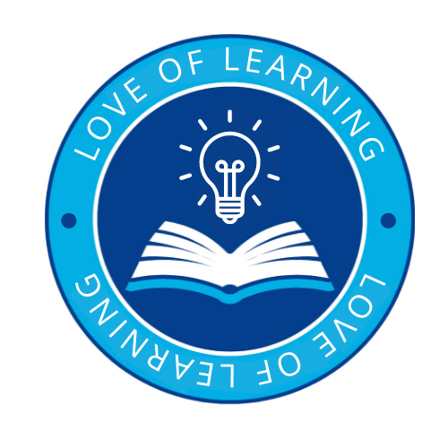 | Introduce a love of learning through:  - To nurture and enrich each individual child through providing a positive, happy and healthy environment in which all people within both our school community and the wider global community are valued and respected.  - To develop the pupils’ love for the world around them and inspiring in them the curiosity and fascination for the planet and their place in it.  - To provide our pupils with a broad and balanced curriculum that allows them to become motivated and fascinated with the world and environment.  - To encourage pupils to develop a passion for the subject by engaging in exciting learning experiences and creative lessons.
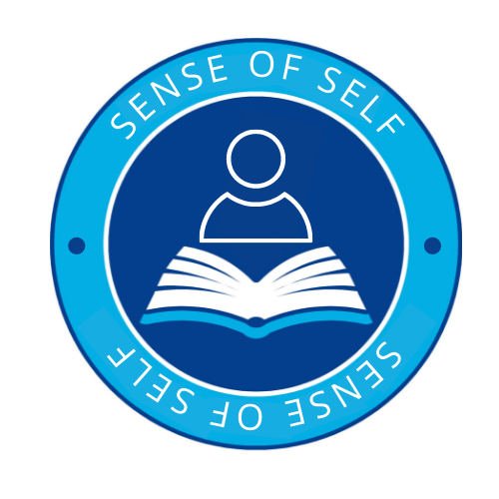 | A sense of self through:  - To inspire pupils to have a good understanding of the world and of their place in it.  - To encourage pupils to ask questions, think critically and develop their own sense of perspective of the world.  - To support pupils in communicating their learning in a variety of ways including sketch maps with a key and diagrams, tables, graphs and writing.  Under the UN Convention on the Rights of the Child- Article 13 (freedom of expression)  Every child must be free to express their thoughts and opinions and to access all kinds of information, as long as it is within the law.  - To help pupils make sense of their own surroundings through learning about their own locality, and the interaction between people and environment.  - To support pupils in developing knowledge and understanding of the human and physical processes which shape places  - To support pupils in appreciating similarities and differences in the world around them and respecting other peoples’ beliefs, attitudes and values.  - To inspire pupils be become creative, resourceful and work cooperatively with others.  - To enable pupils to enjoy learning about geography both inside and outside the classroom, including educational visits and fieldwork.
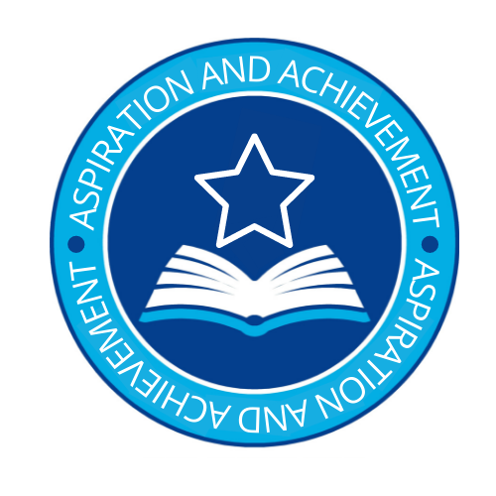 | Aspiration and Achievement:  - To use real world examples and first hand experiences to help explain current environmental issues and develop knowledge and understanding of the world around them.  - To develop interest and enjoyment of geographical experiences and build confidence and understanding.  - To recognise and understand issues concerning the environment and sustainable development.  - We seek to inspire in children a curiosity and fascination about the world and its people which will remain with them for the rest of their lives, equipping them well for further education and beyond.  - To have a greater understanding of their place in the world, and their rights and responsibilities to other people and the environment.
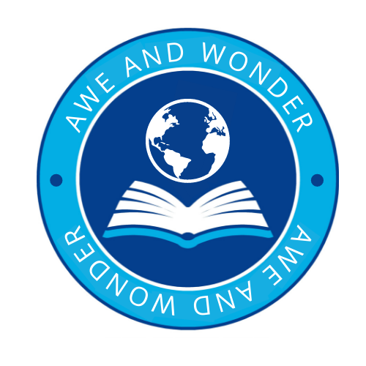 | Awe and Wonder:  - To develop a curiosity and fascination about the world and its people that will remain with them for the rest of their lives.  - To have sound Geographical knowledge, understanding and skills; providing the frameworks and approaches that explain how the Earth’s features at different scales are shaped, interconnected and change over time.  - To use a curiosity based learning approach to help embed key skills and knowledge and create memorable experiences.

