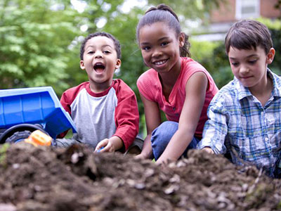

*EYFS for Parents*

**There are 4 guiding principles in the EYFS**

1. That every child is unique.

2. That every child can learn to be strong and independent through positive relationships.

3. That children learn and develop best in enabling environments.

4. That children develop and learn in different ways and at different rates.

The Early Years Foundation Stage (EYFS) sets the standards for the learning, development and care of children from birth to 5 years old. All schools and Ofsted-registered early years providers must follow the EYFS, including childminders, nannies, after school care, preschools, nurseries and school reception classes. The Early Years Foundation Stage (EYFS) Framework is the core document for all professionals working in the foundation years. It supports an integrated approach to early learning and care. It gives all professionals a set of common principles and commitments to deliver quality early education and childcare experiences to all children.

**Physical Development**

**Communication and Language**

These areas of learning underpin the other areas.

Literacy

Mathematics

Expressive Art and Design

Understanding the World

These 7 areas are used to plan your child’s learning and activities.

The professionals teaching and supporting your child will make sure that the activities are suited to your child’s unique needs. This is a little bit like a curriculum in primary and secondary schools, but it's suitable for very young children, and it's designed to be really flexible so that staff can follow your child's unique needs and interests.

Children learn and develop through play in the Early Years displaying the ‘Characteristics of Effective Learning’. These are playing and exploring, active learning and creating and thinking critically.

Children will play for long periods inside and outside, during this time practitioners will carefully facilitate their play to move their development onto the next stage. They will observe children and plan their next steps, often in the moment. The EYFS recommends a balance of child-initiated learning and adult-initiated learning therefore there will be times when adults initiate learning for example during story time or circle time.

These will be for short periods and in small groups.

**Key Person**

Is your main point of contact within the setting and helps your child to become settled, happy and safe. They are responsible for your child’s care, development and learning. Your child’s key person takes a careful note of your child’s progress, sharing this with you and they will give you ideas as to how to help your child at home.

**Progress Checks**

Providers will track your child’s progress through their stages of development from birth to the end of the reception year. This should be shared and passed on between providers caring for your child if they more from childminder to pre-school for example.

Your child’s progress will be reviewed when they’re between 2 and 3 by an early year’s practitioner or health visitor. Their class teacher will assess them at the end of the school year when they turn 5. The assessment is based on classroom observation, your child won’t be tested. It uses the early learning goals, which can be found in the Early Years Framework.

An important part of the EYFS Profile is your knowledge about your child’s learning and development, so do let your child’s class teacher know about what your child does with you: such as how confident your child is in writing their name, reading and talking about a favourite book, speaking to people your child is not so familiar with or their understanding of numbers. All of the information collected is used to judge how your child is doing in the 7 areas of learning and development. The school will give you a report of your child’s progress, including information from his or her EYFS Profile.

**Where can I go for further information?**

**The most important place to find out more is by speaking to the professionals caring for your child, do ask as many questions as you need to. Providers really do welcome speaking with you.**