WHY DO WE STUDY GLOBAL DIMENSIONS?
Global issues are part of young people’s lives in a way that they never were for previous generations. Television, the internet, international sport and increased opportunities for travel, all bring the wider world into everyone’s daily life.
Society today is enhanced by peoples, cultures, languages, religions, art, technologies, music and literature originating in many different parts of the world. This provides a tremendous range of positive opportunities to broaden pupils’ experience and knowledge.
However, whilst there have been huge improvements that have changed the lives of millions of people, one in five of the world’s population still lives in extreme poverty. They lack access to basic healthcare, education and clean water, with little opportunity to improve their condition. Moreover, there is increasing acknowledgement of the far-reaching impact of levels of global poverty. Environmental damage, for example, which is exacerbated by poverty, does not stop at national boundaries.
Economies around the world are more than ever interdependent on both trade with, and investment from, other countries.

At St Bede’s Catholic Primary School, we acknowledge importance of education in helping our pupils recognise their role and responsibilities as members of this global community. Through including a global dimension in our teaching, links can be made between local and global issues. It also means that our pupils are given opportunities to examine their own values and attitudes, to appreciate the similarities between peoples everywhere, to understand the global context of their local lives, and to develop skills that will enable them to combat prejudice and discrimination. This in turn gives the pupils at St Bede’s the knowledge, skills and understanding to play an active role in the global community.
INTENT
Intent
To nurture and enrich each individual child through providing a positive, happy and healthy environment in which all people within both our school community and the wider global community are valued and respected.

From Fair Trade to global goals and understanding the Rights of a Child, at St Bede’s Catholic Primary School, we aim to help our pupils appreciate the wider world around them and their place within it. Global learning at St Bede’s is concerned with teaching and learning about global issues, events and perspectives. It is not a subject but an approach which combines active and experiential activities to encourage a critical thinking approach.
Through carefully planned experiences and learning activities we aim to help our pupils learn about the challenges the world faces and think critically about how to deal with challenges such as poverty, inequality and sustainability. This approach also supports the spiritual, moral, social and cultural development of our pupils and helps them to prepare for the opportunities, responsibilities and experiences of later life.
At St Bede’s Catholic Primary School, we seek to enable individuals to achieve their full potential through global learning and an understanding of Catholic social teaching which calls upon us to preserve the dignity of all human beings, to care for creation, and to reach out to our sisters and brothers in need. Pope Francis emphasises that it is our duty to work together to bring about a more just and peaceful world: to put love into action.

"We are called to solidarity with the poor as well as stewardship of the Earth. Our deep regard for the dignity of every person commands us to cultivate a climate of life where each of God's children thrive and join with creation in praising our Creator. This is the 'integral ecology' of which Pope Francis speaks."

(Pope Francis, 'Laudato Si' - Care of our common home', in 2015.

At St Bede’s Primary School, we recognise our responsibility in helping our pupils develop an understanding of their roles and responsibilities as global citizens and in recognising and understanding the messages of Pope Francis in Laudato Si. We aim for the promotion of the global dimension in all aspects of the curriculum to assist in removing barriers between cultures and encourage openness and positive communication between individuals and groups.
At St Bede’s Catholic Primary School, we believe that incorporating the Global Dimension into the curriculum will ensure that pupils develop their awareness of Global Citizenship, which goes beyond simply knowing that we are citizens of the globe to an acknowledgement of our responsibilities both to each other and to the Earth itself.
Global Citizenship is about understanding the need to tackle injustice and inequality, and having the desire and ability to work actively to do so. It is about valuing the Earth as precious and unique, and safeguarding the future for those who come after us. Global Citizenship is a way of thinking and behaving. It is an outlook on life, a belief that we can make a difference.
(From Global Citizenship: the handbook for Primary teaching – Oxfam)

ESSENTIAL GLOBAL VOCABULARY: citizenship, sustainable development, social justice, values and perceptions, diversity, interdependence, conflict resolution, human rights

IMPLEMENTATION
Every child arrives in school with some level of global awareness and understanding, thanks to an increasingly interdependent world. Research has shown that children as young as three have already formed ideas about people, cultures and countries. In our teaching, this means recognising that ‘the global’ is not only ‘out there’ – but it is wherever children live. This offers learners great scope for exploring their commonality with others.
The school will fulfil its commitment to the Global Dimension and Laudato Si by ensuring that Catholic social teaching is an integral part of subjects such as history, geography and English, it is not taught just in RE. Our revised Curriculum offers more opportunities than ever before for a global dimension to be incorporated into the life and work of the school. Here at St Bede’s, we take a cross curricular approach to teaching our children to be thoughtful about and challenging of the world’s organisations and communities and to recognise the importance in us all working together to build a better world for the future.

The school will fulfil its commitment to the global dimension by ensuring that learners are given opportunities to fulfil the following aims:

- Ensure that our children can articulate the connection between Jesus' teaching and doing good deeds and our mission statement, core values and ethos of the whole school community are built around this.

- As part of our custodial duty to our world, we wish to provide our pupils with the information and skills needed to become aware of the links between the personal, social, local and the global, and enable them to become active global citizens.

- To challenge and support all our pupils to become critical thinkers, developing independent learning skills so they can critically evaluate their own values and attitudes, appreciating the similarities between people everywhere and learning to value diversity

- To learn about their rights and accept responsibilities as Catholics and global citizens who actively explore global dimension concepts including conflict, diversity, human rights, interdependence, social justice and sustainable development.

- To appreciate the importance of a global context and engage in a range of culturally diverse experiences;

- To develop skills that will enable them to identify and challenge injustice, prejudice and discrimination;

- To understand and potentially make their own distinctive contribution to local and global communities

- To consider probable and preferable futures and how to achieve the latter.

EYFS Learning Projects
Me and My Community | Exploring  Autumn | Once Upon a Time | Sparkle & Shine | Starry Night | Winter Womderland | Dangerous Dinosaurs | Puddles and Rainbows | Sunshine & Sunflowers |  | Shadows & Reflections | Big Wide World | Splash
Year 1 Learning Projects
Childhood | Splendid Skies | Are All Leaves the Same? | Moon zoom! | School Days | Street View | Paws, Claws and Whiskers | Bright Lights Big City |  | Taxi!
Year 2 Learning Projects
Movers & Shakers | Portraits and Poses | Coastline | Beach Huts | Much, Mess & Mixtures | Magnificent Monarchs | Still Life | Beachcombers |  | The Scented Garden
Year 3 Learning Projects

Through the Ages | Prehistoric Pots | Predator | Rocks, Relics and Rumbles | Ammonite | Emperors & Empires | Heroes and Villains | Urban Pioneers
Year 4 Learning Projects
Invasion | Warp& Weft | Burps, Bottoms and Bile | Misty Mountain, Winding River | Vista | Ancient Civilisations | Tomb Builders | Playlist | Blue Abyss
Year 5 Learning Projects
Dynamic Dynasties | Taotie | Firedamp & Davy Lamps | Stargazers | Ground breaking Greeks | Architecture | Beast Creator | Sow, Grow & Farm | Eat the Seasons
Year 6 Learning Projects
Britain at War | Blood Heart | Frozen Kingdoms | Innuit | Maafa | ID | Tomorrow’s World

Key Aspects of Global Curriculum: The following aspects and ideas are mapped across the curriculum to ensure pupils develop a rich and deep subject knowledge.
My Place In the World  To help young people understand their role in a globally-interdependent world and explore strategies by which they can make it more just and sustainable | Poverty  To promote greater awareness of poverty and sustainability | Global Inequality  To help young people understand their role in a globally-interdependent world and explore strategies by which they can make it more just and sustainable | Social Justice  To move pupils from a charity mentality to a social justice mentality | Sustainable Development  To enable pupils to explore alternative models of development and sustainability in the classroom | Global Interdependence  To familiarise pupils with concepts of interdependence, development, globalisation and sustainability
To stimulate critical thinking about global issues
Over the key stages pupils’ awareness and understanding of global issues might progress as follows:
At key stage 1 pupils begin to develop a sense of their own worth and the worth of others. They develop a sense of themselves as part of a wider world and gain awareness of a range of different cultures and places. They learn that all humanity shares the same basic needs but that there are differences in how these needs are met.

Pupils begin to develop a sense of their own worth and the worth of others. They develop a sense of themselves as part of a wider world and gain awareness of a range of different cultures and places. They learn that all humanity shares the same basic needs but that there are differences in how these needs are met.

At key stage 2 pupils develop their understanding beyond their own experience and build up their knowledge of the wider world and of different societies and cultures. They learn about the similarities and differences between people and places around the world and about disparities in the world. They develop their sense of social justice and moral responsibility and begin to understand that their own choices can affect global issues as well as local ones.

Pupils develop their understanding beyond their own experience and build up their knowledge of the wider world and of different societies and cultures. They learn about the similarities and differences between people and places around the world and about disparities in the world. They develop their sense of social justice and moral responsibility and begin to understand that their own choices can affect global issues as well as local ones

ENRICHMENT OPPORTUNITIES | - Visits and workshops focussing on developing understanding of other cultures through storytelling, music, guest speakers, organisational presentations, Philosophy for children workshops to explore equality, diversity and global citizenship, teaching about global goals and children’s rights, Equality and diversity enrichment days
Trips /visits: | Connecting classrooms  Visits to alternative places of worship  Visits from people within the community who can share their experiences and cultural heritage with the pupils |  | Diversity/ Celebration Days/ Weeks: | We hold specialist celebration days focussing on different countries/ cultures/ religions – festivals, celebrations and traditions
Pupil ambassador’s: |  | Pupil ambassador’s will have the opportunity to:  - say what they like and dislike about their learning  - take part in age-appropriate discussions  - express their opinions on a range of different topics and issues  - promote whole school themes and initiatives

IMPACT
Through our curriculum and teaching, we aim to empower our pupils to develop their potential and to make informed and responsible choices and decisions throughout their lives within our increasingly unequal, interdependent and rapidly changing world, which presents them with many challenges as well as opportunities.
The global dimension will help learners to:
- explore and make sense of the big issues in the world
- think critically and creatively about topical and controversial issues
- deconstruct issues and events and consider them from a range of perspectives
- communicate with people from a range of countries and cultures
- develop self-awareness and a positive attitude to difference
- argue a case on behalf of themselves and others
- reflect on the consequences of their own actions now and in the future
- link learning to taking responsible action
- participate in society as active and responsible global citizens.

These different aspects of our school will promote development of global citizenship

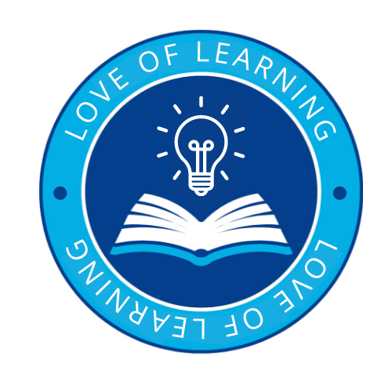 | Introduce a love of learning through:  - helping pupils to see themselves as citizens of the world and to help them realise how their actions today can affect others tomorrow  - using global learning to enrich the classroom and the curriculum.  - teaching pupils about current issues and modern day problems that affect the world today and that they can relate to  - nurturing and enriching each individual child through providing a positive, happy and healthy environment in which all people within both our school community and the wider global community are valued and respected.  - developing the pupils’ love for the world around them and inspiring in them the curiosity and fascination for the planet and their place in it.  - providing our pupils with a broad and balanced curriculum that allows them to become motivated and fascinated with the world and environment.  - encouraging pupils to develop a passion for the subject by engaging in exciting learning experiences and creative lessons.
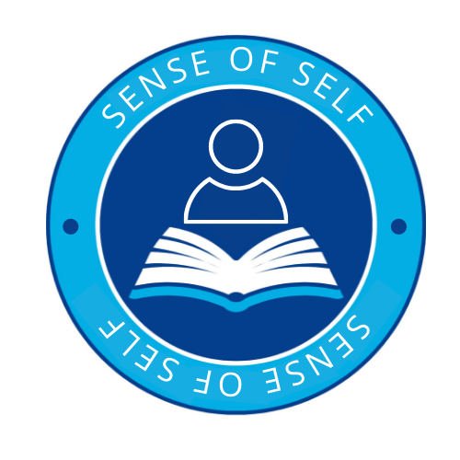 | A sense of self through:  - helping pupils develop self-esteem and a sense of self by encouraging them to take more responsibility for themselves, their actions and choices and their learning  - inspiring pupils to have a good understanding of the world and of their place in it.  - encouraging pupils to ask questions, think critically and develop their own sense of perspective of the world.  - Supporting pupils in communicating their learning in a variety of ways  - Understanding that they are citizens of the world and that with this comes great responsibilities  - Understanding children’s rights and global goals  - Recognising their duty as Catholic children to protect the world and the environment, promoting the belief of a common world where all things are interconnected  Under the UN Convention on the Rights of the Child- Article 13 (freedom of expression)  Every child must be free to express their thoughts and opinions and to access all kinds of information, as long as it is within the law.
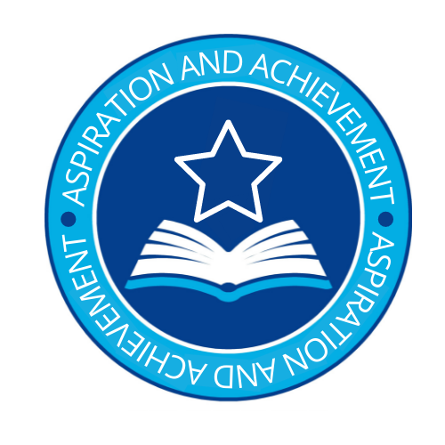 | Aspiration and Achievement:  - We seek to inspire in children a curiosity and fascination about the world and its people which will remain with them for the rest of their lives, equipping them well for further education and beyond.  - To use real world examples and first hand experiences to help explain current issues and develop knowledge and understanding of the world around them.  - To develop interest and enjoyment across the curriculum and build confidence and understanding.  - To recognise and understand issues concerning the environment and sustainable development.  - To have a greater understanding of their place in the world, and their rights and responsibilities to other people and the environment.
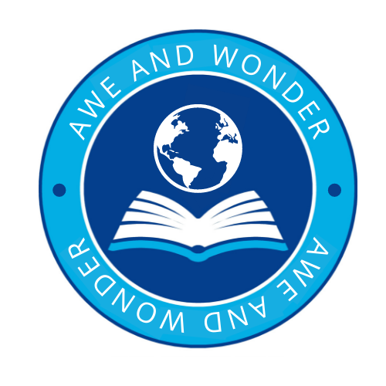 | Awe and Wonder:  - To develop a curiosity and fascination about the world and its people that will remain with them for the rest of their lives.  - To build links with other schools, people, cultures and communities to help broaden our pupils’ views of themselves and their place and responsibilities in society  - Building an understanding of their role in the world and their impact on society  - Increasing subject knowledge, interest and enthusiasm through first hand experiences and real life opportunities to reinforce learning

