CATEGORY | QUALITY TEXT | RHYMING/REPEATED REFRAIN | DIVERSE BOOKS | WELLBEING/ GROWTH MINDSET | TRADITIONAL TALE | MISC
TITLE | Harry and the Bucket full of Dinosaurs by Ian Whybrow | Dinosaurs Love Underpants by Claire Freedman and Ben Cort | Love makes a Family by Sophie Beer | The Jar of Happiness by Alissa Burrows | The Elves and the Shoemaker | The Smeds and The Smoos by Julia Donaldson
BOOK COVER | 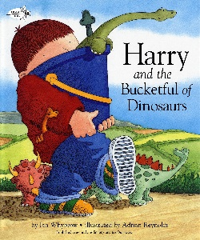 | 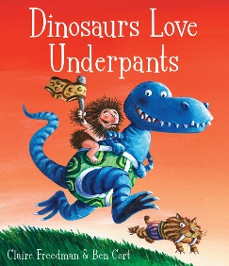 | 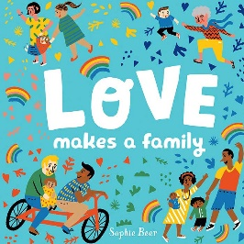 | 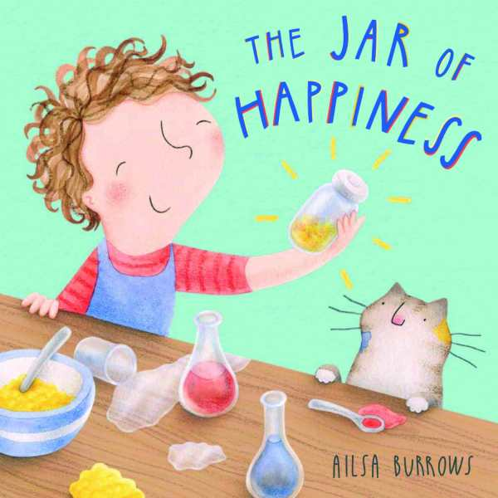 | 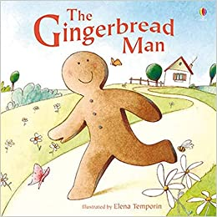 | 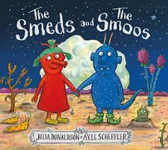
REASONING & PURPOSE | A great story to model and practise inference skills and predication. Vocabulary to explore and also the use of pictures to convey added meaning to text.  Examples of blending and segmenting and opportunities for sounding out/ clapping/ tapping syllables in each dinosaurs name. | This book has rhyme and a repeated refrain which encourages children to predict rhyme and join in. | An easy way to teach chn that there isn't a cookie cutter for family - they're made of all types of set-ups, with one common theme: love.  A great story to model and practise inference skills and predication. Vocabulary to explore and also the use of pictures to convey added meaning to text. | Many children can feel insecure out of their comfort zone and are therefore "unhappy" if something goes wrong - this book strives to acknowledge that these feelings are normal, and that there are ways to feel better.  Lots of opportunities for looking at inference, prediction and empathy as well as making connections to own experiences. Giving children something to explain difficult emotions. | Traditional tale to look at the structure of story, continuing the idea that one story can be retold differently each time. Vehicle to link Helicopter stories and also the use of icons. Using diverse retelling to challenge children’s viewpoints. | This book has rhyme and a repeated refrain which encourages children to predict rhyme and join in.  It also carries an important message about diversity and acceptance.

