CATEGORY | QUALITY TEXT | RHYMING/REPEATED REFRAIN | DIVERSE BOOKS | WELLBEING/ GROWTH MINDSET | TRADITIONAL TALE | MISC
TITLE | Whatever Next by Jill Murphy | The Gruffalo’s Child by Julia Donaldson | Astro Girl by Ken Wilson Max | Susan Laughs by Jeanne Willis | The Elves and the Shoemaker | How to Catch a Star by Oliver Jeffers
BOOK COVER | 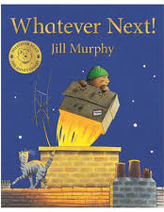 | 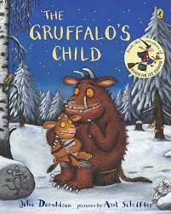 | 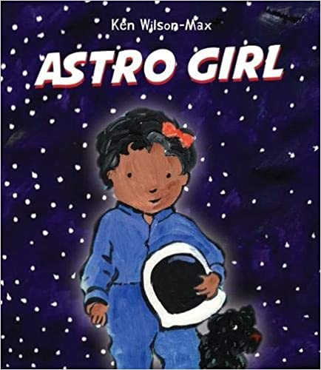 | 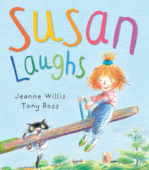 | 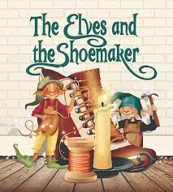 | 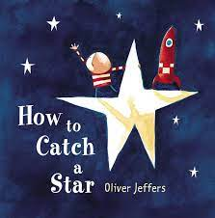
REASONING & PURPOSE | A great story to model and practise inference skills and predication. Vocabulary to explore and also the use of pictures to convey added meaning to text. | This book has rhyme and a repeated refrain which encourages children to predict rhyme and join in. | Lovely story that promotes women and girls and embraces diversity. Wonderful inclusive message at its heart, supported by mini fact-files about female and BAME astronauts at the end.  A great story to model and practise inference skills and predication. Vocabulary to explore and also the use of pictures to convey added meaning to text. | A short story told in rhyming couplets using the simple present. The story describes a range of common emotions and activities experienced by a little girl.  Celebrating the similarities between disabled and able-bodied children. Encouraging acceptance and tolerance of differences.  Lots of opportunities for looking at inference, prediction and empathy as well as making connections to own experiences. Giving children something to explain difficult emotions. | Traditional tale to look at the structure of story, continuing the idea that one story can be retold differently each time. Vehicle to link Helicopter stories and also the use of icons. Using diverse retelling to challenge children’s viewpoints. | A lovely message, reminding chn to reach for their biggest dreams and never give up!  Enc creative thinking and links in well with topic on space. Bold, colourful illustrations and simple text which is easy to follow.

