Nursery Class
CATEGORY | QUALITY TEXT | RHYMING/REPEATED REFRAIN | DIVERSE BOOKS | WELLBEING/ GROWTH MINDSET | TRADITIONAL TALE | MISC
TITLE | Whatever Next by Jill Murphy | Room on the Broom by Julia Donaldson | Pink is for boys by Rob Pearlman | Lucy’s Blue Day by Chris Duke | The Three Little Pigs | Rama and Sita the story of Diwali by Malachy Dole
BOOK COVER | 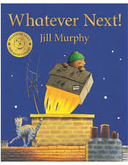 | 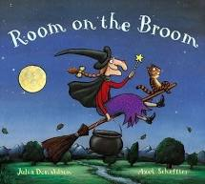 | 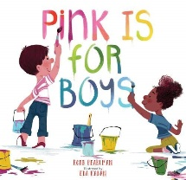 | 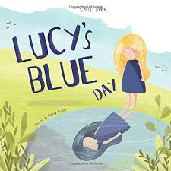 | 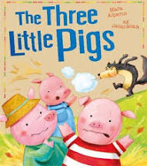 | 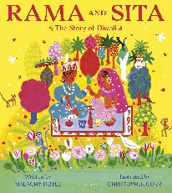
REASONING & PURPOSE | A great story to model and practise inference skills and predication. Vocabulary to explore and also the use of pictures to convey added meaning to text. | This book has rhyme and a repeated refrain which encourages children to predict rhyme and join in. | Pink is for boys... and girls... and everyone! This book rethinks and reframes the stereotypical blue/pink gender binary and empowers children – and their grown-ups – to express themselves in every colour of the rainbow. | A good book for teaching children that it’s okay not to be okay.  Lots of opportunities for looking at inference, prediction and empathy as well as making connections to own experiences. Giving children something to explain difficult emotions. | Traditional tale to look at the structure of story, continuing the idea that one story can be retold differently each time. Vehicle to link Helicopter stories and also the use of icons. Using diverse retelling to challenge children’s viewpoints. | A great story for teaching about religions other than our own, tying in with the theme of celebrations and festivals and light.  Good vocabulary to explore. Predictions and inference. Links to emotions and celebrations of differences.

Reception Class
CATEGORY | QUALITY TEXT | RHYMING/REPEATED REFRAIN | DIVERSE BOOKS | WELLBEING/ GROWTH MINDSET | TRADITIONAL TALE | MISC
TITLE | Owl Babies by Martin Waddell | We’re Going on a Bear Hunt by Michal Rosen | Handa’s Surprise by Eileen Browne | Susan Laughs by Jeanne Willis | Goldilocks and the Three Bears | Rama and Sita the story of Diwali by Malachy Dole
BOOK COVER | 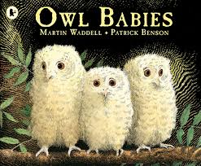 | 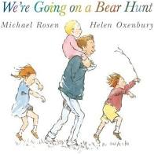 | 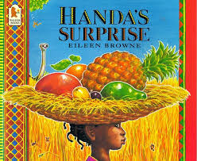 | 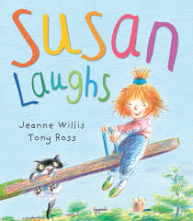 | 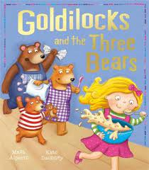
REASONING & PURPOSE | A great story to model and practise inference skills and predication. Vocabulary to explore and also the use of pictures to convey added meaning to text. Links to quality friendships.  Quality Text | This book has rhyme and a repeated refrain which encourages children to predict rhyme and join in. | This book provides an opportunity for discussing cultural diversity as children explore the world of Handa and Akeyo, meet some of the animals surrounding their village and are introduced to some of the delicious fruits that Handa picks for her friend.  Vocabulary to explore and opportunities for modelling inference and prediction. | A short story told in rhyming couplets using the simple present. The story describes a range of common emotions and activities experienced by a little girl.  Celebrating the similarities between disabled and able-bodied children. Encouraging acceptance and tolerance of differences.  Lots of opportunities for looking at inference, prediction and empathy as well as making connections to own experiences. Giving children something to explain difficult emotions. | Traditional tale to look at the structure of story, continuing the idea that one story can be retold differently each time. Vehicle to link Helicopter stories and also the use of icons. Using diverse retelling to challenge children’s viewpoints. | Good vocabulary to explore. Predictions and inference. Links to emotions, memories and friendships.

