Nursery Class
CATEGORY | QUALITY TEXT | RHYMING/REPEATED REFRAIN | DIVERSE BOOKS | WELLBEING/ GROWTH MINDSET | TRADITIONAL TALE | MISC
TITLE | Owl Babies by Martin Waddell | We’re Going on a Bear Hunt by Michael Rosen | Handa’s Surprise by Eileen Browne | The Colour Monster by Anna Llenas | The Little Red Hen | Elmer by David McKee
BOOK COVER | 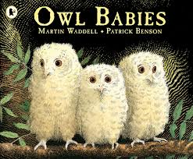 | 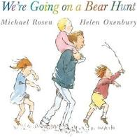 | 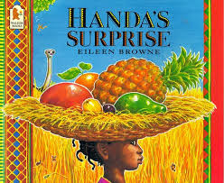 | 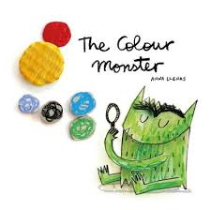 | 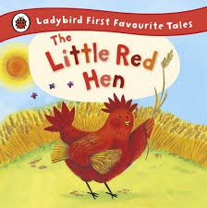 | 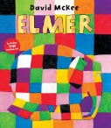
REASONING & PURPOSE | A great story to model and practise inference skills and predication. Vocabulary to explore and also the use of pictures to convey added meaning to text. | This book has rhyme and a repeated refrain which encourages children to predict rhyme and join in. | This book provides an opportunity for discussing cultural diversity as children explore the world of Handa and Akeyo, meet some of the animals surrounding their village and are introduced to some of the delicious fruits that Handa picks for her friend.  Vocabulary to explore and opportunities for modelling inference and prediction. | It can be read as a simple story about friendship, but can also help children to recognise, discuss and label emotions, providing them with vital emotional literacy skills.  Lots of opportunities for looking at inference, prediction and empathy as well as making connections to own experiences. Giving children something to explain difficult emotions. | Traditional tale to look at the structure of story, continuing the idea that one story can be retold differently each time. Vehicle to link Helicopter stories and also the use of icons. Using diverse retelling to challenge children’s viewpoints. | Good vocabulary to explore. Predictions and inference. Links to emotions and celebrations of differences.

Reception Class
CATEGORY | QUALITY TEXT | RHYMING/REPEATED REFRAIN | DIVERSE BOOKS | WELLBEING/ GROWTH MINDSET | TRADITIONAL TALE | MISC
TITLE | Penguin by Polly Dunbar | The Gruffalo by Julia Donaldson | Handa’s Surprise by Eileen Browne | The Colour Monster by Anna Llenas | The Little Red Hen | The Paper Dolls by Julia Donaldson
BOOK COVER | 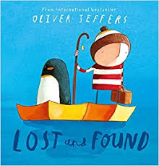 | 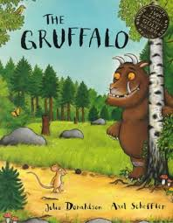 |  |  |  | 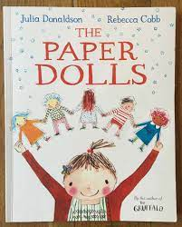
REASONING & PURPOSE | A great story to model and practise inference skills and predication. Vocabulary to explore and also the use of pictures to convey added meaning to text. Links to quality friendships.  Quality Text | This book has rhyme and a repeated refrain which encourages children to predict rhyme and join in. | This book provides an opportunity for discussing cultural diversity as children explore the world of Handa and Akeyo, meet some of the animals surrounding their village and are introduced to some of the delicious fruits that Handa picks for her friend.  Vocabulary to explore and opportunities for modelling inference and prediction. | It can be read as a simple story about friendship, but can also help children to recognise, discuss and label emotions, providing them with vital emotional literacy skills.  Lots of opportunities for looking at inference, prediction and empathy as well as making connections to own experiences. Giving children something to explain difficult emotions. | Traditional tale to look at the structure of story, continuing the idea that one story can be retold differently each time. Vehicle to link Helicopter stories and also the use of icons. Using diverse retelling to challenge children’s viewpoints. | Good vocabulary to explore. Predictions and inference. Links to emotions, memories and friendships.

