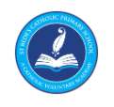
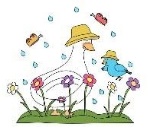
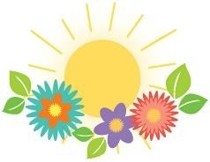
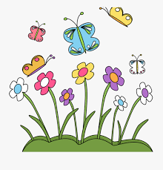
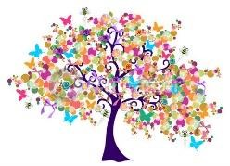
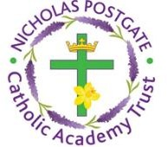

The BIG Question
Spring Two: How and why do things grow?
Possible lines of enquiry led by children’s interests:
- Discuss the season spring and why it is different to the other seasons.
- Explore things that grow in spring.
- Life cycle of a plant and different animals (chick/tadpole).
- Plant cress/sun flower
- How to recognise and make observations about our local area and explore the area around our school.
- How to investigate using all our senses.
Come and See
Our RE BIG Questions this term are:
Local Church - Community
Staff
- Miss Brown
* Mrs Gribbon
- Miss Jowsey
* Mrs Nevison
‘Together we love, laugh, play and learn’
Foundation Stage 2 Spring Term Newsletter 2021

The BIG Question | Celebrating: What and why do people celebrate?
Spring One: Do Penguins and Polar Bears live in the same place? | Eucharist - Relating  Gathering: Why do people gather together?
Possible lines of enquiry led by children’s interests: | Lent/Easter – Giving  Growing: How and why do things grow?
- Winter weather and the properties of snow and ice.  - How animals adapt to colder weather.  - Winter adjectives.  - Colours in the natural and man-made world.  - Which animals live in cold places?  - Where in the world are the cold places?  - Where do polar bears and penguins live? | Islam – Precious objects  The children will study various aspects of Islam.
 |  | Other Areas of Learning
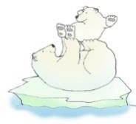 |  | The 7 areas of learning and development involves engagement with your child’s play and activities as they learn new skills and knowledge. Children learn by playing and exploring, being active, and through creative and critical thinking which takes place both indoors and outside.  Personal and Social Development Communication and Language Physical Development Expressive Arts and Design Understanding the World
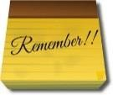

Keeping Up-to-date

School Website: stbedes.npcat.org.uk
Twitter: @StBedesMarske
Google Classroom: Live welcome/drop in (if permission was given). Recorded lessons and work posted daily.
Reminder: School needs fortnightly contact with parents to ensure that all St Bede’s children are safe and well.
Maths:
Mathematics in the Early Years involves providing the children with the experience and practice that will help to improve their skills in counting, numbers, and calculation, addition and subtraction problems. They also learn to describe different shapes, spaces and measures.
Our topics for the Sprint Term are; Alive in 5! Growing 6,7, 8 and Building 9 and 10.

Literacy
Literacy in the Early Years provides opportunities for the children to talk about different books, print in the environment, mark making and writing, as well as sharing books and reading. The children must also be able to write and spell their full name correctly by the end of Reception.

