ISSUE 26 – 2019/20
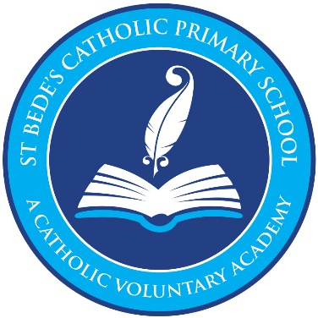
Newsletter
‘In St Bede’s we welcome everyone, grow and learn together as God’s family, and use our gifts to serve with love’
Welcome

Dear Parents and Carers,

Well we made it! What a year it has been, we are so proud of our St Bede's family and all that we have achieved through this difficult period. As always, the end of the year is an emotional time as we say goodbye and prepare for the new adventures ahead, this year it is more so than ever. We would like to thank all of you for your continued support and everything you have done in this unprecedented time.

All the staff here at St Bede's would like to wish our wonderful Year Six's best wishes as they leave our school and move onto the next phase of their journey. They are a wonderful, talented year group that we are very proud of and it was lovely to see them reunited this week at their picnic gathering.

You will have received a detailed letter this week with all the information regarding the wider reopening of school in September. Please read this letter carefully as there is a lot of information regarding precautions, safety measures, staggered start times and finishing times and pupil illness. Reception and nursery parents have also received separate letters detailing start dates and transition to full time school.

We have some exciting news to share. Over the summer, the front of school is having a complete make- over! Expansive work will start in the summer break to improve the playground, signage and fire doors. The staff carpark is to be extended and footpaths laid to improve pedestrian access to the main entrance. Our school frontage will have a completely fresh look and children will have access to a running track and up to three synthetic multi-sport pitches. There will also be work starting on a reading shed and quieter zone for those who prefer calmer breaktimes. This will enhance learning as a wider variety of lessons can be brought outside.

All that is left to say is stay safe, have a wonderful summer and we look forward to welcoming back the whole school in September.

Warm wishes

Mrs Brown, Mrs Bennett and Mrs Gribbon
Senior Leadership Team

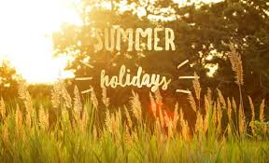
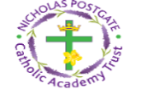
Part of
Nicholas Postgate Academy Trust
Postgate House, Trinity Catholic College, Saltersgill Avenue, Middlesbrough, TS4 3JW
Tel: +44 (0) 1642 298100 Email: enquiries@npcat.org.uk
A MESSAGE FROM MRS MARY BROWN, EXECUTIVE HEADTEACHER

17 weeks ago we set out our plans and procedures to enable the school to open for the children of key workers and what a resilient group of children they were and still are- a credit to you. 17 weeks ago we began to put in place google classrooms and working from home- pupils accessed the learning and what a remarkable job they made of it; showing a mature attitude when working away from their peers and staff. 17 weeks ago you put in plans to support your children whilst juggling your own challenges with work and family commitments- you as parents have been amazing.Throughout these 17 weeks, in our school community we have heard stories of sadness, hope and support- our prayers and thoughts are still with you all.17 weeks was such a long time ago and yet we are here now- finishing for the summer break. I cannot believe that the academic year is over. Can I express my huge thanks to the staff, parents and.... especially the wonderful pupils for working together throughout the journey. Good luck to our wonderful year 6 pupils!
Please take a moment to reflect as you read our final newsletter of the year.

Please take care.
Mrs M D Brown
Executive Headteacher

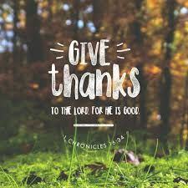
A MESSAGE FROM FATHER DEREK

Dear Children and Families

‘Give thanks to the Lord, for he is good, his love lasts for ever’. This quote from the First Book of Chronicles Chapter 1 verse 34 with which I begin this message is just how we should be feeling now. Everyone has had a hard time during the last few months but our schools through the staff, parents and especially the children have worked tirelessly to keep our communities together and help us to keep learning but in new and exciting ways.

As well as saying thank you to everyone I pray that you will all have a good summer break and come back to school in September full of enthusiasm for new challenges. I especially in my prayers the children who are leaving and will be going to new schools in September, thank you for your time in our school and please continue to do your best in your new schools. You all might like to use this thank you prayer:

‘Dear God,
Thank you for all the blessings in my life, big and small.
Thank you for surrounding me with people who love and care about me.
In Jesus’ Holy Name I pray.
Amen’

CLASS NEWS
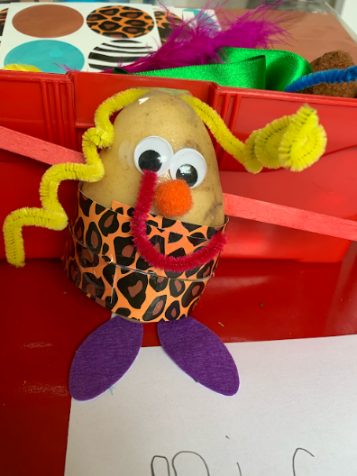
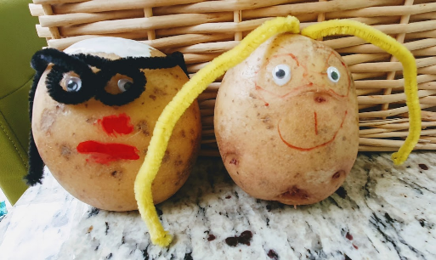
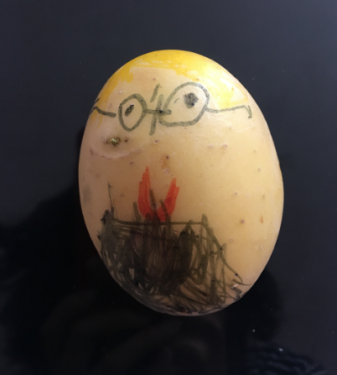
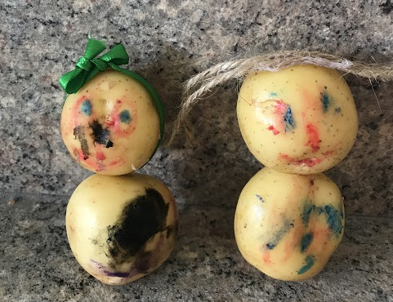
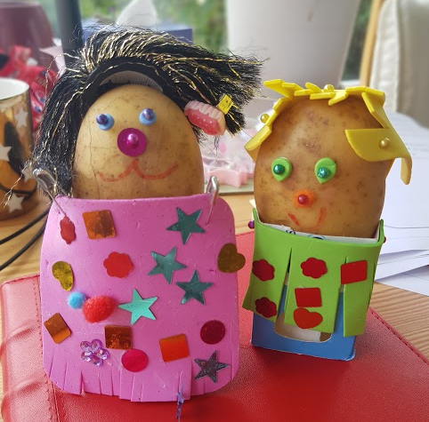
NURSERY
Well what can I say, what a year it has been! When I met all your smiley faces in January we couldn't have predicted the remainder of the year!

The whole of the EY Team is absolutely blown away by your kindness, resilience and determination we have seen throughout lockdown. It hasn't always been easy but our community on google classroom has definitely helped us all through these difficult times.

We are pleased to announce that our worker of the week certificate is awarded to each and every one of you, and to every parent too! We are so impressed with your home learning and how you have all engaged with our themes at home. This week it has been wonderful to hear your memories of both school and home, it has been wonderful to see you enjoying the transition activities and stories and also the Mrs Potato Head Portraits of your teachers!

This week there have been a number of parent mails sent with information regarding September. Please could you make sure you have read these and added important dates to your calendar. There was a detailed parent mail sent on Tuesday regarding the phased return to reception with your child's start date and timings. And another detailed letter to our children who will continue their journey in nursery. If you have any questions please contact us.

All that is left to say is a huge thank you to you all, please enjoy the summer break and we really do look forward to welcoming you all back in September.

Love Mrs Gribbon and The Early Years Team.
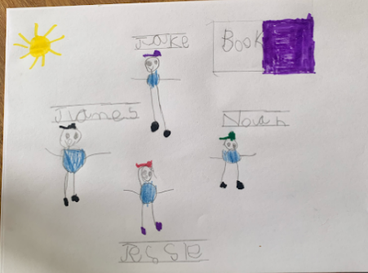
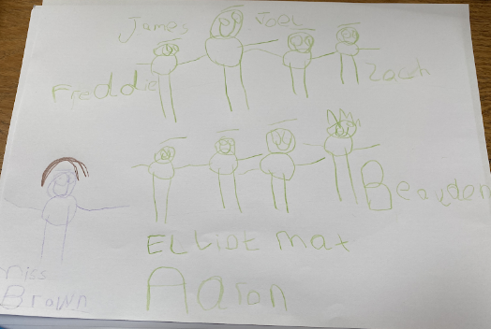
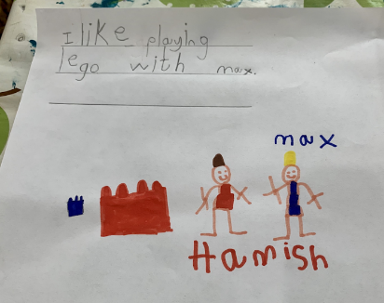
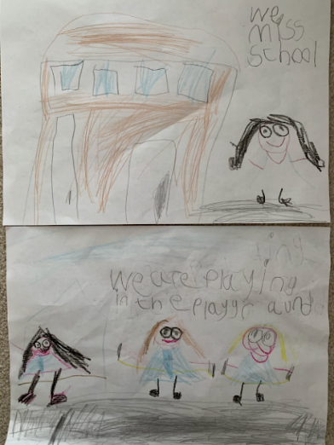
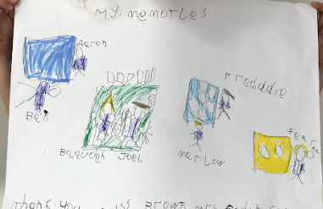
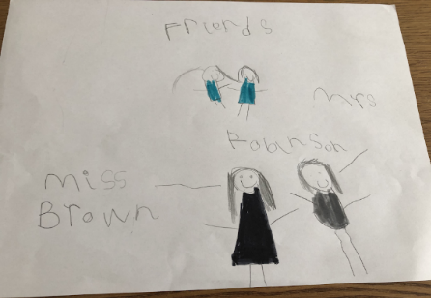
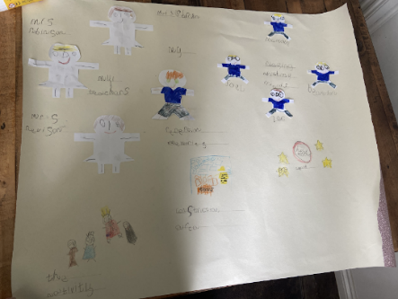
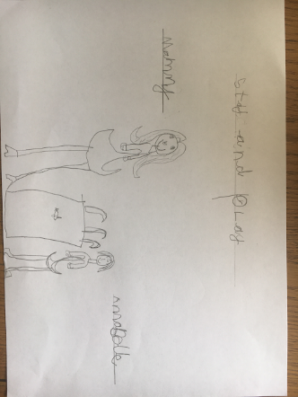
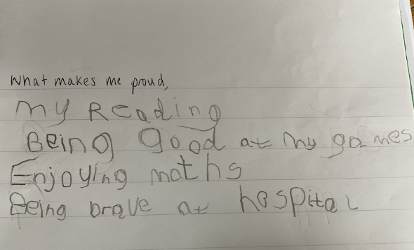
RECEPTION
Hello Reception,
I can't believe it is time for our year together to come to an end and that you have completed your very first year at school.You have been a fantastic class and I am so pleased that I got to be your teacher.
It has been a very strange sort of year that none of us could have predicted but you have been absolute superstars through it all. This week we would like to award the Worker of the Week certificate to everyone, parents too! We have been so impressed by your determination, relissilence and thoughtfulness during this challenging time. The support we have received from parents has been phenomenal. Reception we have loved teaching you both in school and through home learning. You have embraced this new way of learning and it has been fantastic to see your work and the progress that you have made at home. We have particularly loved seeing your work this week and the memories you have shared with us from the past year. It has put big smiles on our faces.
We would like to give a special mention to Elliot who unfortunately hasn't been able to attend very much of school this academic year. This has not stopped him from still trying so hard with his school work and completing tasks at home. We are super proud of how brave he has been over the past year. Along with his classmates, we have missed seeing him in school but we are really looking forward to hopefully seeing you again soon. Well done Elliot, you are amazing!

All that is left to say is a massive thank you to everyone. Enjoy your very well deserved break this summer and we are really looking forward to welcoming you back in September.

Love Miss Brown, Mrs Robinson and The EY Team.
YEAR 1
We have made it to the summer holidays! Who would have thought back in March that this is how our year would end!? I wanted to take this time to say a huge THANK YOU and WELL DONE to you all, including you too grown ups. Your kind words, cards and gifts and smiles are greatly appreciated and I am very grateful to you all for welcoming me into St Bede's this year.

Online learning is something which we hadn't ever imagined would be necessary this time last year but you have all taken to it so well. Grown ups- your continued support has been hugely appreciated and has helped us to work together to support our lovely, little learners. Also, I'd like you to take a moment for us to thank our wonderful Y1 team. Mrs Davies. Miss Jowsey and Mrs Nevison have been amazing, being there to support our online learning and in school.

It has been a privilege teaching you all, albeit short and sweet; watching you all grow in confidence and independence these last few months and I could not be any more proud of you all. I hope you have the BEST SUMMER EVER, have lots of rest and make lots of fun memories. I will look forward to seeing your gorgeous faces as you skip into Year 2 in September.

Take care. Stay safe and keep smiling and have lots of fun! Miss Cooper 😊

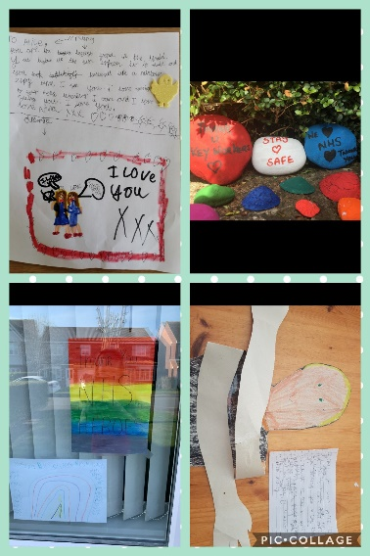
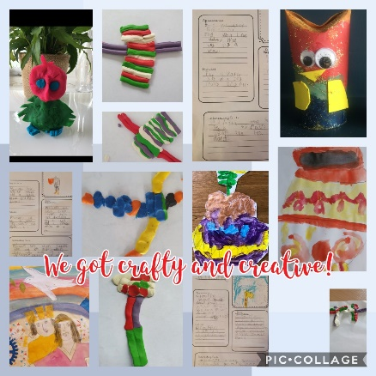
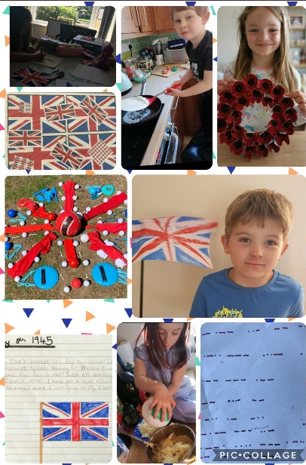
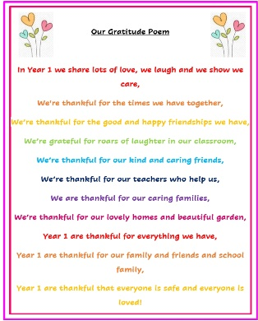
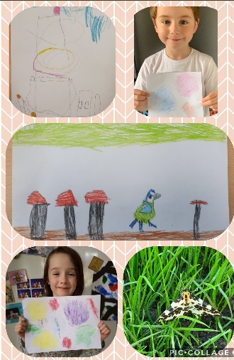
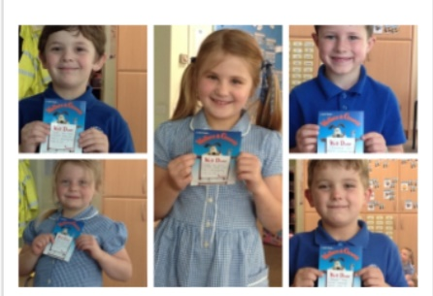
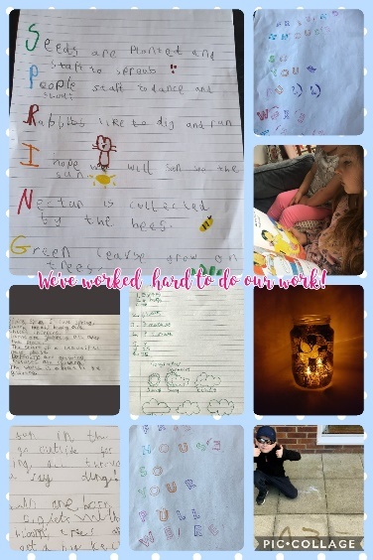
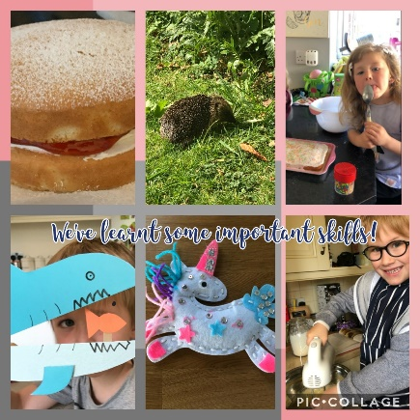
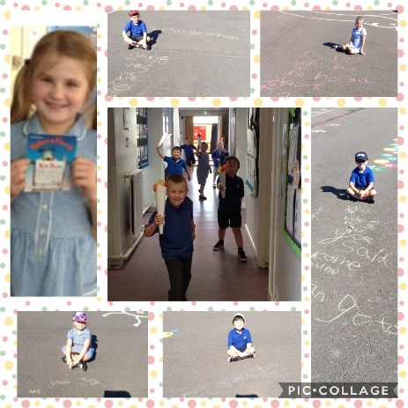
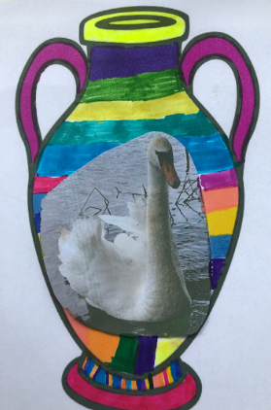
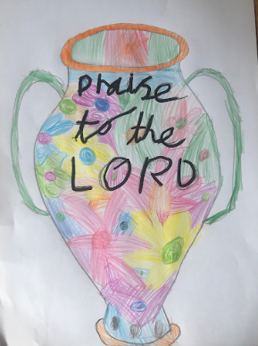
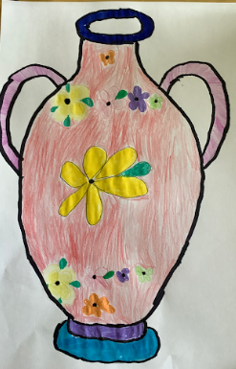
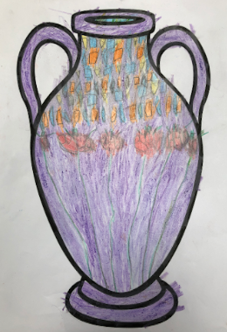
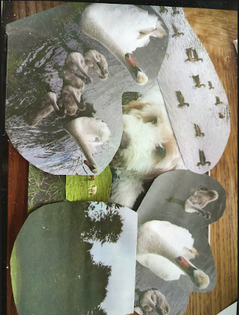
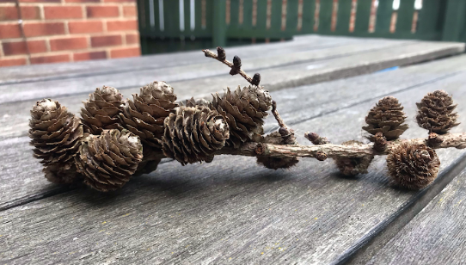
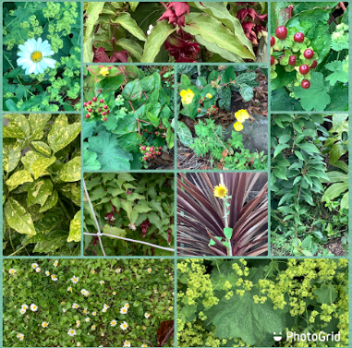
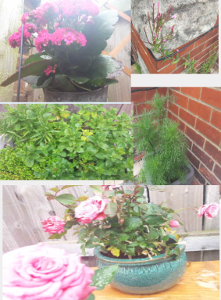
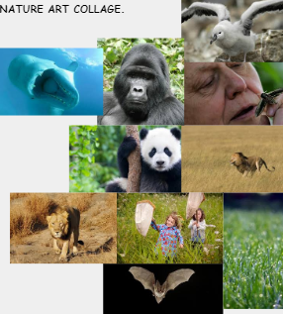
YEAR 2
It is the end of another school year for your children, a school year like no other. You and your families have done an amazing job to support us and your children with their education. That is why the workers of the week, this week in Year 2, are all of the adults at home for their excellent support...thank you and well done.

This week we have been completing our Olympic challenges and undertaking a number of summer related tasks. We have also focused on nature and have created some excellent pieces of artwork.

Have a well deserved summer break and we look forward to seeing you in September.
YEAR 3
This week has been just as busy as ever. Our theme this week has been about looking back at our starting points this year, expressing what we have learnt about ourselves and how we can apply this to moving on to Year 4. Some children took their memories and turned them into stories and newspaper reports. It has been fascinating reading about their emotions at that time. We have accounts of riding a bike, learning to play a musical instrument, passing a piano exam with distinction, plucking up courage to apply for school council elections and giving a speech, giving bodyboarding lessons and visiting the hairdresser for the first time since lockdown. What talented young people we have in Year 3 and we are very proud of the way they have been able to express themselves so openly.

The final week in Children's Art has had a focus on linking art and literacy. Children have created their own book covers and also created some wonderful blackout poetry.
We have had the most fantastic year as a class team and the children have maintained their high standards throughout.

We wish all our families a well earned summer break.

Warm wishes

Mrs Bennett and Mrs Winn
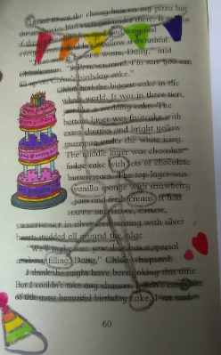
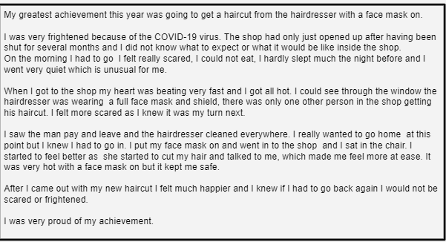
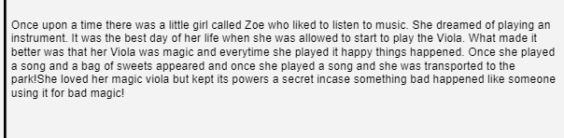
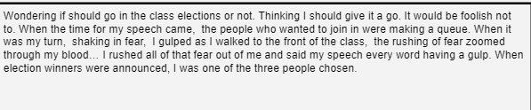
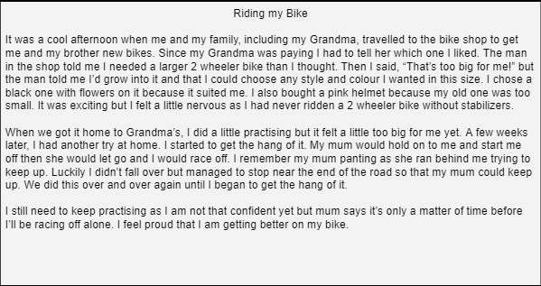
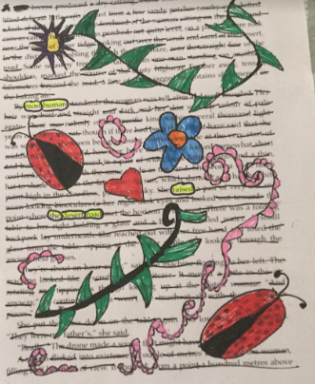
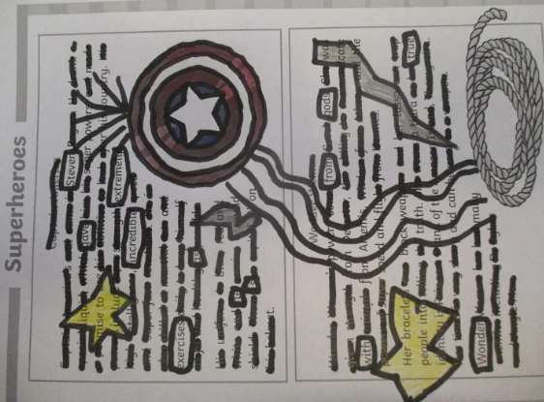
YEAR 4
This week, Year 4 have been reflecting on the year and writing some of their favourite memories. The children have completed a diorama in Art where they had to design/create a scene from their favourite book. They have also written beautiful descriptions about a sunset. As well as this, the children have written a letter to a friend.

We have been extremely impressed with your hard work and determination throughout the year. A huge thank you to all of Year 4 and to the parents and guardians for your continued support throughout. We really appreciate your kind words and gifts. It has been a different year but it has brought us together as a school family. It has been a pleasure to teach each and every one of you in Year 4 this year. I look forward to seeing you all grow and continue to work hard in Year 5.

Take care, stay safe and have a fantastic summer holiday.

Miss Vickers, Mrs Atkinson, Mrs Nevison and Mrs Whyman.

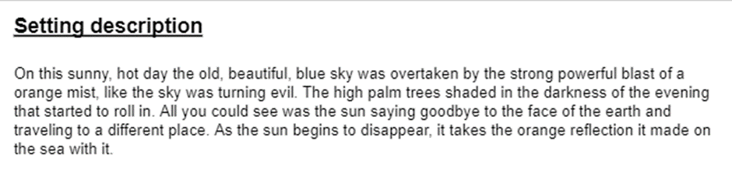
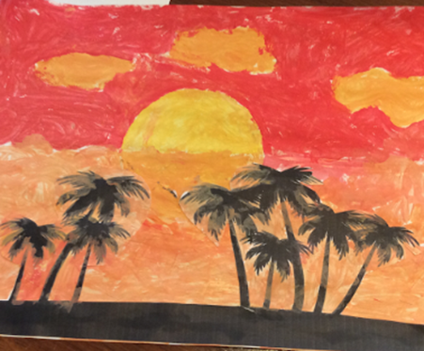
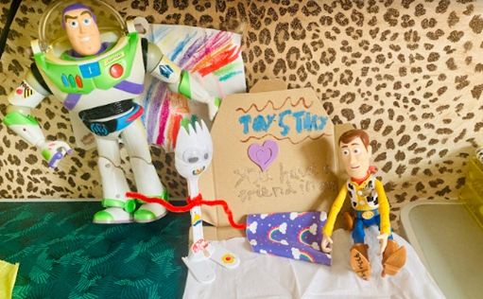
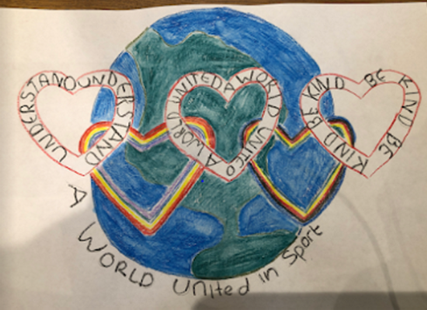
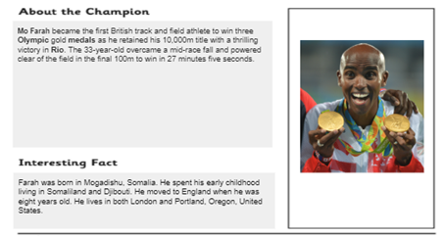
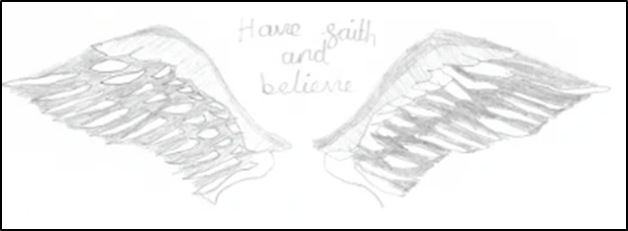
YEAR 5
This week Year 5 have been following an Olympic theme and have produced some wonderful work. The children have designed amazing Olympic logos and mascots. They have also used their research skills to create fact files about Olympic champions. Year 5 have also explored a range of summer themed Maths and English activities.

We have continuously been impressed with the determination and quality of work that our Year 5 children have produced throughout home learning. A huge thank you to all the children for a brilliant year and to the parents and guardians for their amazing continued support throughout. All your kind words and gifts are immensely appreciated. It has been a pleasure to teach you Year 5 and I look forward to seeing you all continue to flourish in Year 6.

Take care, stay safe and have a lovely summer holidays Year 5!

Miss Stainthorpe and Ms Fox

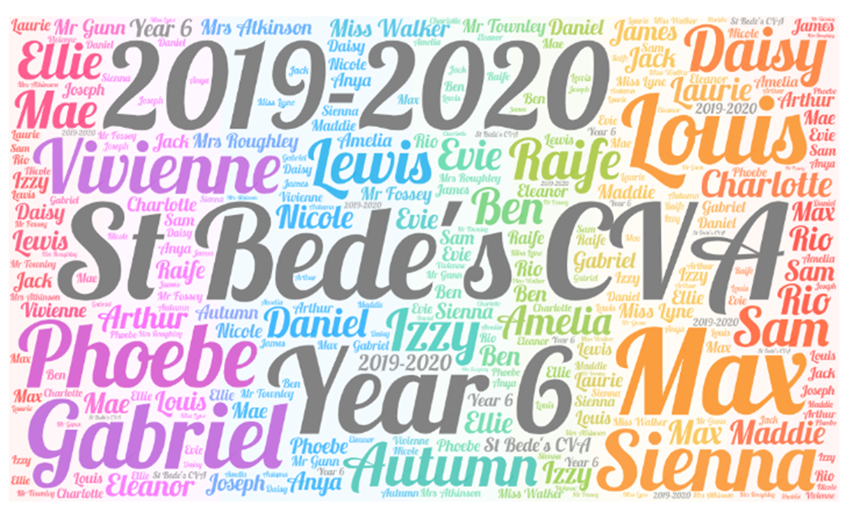
YEAR 6

And so, incredibly, the final week is here. This year has gone very quickly – it seems like only yesterday that we were walking in through the door for our first day together in September. This is not how any of us imagined, or hoped, that the year would end, but we hope that for those who were able to attend our get together yesterday it was a chance to say goodbye to friends and to staff.

The children have been through a lot this year, particularly over the last few months, and have shown everyone just how adaptable and resilient they can be. We are all very proud of them, and what they have achieved, and I’m sure that parents are too.

We would like to take this opportunity to thank the children for all their hard work this year and the parents for their continued, unwavering support. We are very lucky to have such a wonderful school family.

From speaking to the children, we know that they are both excited and nervous about the next chapter in their school life. We are confident that they will all go on to thrive at whichever secondary school they are going to and wish them the best of luck for their future. Hopefully, they will find time to come and see us and let us know how they’re getting on.

Stay safe and well

Mrs Atkinson, Mr Gunn, Miss Lyne, Mrs Roughley, Mr Townley and Miss Walker

