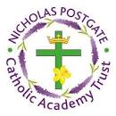

St Augustine’s Catholic Primary School
Autumn Term 2025-26 Curriculum Newsletter
Year Group: 4
Staff: Mr Manders, Mrs Laden and Mrs Dismore

Welcome back!
A very warm welcome to Year 4 and the start of the Autumn term! Over the past couple of weeks, it has been wonderful getting to know this fantastic group of children. This term, we are concentrating on establishing routines, fostering independence in learning, and working collaboratively as a class. We have also completed some back-to-school assessments, which will guide us in tailoring future lessons to ensure the right content is covered. Additionally, we began the year with Art Week, where we explored the work of Georgia O’Keeffe. The children researched the artist and experimented with water colours to create their final pieces.

English  Writing - Within our writing for this term we will be exploring poetry by writing our own poems and critically analysing poems by famous poets. Next, we will move on to writing a diary entry, a newspaper report, a piece of persuasive writing and a third person narrative. During these lessons we will be focusing on writing skills such as grammar and spelling.  Reading- During this term, we will read The Queen’s nose, Young, Gifted and Black and begin to read The Girl Who Stole an Elephant. Alongside the book, we will practise skills which focus on retrieving, summarising, predicting and inference skills. | Religious Education    During the Autumn term, we will be exploring the books of Genesis. We will remind ourselves of the creation story and how the world began before learning about the different covenants. We will use scripture and different creative ways to demonstrate our understanding. | 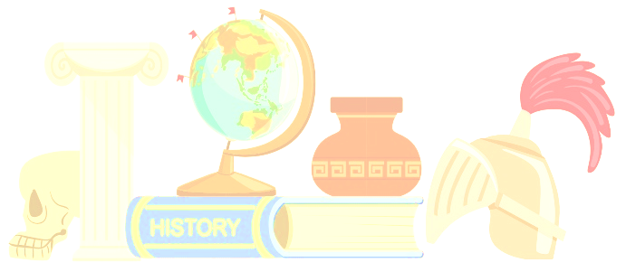  History  This term, we will be studying Britain’s settlement by Anglo-Saxons and Scots. During this module we will be focusing on chronology, causation and relationships.
Maths  In Maths, we will continue to develop and strengthen our number and place value work. Once we have a solid understanding, we will build on our addition and subtraction skills before starting the small topic of Measurement focusing on Area. As we come to the end of the term, we will use our Multiplication and Division facts to answer written methods for increasingly large numbers. Children should also continue to practise their -Times Tables regularly. The ability to recall multiples helps children across a range of mathematical concepts. To support this in school, we will practise arithmetic skills daily. | PE  In PE, the children will be building a range of skills with a focus in Dodgeball with Beth our coach from MFC. In addition, the children will be practising different skills as part of their tag rugby PE lessons delivered alongside Mr Bowman. As the term develops, the children will move on to practising their dance and basketball skills. | Geography    This term we will learn about the three courses of a river, how they are formed and their features. Towards the end of the term, we will learn the difference between longitude and latitude. | French  The children will continue using the French language throughout different times during the week calling on their Knowledge from Year 3. During lessons, we will focus on the calendar looking at the days, month and the date. After that, we will learn colours, emotions and numbers to 20.
Music
Our Music curriculum continues to be supported by Mrs Maxson who focuses on Liturgical Singing. In other areas of Music we will explore musical notation and untuned percussion.
Science  In Science, the children will start by learning about the topic; Living Things and Their Habitats. During this topic, the children will look at the characters which help us group animals in a variety of ways, use classification keys and the different animal environments. Later in the term, the children will start the topic States of Matter where they will focus on comparing, observing and identifying. | Computing  We will start this subject by focusing on Online Safety. In the second half of the term, the children will look in depth at computing systems and networks. | Art & Design  The children will continue to study the work of Georgia O’Keefe. Later in the term, the children will focus on taking inspiration from the artist Giorgio Morandi. | Design & Technology  The children will start with a focus on food and nutrition by doing some cooking. As we enter the second half of the term, the children will start learning about mechanisms.
PSHE - Health and Wellbeing
We will be learning a range of personal and social skills through stories, games and more. Our topics include;
- The Sacraments
- We Don’t Have to be the Same
- Respecting our Bodies
Planning will be made available to parents/ guardians. Please get in touch if you have any questions or concerns.

Parents’ Information Page



Meet the Team

Miss Thompson Mrs Laden Mrs Dismore
Here to help!
Please contact us at school (by phone) if you have any questions or concerns.
Homework
Homework will be sent home each Friday to be completed by the following Friday.
It will include:
· Spelling home learning task
· A set of maths questions
· A set of SPAG questions
Our homework will concentrate on building confidence and extending ability across key curriculum areas. We would also like the children to continue practising their times tables, as well as their home reading.

Stay in touch
You will see how the children are doing as we send regular updates through the Marvellous Me App as well as through our social media pages on Twitter and Facebook.
Trips
As part of our Geography topic, the children will be going on a trip to the Teesmouth Field Centre. This will support and help embed their learning. A letter with further details will be sent closer to the time.
P.E-
This term, PE will be on a Monday and Friday. Please can children come into school on these days wearing their correct P.E kits.

Reading at Home
Reading is the key to so many aspects of your child’s learning. We ask that children try to read for at least 10 minutes every night. We realise that sometimes this may not be possible so please ensure it happens at least four times a week. Also, please bear in mind that one of the most wonderful things is to share a book together with your child before bedtime. All home reading must be recorded and signed in your child reading record.

Children need to bring their reading books in everyday so we can read with the children and change their books when needed.

