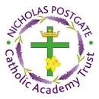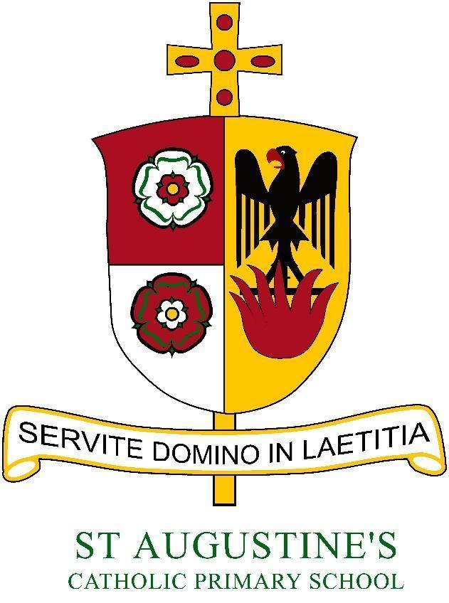

***St Augustine’s Catholic Primary School***

Autumn Term 2024-2025 Curriculum Newsletter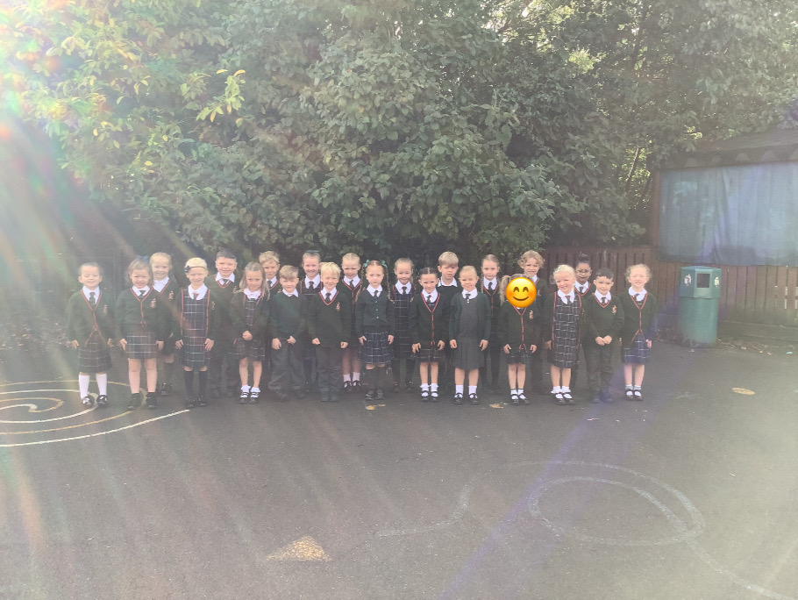

Year Group: 1  
Staff: Miss Davison and Mrs Pilling

Welcome back!

A warm welcome to Year 1 and the Autumn term. It has been wonderful to work with the children over these first two weeks; they are a lovely group of children. In these early days, we have been concentrating on establishing routines, building positive relationships and giving time to reflect on being back at school and together as a whole class. The children have also completed some back-to-school assessments, which will help to ensure what is taught is suitable for them. We have also enjoyed an ‘Art Week’ in school with the children producing incredible work in the style of illustrator and artist, Albrecht Durer.

| English    **Writing** - Within our writing for this term, we will be writing using simple sentences, capital letters, finger spaces and full stops. We will look at poetry focusing on poetry, setting descriptions, instructional writing and stories with familiar settings.  **Reading –** We will continue to use Little Wandle books to develop our vocabulary, expression and comprehension.  We will read a wide range of fiction and non-fiction books. | Religious Education  This term in RE, we will be learning and focusing on creation and covenant which looks at the world and how it was created as well as all the good things in it.  Later in the term we will be focusing on Prophecy and Promise, particularly in the run up to Advent.  All of our RE teaching links to Catholic Social Teaching. | History    This term, we will be exploring changes within our living memory and we will specifically be looking at how we have grown in different stages of our lives. We will also look at our local community of Coulby Newham and how it has changed. | |
| --- | --- | --- | --- |
| Maths  In Maths, we will continue to develop and strengthen our number and place value work. We will work on reading, writing, representing and ordering numbers up to 10 ● Using the language of comparison (including more, less, greater, fewer) ● Finding 1 more / 1 less than a number ● Using a part-whole model to identify the ‘parts’ that add together to make a ‘whole number’ ● Adding and subtracting using numbers within 10 ● Naming simple 2D and 3D shapes | PE  In PE, the children will be building skills in a range of team games and working with a coach from MFC on our fundamental skills and then we will move unto dance. | Geography  This term, we will explore and study the names and locate the 4 countries of the UK. Then look wider at the world and name and locate seven continents and 5 oceans. | |
| Music  In our Music lessons we will be exploring representing sounds and controlling our voices focusing on using different nursery rhymes to copy back body percussion and with untuned instruments. |
| Science  In Science, the children will be investigating two wonderful topics. The first will be identifying seasonal changes and weather.  The second topic is ‘Animals Including Humans’ and introduces plants with a focus on trees. | Computing  In Computing this term, we will be focusing on online safety and using computers safely and responsibly.  PSHE- Health and Wellbeing  Over the Autumn term, year one will be exploring how we created and loved by God and also how we are created to love others. | Art & Design  During the first week, we have been drawing using work by Albrecht Durer. Developing our observational and drawing skills by using a variety of materials and experimenting with a range of tools. | Design & Technology  In Design, we’ll be looking at structures, making models and also mechanisms leading up to Christmas. We will also be looking at designers who inspire our work. |

***Parents’ Information Page***

Meet the Team

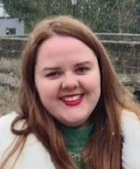         
Miss Davison Mrs Pilling  
Here to help!  
Please contact us at school (by phone) if you have any questions or concerns.

| Homework  Homework will be sent home each Friday to be completed by the following Friday.  It will include:  · Spelling home learning task  · A set of maths questions  · A set of SPAG questions  Our homework will concentrate on building confidence and extending ability across key curriculum areas. |
| --- |

Stay in touch -

You will see how the children are doing as we send regular  
updates through the Marvellous Me App.

| P.E-  This term, PE will be on a **Thursday and Friday**. Children need to come into school on these days wearing their P.E kits. |
| --- |

***Reading at Home***

Reading is the key to so many aspects of your child’s learning. We ask that children try to read for at least 10 minutes every night. We realise that sometimes this may not be possible so please ensure it happens at least four times a week. Also, please bear in mind that one of the most wonderful things is to share a book together with your child before bedtime. All home reading must be recorded and signed in your child reading record.

In Year 1, children will bring a Little Wandle book and a free choice book home to share with you on a Thursday. Both books need to be returned on a Monday so they can be changed and sent home for the following week.