

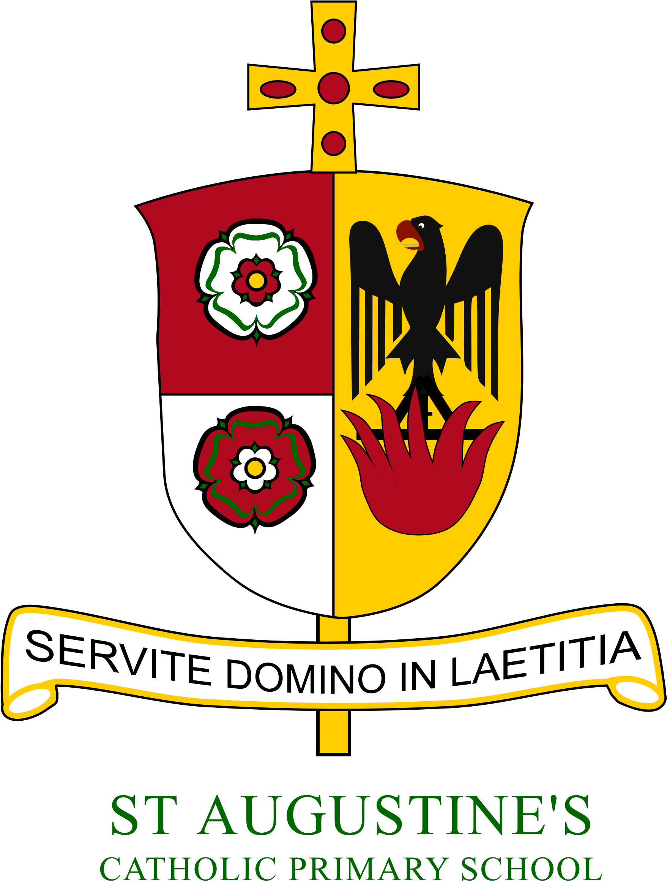
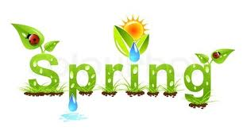
Year 6
Year 6 Newsletter Autumn 2020
Year 2 Newsletter: Spring 2022

St Augustine’s Catholic Primary

A warm welcome to the new year and the Spring term. Year 2 have started the term with a very mature and positive attitude. Over the course of this term, the children will continue to develop a range mathematical, writing and reading skills and applying these across the curriculum. This week, we have started our new topic- a local study, focusing on Coulby Newham. We have also enjoyed our new P.E topic of Yoga as well as new topics in Science and Computing. Mrs Pilling and I look forward to seeing the brilliant work Year 2 produce this term.
 | RE  During the Spring term, we will be exploring three themes: Books, Thanksgiving and Opportunities. In our first topic Domestic Church (Books), we will be exploring the community. In our next topic (Thanksgiving), we will look at Mass- a special time for saying thank you to God for everything. Our Lent/Easter topic (Opportunities) will focus on opportunities for self-giving and sharing.
English  During this first half-term, we will be focusing on non-traditional tales, starting with ‘The Three Little Wolves and The Big Bad Pig’. We will be continuing to use actions and story-maps to support our Writing following a Talk 4 Writing approach.  Moving into the second part of the term, we will be focusing on topic-based writing in which we will look at writing a guide to Coulby Newham and recounting our trip out of school.    Reading  During this term, we will be continuing to develop our vocabulary, expression and comprehension skills reading a wide range of fiction and non-fiction books.  The books we send home for the children to read, will match their reading ability as well as those set as Collins e-books (link below).  ebooks.collinsopenpage.com  Please can parents/carers continue to sign the record to confirm reading. |  | Maths  In Maths, we will continue to develop and strengthen our number and place value work. We will also continue to focus on both Multiplication and division. Later in the Spring term, Year 2 will be looking at properties of 2D and 3D shapes as well as fractions. Children should also continue to practice their 2, 5, and 10-Times Tables regularly. The ability to recall multiples helps children across a range of mathematical concepts. To support this in school, we will practice arithmetic skills, daily.  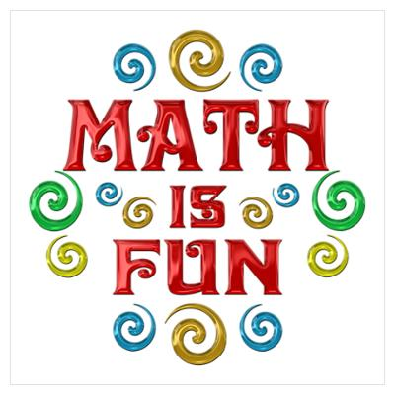  Science    In Science, the children will be investigating two wonderful topics. The first will be ‘Living Things and Their Habitats’ where the children learn about a variety of creates and how they are best suited to their habitats. The second topic is ‘Animals Including Humans’, where the children will look at food humans and animals eat and the importance for humans to have exercise, eating the right amounts of different types of food and hygiene.  Topic  This term, our new topic will be a local study, focusing primarily on Coulby Newham. We will be exploring its location and its geographical features. Furthermore, we will look at how Coulby Newham has changed and comparing it to the past. We will also be discussing and exploring the question- Why was Coulby Newham built?   |   PE  In PE, the children will be building skills in a range of target games with our MFC coach. As the term develops, we will develop our Yoga skills over a series of lessons, too.
P.E days

This term, PE will be on a Thursday and Friday. Children need to come into school wearing their P.E kit.
Kits should be a plain white t shirt (school logo t shirts are available from Lollipops), plain black/grey/navy jogging bottoms and optional plain tracksuit top/hoodie. Dark green PE hoodies are available to buy from Lollipops.
Homework
Homework will be posted on the Google Classroom and sent home each Friday to be completed by the following Friday. It will include:
- Spellings to learn for a test in school the following Friday
- A set of maths questions
- A set of grammar and punctuation questions too.
Our homework will concentrate on building confidence and extending ability across key curriculum areas. Children may also be asked to complete tasks on Purple Mash.


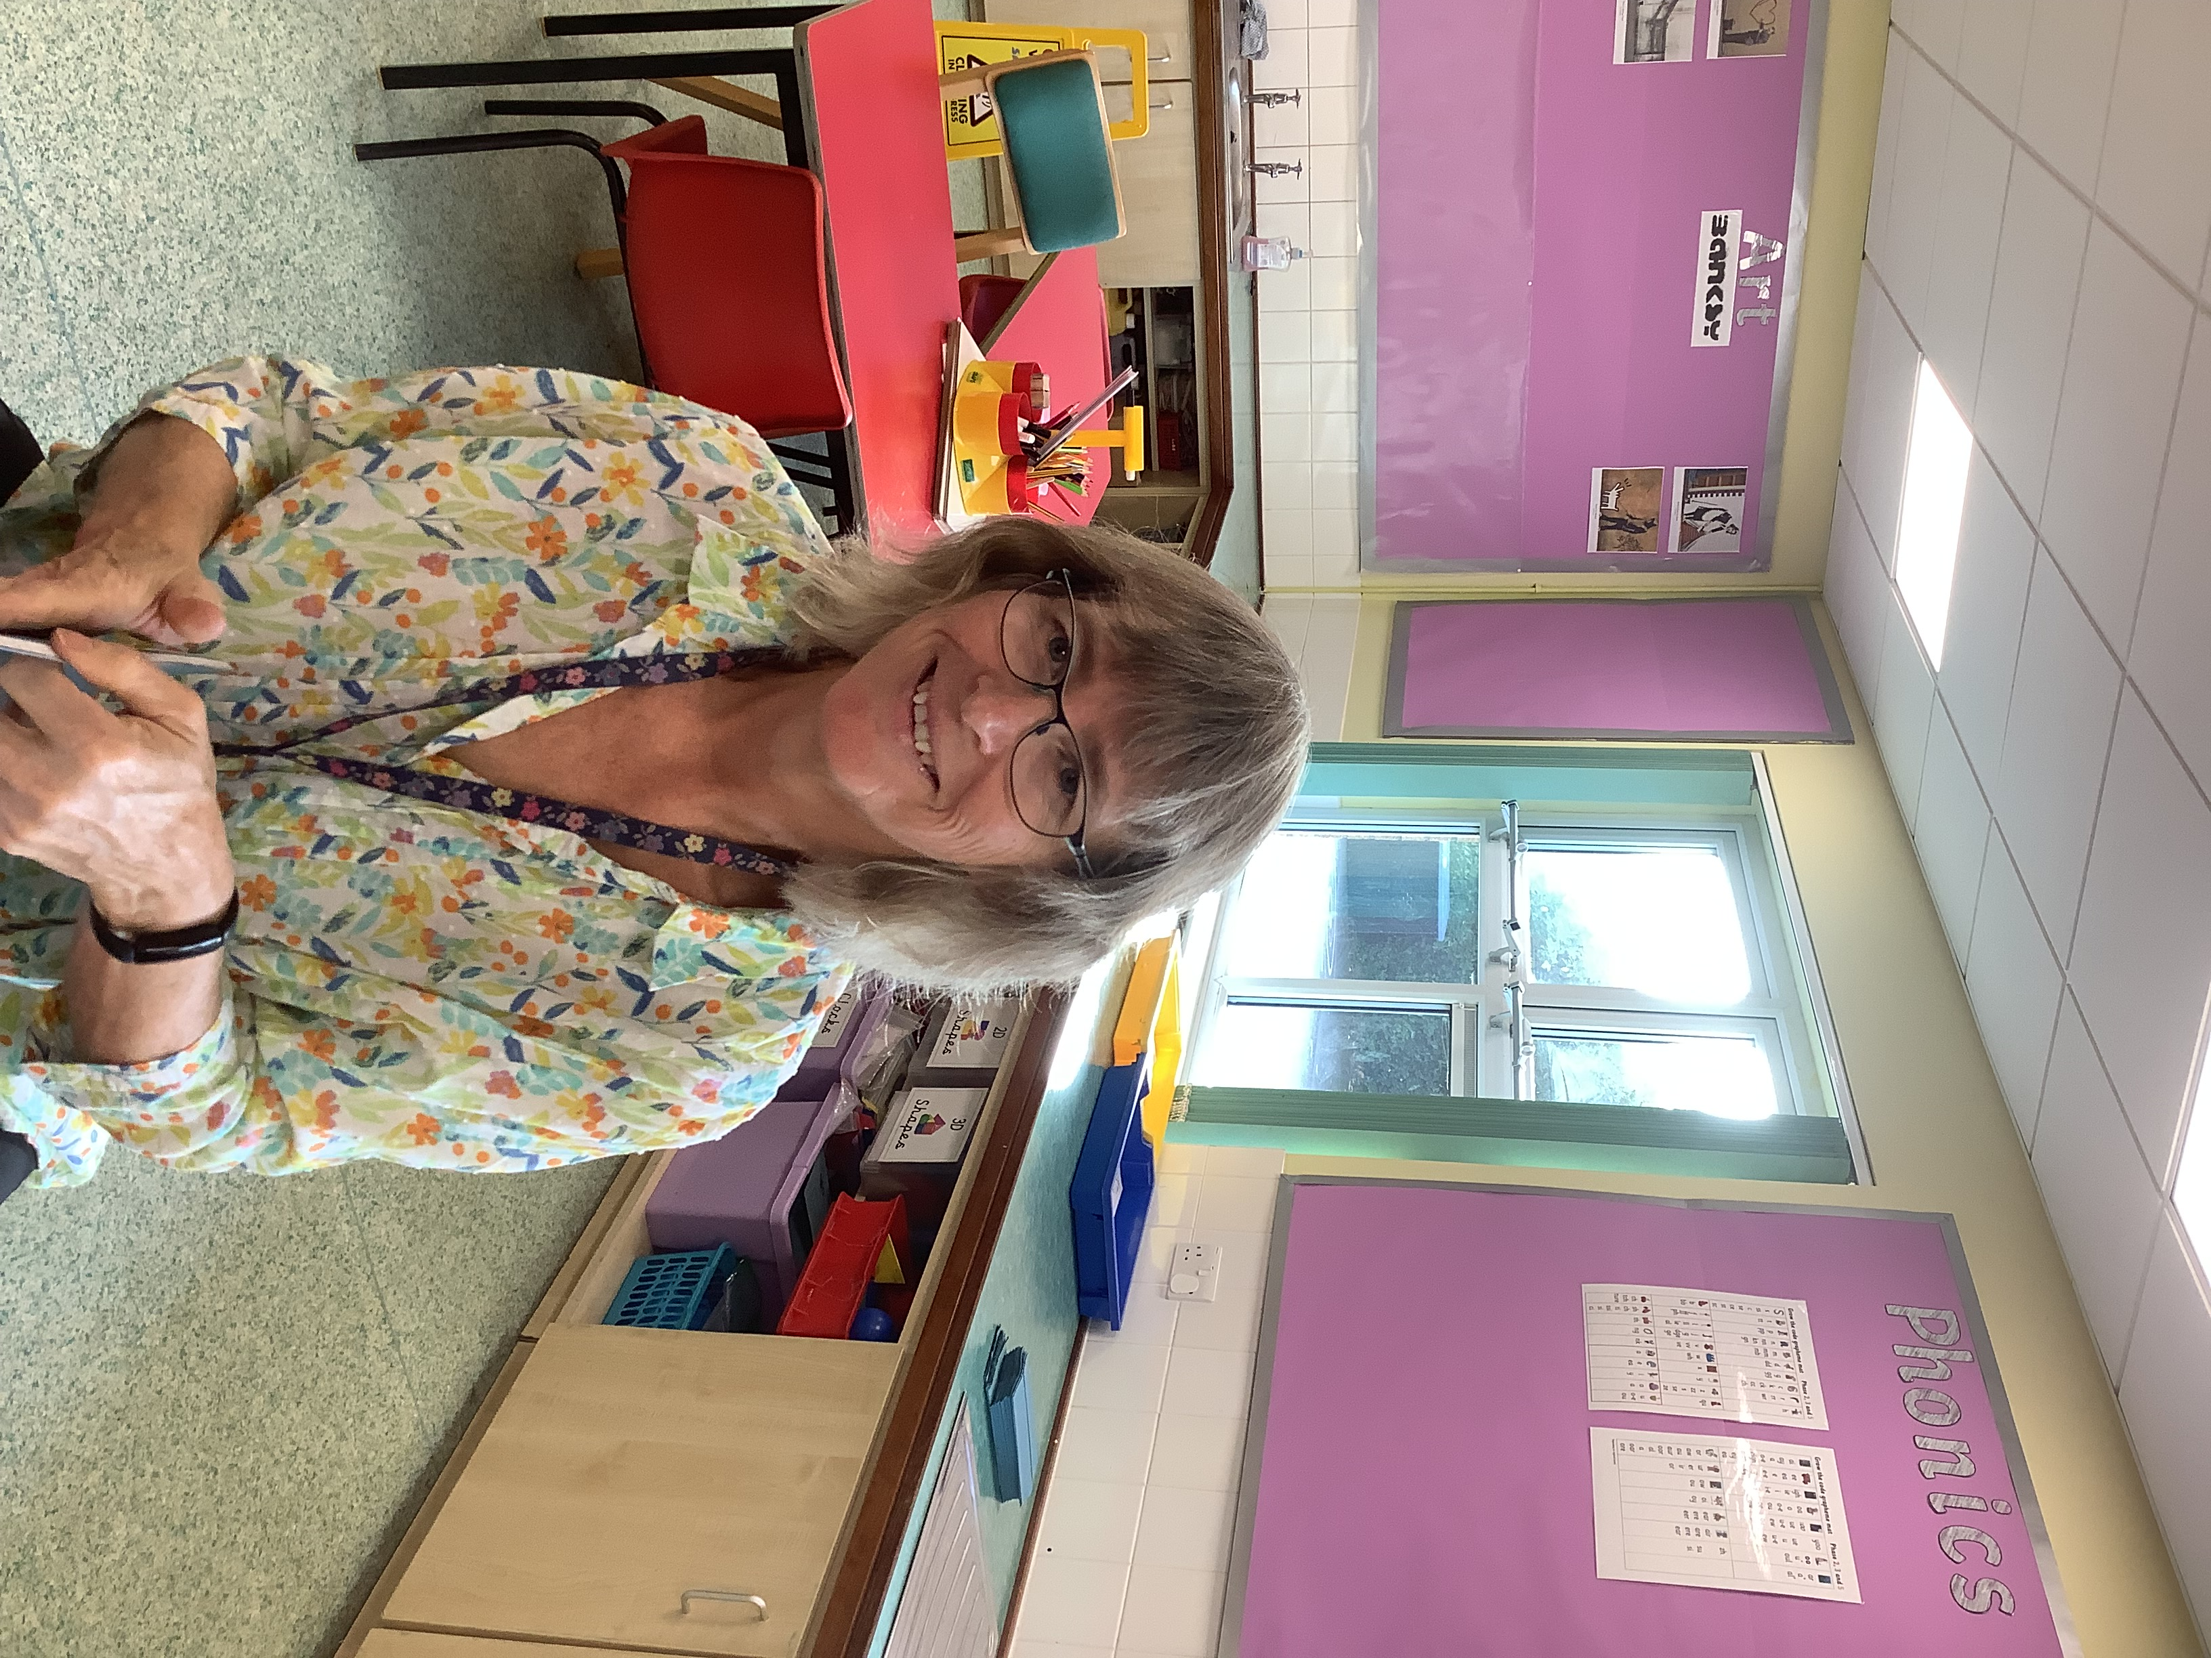
Meet the Team:

Mr Robbins Mrs Pilling

Here to help!
Please contact us at school (by phone) if you have any questions or concerns.
Stay in touch - You will see how the
children are doing as we send regular
updates through the Marvellous Me App.



