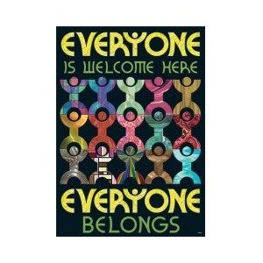

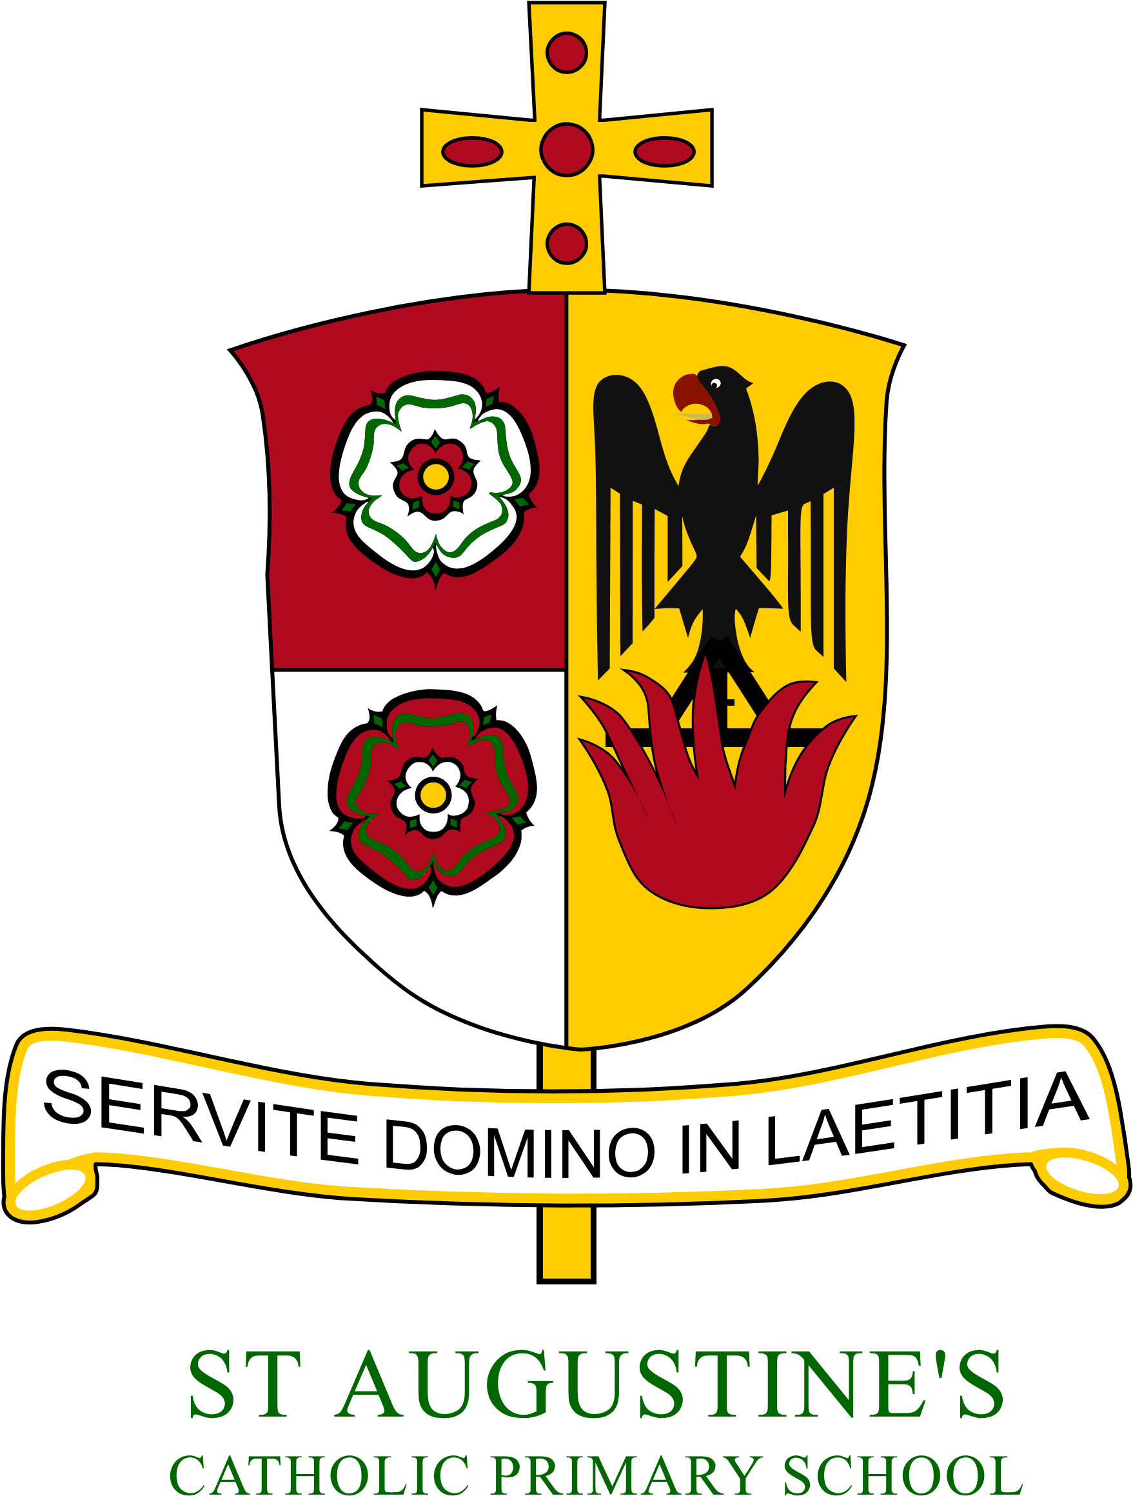
Year 6
Year 6 Newsletter Autumn 2020
Year 4 Newsletter: Autumn 2021

St Augustine’s Catholic Primary
Hello and welcome to Year 4! It has been a busy start to the term establishing routines, building positive relationships and reflecting upon our goals for this year. Year 4 have made a wonderful impression and have been kind, helpful and patient as we ease our way back in to learning and school life. This week we have enjoyed an art week in school with the children exploring and recreating artwork from Henri Matisse’s collection “Windows”. Next week we will move towards our normal timetable with the subjects and skills we are teaching building over the half term as and when the children are ready.
 | RE    During the Autumn term, we will be exploring three themes: Family, Belonging and Loving. In our first topic Domestic Church (Family), we will be exploring Jesus and his family. Our Baptism and Confirmation topic (Belonging) will allow us to think how we and other people share their lives with God. As we approach Advent, we will be celebrating love becoming a reality through Jesus’ birth - Loving.
English  During the first few weeks, we will focus on our whole school theme Let There Be Light. Within this we will be reflecting on the type of world we want and taking time to think about how we interact and treat the Earth. This topic has provided a fantastic opportunity to discover the wonders of Bangladesh. Together we will explore the diverse culture and how our cultures are different. We will focus and practice our non-fiction skills by creating an informal letter to send to our partner school in Bangladesh. Later in the term we will begin to plan how we can make our dreams a reality by writing speeches with the focus of recycling. Towards the end of term we will begin to focus on our poetry writing.    The children need to bring their reading book and home reading log into school everyday.  It is important children are reading every day at home and that all children read aloud regularly to an adult. Even the most fluent readers benefit from the experience of sharing stories and information with others.  Please can parents/carers sign to confirm reading. |  | Maths  In maths, we will continue to build and develop our mental arithmetic and reasoning skills across all operations. We will focus this term on place value, multiplication facts, length, perimeter and formal written methods for addition, subtraction, multiplication and division. Children should also continue to practice their Times Tables regularly to help them recall facts across a range of concepts. To support this in school, we will practice arithmetic skills daily.    Science  In Science, with Mrs Sawdon, the children will be exploring two wonderful topics. The first will be animals and there habitats where the children learn of different animals, their place in the food chain and how they have adapted to their environment. The second is Electricity where the children will investigate how electricity and circuits work.  Topic  We are starting the term by delving in to our given Global Caretaker’s appointed country, Bangladesh. We will begin navigating the world through learning globe and atlas skills which will allow us to not only find our given country but other exciting locations. We will learn the difference between human and physical geography and use this knowledge to compare different countries. Further in to the term we will start our topic; Romans, Past and Present. We will start by taking a tour of historic events before learning about life as a Roman soldier.  Not forgetting…  Before we dive in to the Year 4 French curriculum we will be reviewing some of your Year 3 vocabulary starting with vegetables and the market.  Please can children bring their reading records and books in to school every day. | PE  In PE, the children will be building their stamina and core strength in Fitness. As the term progresses the children will be practicing their balance and control skills during Gymnastics. This term PE will be on Monday afternoons and Thursday mornings.  PE kit should be a plain white T-shirt, black/blue shorts or jogging bottoms and trainers/plimsoles (tracksuit tops are useful if the weather is cold).

Computing
This term, we will focus on internet safety and how to stay safe when working and playing online. Further in to the term we will develop our understanding of coding and build our skills to support us in programming.
Homework
Homework will be posted on the Google Classroom each Friday to be completed by the following Friday. It will include:
- Spellings to learn for a test in school the following Friday
- A set of maths questions
- A set of grammar and punctuation questions
Answers will be posted too for self/parent marking. Our homework will concentrate on building confidence and extending ability across key curriculum areas.

Meet the Team:

Miss Thompson is the Year 4 class teacher.
Mrs Laden will be in class with the children Monday, Tuesday and Wednesday.
Mrs Dismore will be in class with the children on Thursday and Friday.
Mrs Sawdon will be in class with the children every Wednesday morning teaching Science.

Here to help!
Please contact us at school (by phone or email) if you have any questions or concerns.
Stay in touch - You will see how the
children are doing as we send regular
updates through the Marvellous Me App.



