

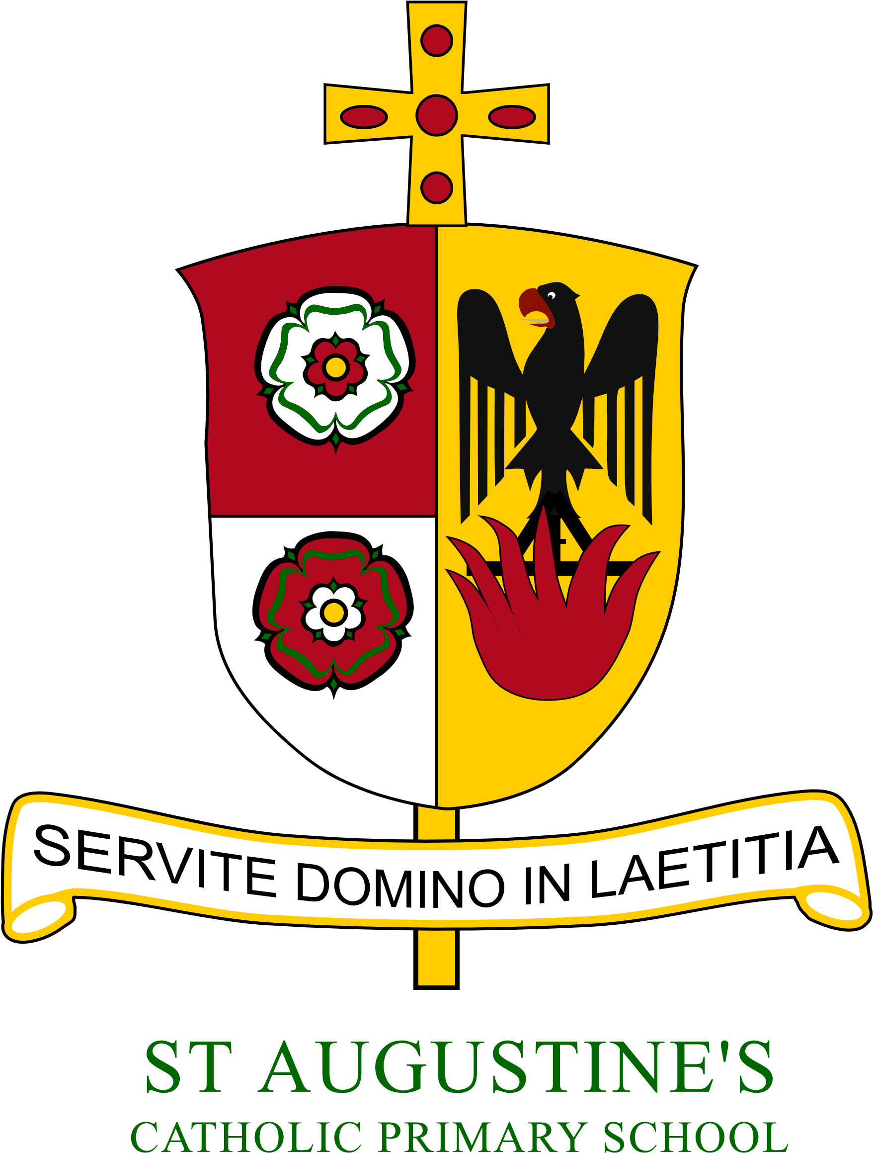
Year 6
Year 6 Newsletter Autumn 2020
Year 2 Newsletter: Autumn 2021

St Augustine’s Catholic Primary

A warm welcome to Year 2 and the Autumn term. It has been wonderful to work with the children over these first two weeks; they are a lovely group of children. In these early days, we have been concentrating on establishing routines, building positive relationships and giving time to reflect on being back at school and together as a whole class. The children have also completed Phonic assessments, which will help to ensure what is taught is suitable for them. We have also enjoyed an art week in school with the children producing incredible work in the style of Banksy. Next week, starting out new topic – Make a house a home. We will be focusing on Mongolia.
 | RE  During the Autumn term, we will be exploring three themes: Beginnings, Signs and Symbols and Preparations. In our first topic Domestic Church (Beginnings), we will be exploring God’s wonderful creations. Our Baptism topic (Signs and Symbols) invited to share in the life and work of God. As we approach Advent, we will be celebrating Jesus’ birth in our final topic – Preparations.
English  During these first couple weeks, we will be focusing on a book called What We’ll Build. This is a beautiful story which provides an insight into life’s endless opportunities. The words and pictures work together to help children to understand their place in the world and to move forward together in a positive and constructive way.  Continuing with a focus on books and enriching stories, we will then be reading a book called. The colour of home to inspire our imagination and creative writing.    Reading  As we are starting a new Phonics scheme, the books we send home for the children to read will match what they have been learning in Phonics. Home reading books will be sent out in due- course. Please bear with us whilst we get this organised.  Please can parents/carers sign the record to confirm reading. |  | Maths  In Maths, we will continue to develop and strengthen our number and place value work and addition and subtraction. Children should also continue to practice their 2, 5, and 10 Times Tables regularly. The ability to recall multiples helps children across a range of mathematical concepts. In addition, overall confidence flourishes. To support this in school, we will practice arithmetic skills daily.    Science  In Science the children will be investigating two wonderful topics. The first will be Everyday Materials where the children learn about materials and their uses. The second is Animals Including Humans, where the children will investigate animal habitats and how animals adapt to their environment.  Topic  During the first half term, will be focusing on a topic called ‘Make A House A Home’. We will be exploring the country of Mongolia and its geographical features. We will also be discussing and exploring the question- What kind of world do we want?  Phonics  In the Autumn term, we will be continuing to have daily Phonics lessons. Children will be taught as a class on a new sound.  We will also have group Reading lessons three times a week. |   PE  In PE, the children will be building skills in a range of team games. As the term develops, we will develop our dancing skills. This term PE will be on Thursday morning or Friday afternoons. Children need to leave their PE kit in school every day.
P.E days

This term, PE will be on a Thursday and Friday. Children need to leave their PE kit in school every day and take it home at the weekend to be washed and cleaned.
Homework
Homework will be posted on the Google Classroom and sent home each Friday to be completed by the following Friday. It will include:
- Spellings to learn for a test in school the following Friday
- A set of maths questions
- A set of grammar and punctuation questions too. Our homework will concentrate on building confidence and extending ability across key curriculum areas. Children may also be asked to complete tasks on Purple Mash.


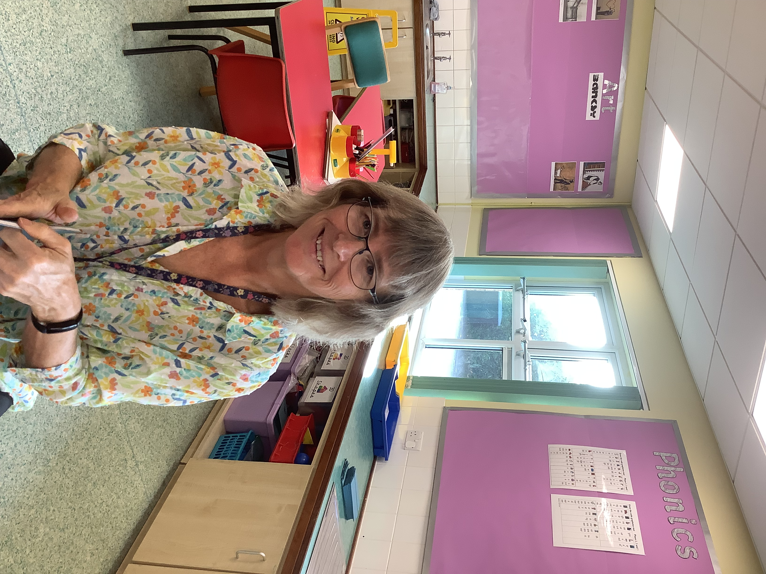
Meet the Team:

Mr Robbins Mrs Pilling

Here to help!
Please contact us at school (by phone or email) if you have any questions or concerns.
Stay in touch - You will see how the
children are doing as we send regular
updates through the Marvellous Me App.



