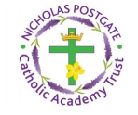
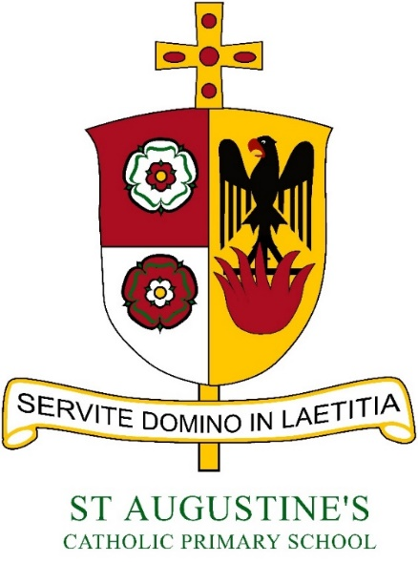

Policy for Geography

Mrs J Manton
Geography Co-ordinator
Reviewed and updated September 2020
‘Geography is the study of Earth’s landscapes, peoples, places and environments. It is, quite simply, about the world in which we live.’

Introduction

Geography is a valued part of the curriculum, providing a purposeful means for exploring, appreciating and understanding the world in which we live and how it has evolved. Geography explores the relationship between the Earth and its people through the study of place, space and environment. In Geography, pupils learn the skills of understanding a locality and how and where people fit into its overall structure. Geography encourages children to learn through experience, particularly through practical and fieldwork activities. Geography is taught through the Cornerstones topics covered by each year group.
The strands in Geography are:

- Locational knowledge
- Place knowledge
- Human and physical geography
- Geographical skills and fieldwork

Aims

The national curriculum for geography aims to ensure that all pupils by the end of each key stage, know, can apply and understand the matters, skills and processes specified in the relevant programmes of study.
The aims of geography are:
- To inspire in pupils about the world and its people that will remain with them for the rest of their lives.
- To provide pupils with knowledge about diverse places, people, resources and natural and human environments.
- To develop a growing knowledge about the world to deepen their understanding of the interaction between physical and human processes, and of the formation and use of landscapes and environments.
- To obtain Geographical knowledge, understanding and skills.
- To enable children to learn and explain how the Earth’s features at different scales are shaped, interconnected and change over time

The Early Years Foundation Stage

We encourage the development of skills, knowledge and understanding that help our youngest children make sense of their world as an integral part of the school’s work. We plan opportunities based on Development Matters in the Early Years Foundation Stage (EYFS). The Development Matters statements for Geography can be mainly found in the EYFS Specific Area of ‘Understanding the World’.
The development matters statements support the curriculum planning for children aged birth to five and forms the foundations for later work in Geography.

These early experiences include:
- observe, find out about, and identify features in the place they live and the natural world;
- Begin to know about their own cultures and beliefs and those of other people;
- Find out about their environment, and talk about those features they like and dislike.

Key Stage 1

Pupils should be taught about:

Location knowledge
- name and locate the world’s seven continents and five oceans
- name, locate and identify characteristics of the four countries and capital cities of the United Kingdom and its surrounding seas

Place knowledge
- understand geographical similarities and differences through studying the human and physical geography of a small area of the United Kingdom, and of a small area in a contrasting non-European country

Human and physical geography
- identify seasonal and daily weather patterns in the United Kingdom and the location of hot and cold areas of the world in relation to the Equator and the North and South Poles
- use basic geographical vocabulary to refer to:
- key physical features, including: beach, cliff, coast, forest, hill, mountain, sea, ocean, river, soil, valley, vegetation, season and weather
- key human features, including: city, town, village, factory, farm, house, office, port, harbour and shop

Geographical skills and fieldwork
- use world maps, atlases and globes to identify the United Kingdom and its countries, as well as the countries, continents and oceans studied at this key stage
- use simple compass directions (North, South, East and West) and locational and directional language (e.g. near and far; left and right) to describe the location of features and routes on a map
- use aerial photographs and plan perspectives to recognise landmarks and basic human and physical features; devise a simple map; and use and construct basic symbols in a key
- use simple fieldwork and observational skills to study the geography of their school and its grounds and the key human and physical features of its surrounding environment.

Key Stage 2

Pupils should be taught about:
- Location knowledge
- locate the world’s countries, using maps to focus on Europe (including the location of Russia) and North
- South America, concentrating on their environmental regions, key physical and human characteristics, countries, and major cities
- name and locate counties and cities of the United Kingdom, geographical regions and their identifying human and physical characteristics, key topographical features (including hills, mountains, coasts and rivers), and land-use patterns; and understand how some of these aspects have changed over time
- identify the position and significance of latitude, longitude, Equator, Northern Hemisphere, Southern Hemisphere, the Tropics of Cancer and Capricorn, Arctic and Antarctic Circle, the Prime/Greenwich Meridian and time zones (including day and night)

Place knowledge
- understand geographical similarities and differences through the study of human and physical geography of a region of the United Kingdom, a region in a European country, and a region within North or South America

Human and physical geography
- describe and understand key aspects of:
- physical geography, including: climate zones, biomes and vegetation belts, rivers, mountains, volcanoes and earthquakes, and the water cycle
- human geography, including: types of settlement and land use, economic activity including trade links, and the distribution of natural resources including energy, food, minerals and water

Geographical skills and fieldwork
- use maps, atlases, globes and digital/computer mapping to locate countries and describe features studied
- use the eight points of a compass, four and six-figure grid references, symbols and key (including the use of Ordnance Survey maps) to build their knowledge of the United Kingdom and the wider world
- use fieldwork to observe, measure and record the human and physical features in the local area using a range of methods, including sketch maps, plans and graphs, and digital technologies.

Spiritual, Moral, Social and Cultural opportunities

Geography is an excellent vehicle for developing children’s learning in this area. Discussions about the use of the world’s resources and the impact of different events on the lives of local people deepen the children’s ability to understand and empathise with fellow humans across the globe. The opportunities to explore ‘putting yourself in someone else’s shoes’ abound in the study of geography and it is embraced during the teaching wherever possible.

Assessment and Monitoring

The Geography subject leader and class teacher are responsible for assessing monitoring the standard of the children’s work and the quality of teaching in Geography. The subject leader is responsible for supporting colleagues in the teaching of Geography, for being informed about current developments in the subject and for providing a strategic lead and direction for the subject in the school. The subject leader will complete an annual action plan where they evaluate the strengths and weaknesses in the subject and indicate areas for further improvement. Throughout each academic year, the subject leader must undertake monitoring of Geography across the whole school.

Assessment will be undertaken using the following methods:
• observation of pupils
• talking with pupils
• marking written work
• self-assessment
• peer assessment
• the evaluation of discussion

Learning Outside the Classroom
Learning Outside the Classroom plays an important role in Geography, to link the skills to real life situations and understand Geography is to be outside and a part of what we are learning about.

Health and Safety

The School’s policy for visits and excursions will be adhered to for all trips. A copy of the Health and Safety policy can be found in the school office. This is supplemented with county guidance concerning Educational Visits.

Remote and Home Learning

We recognise the importance of maintaining high expectations in all areas of school life and ensuring that all our
children have access to the learning resources and support they need to succeed. In the event of a school closure or ‘bubble’ isolating, teachers will use google classroom to set appropriate work for their class. Where possible, online lessons should reflect those that would normally take place in the classroom. Children will submit work onto the classroom so that teachers can mark and provide feedback.

